Add Country / City

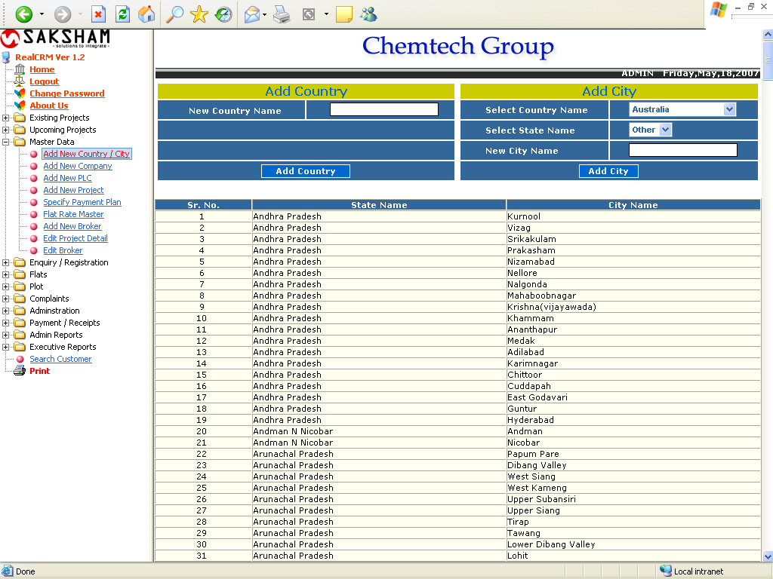

This form is used to Add New Country / City. Type Country Name and Click “Add Country” button to add new Country. To add City, First select Country and State then type City Name in textbox and click “Add City” button.

Add New Company

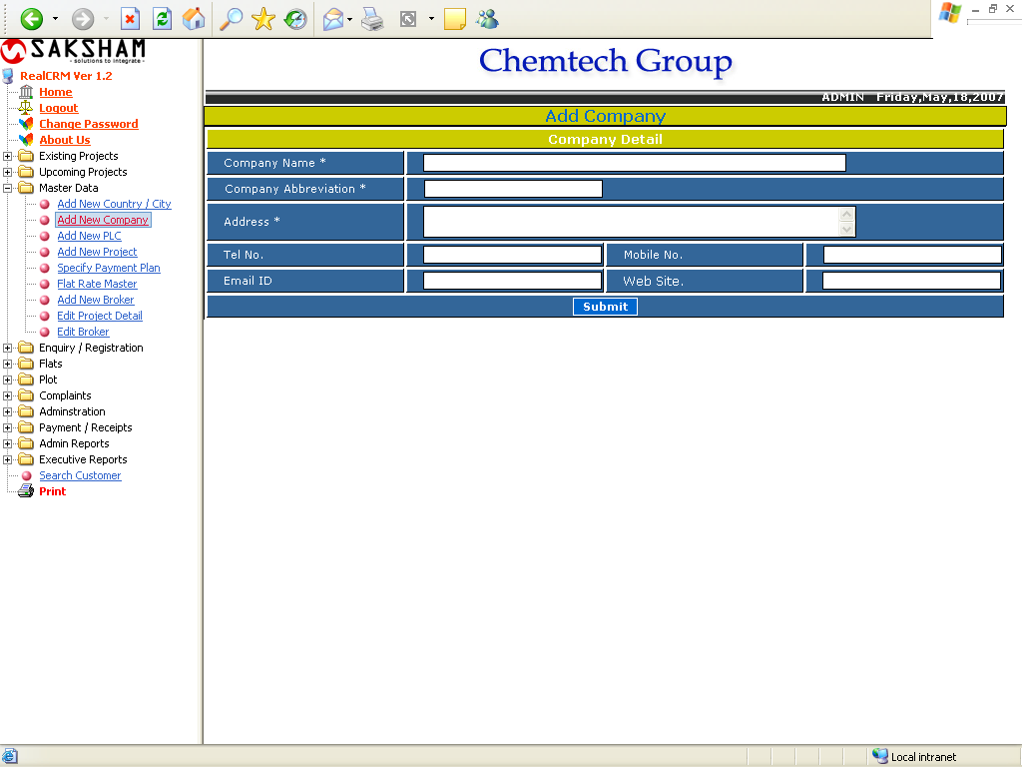

This form is used for ‘Add New Company’. The user must enter all the mandatory fields like Company Name, Company Abbreviation, and Address. The user can enter the Tel No., Mobile No, Email ID and Web site also. After all click the Submit button for adding the new company details into this software.

Add New PLC

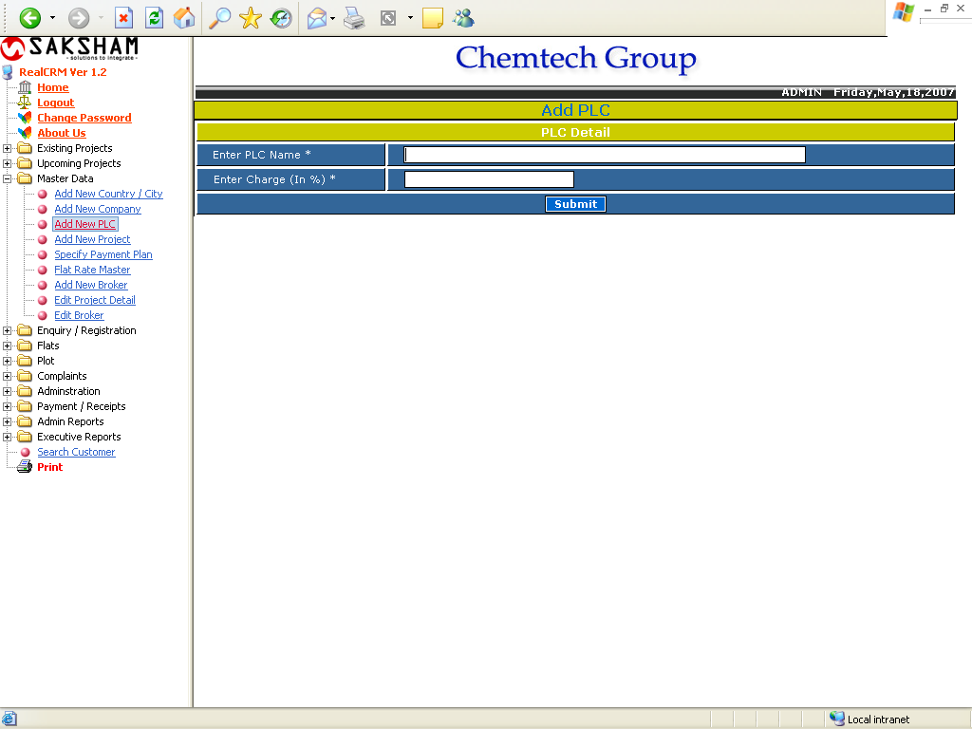

This form is used to ‘Add New PLC’ for each project. The user must Enter PLC Name and Enter Charge (in %), then click the submit button for adding new plc.
Add New Project

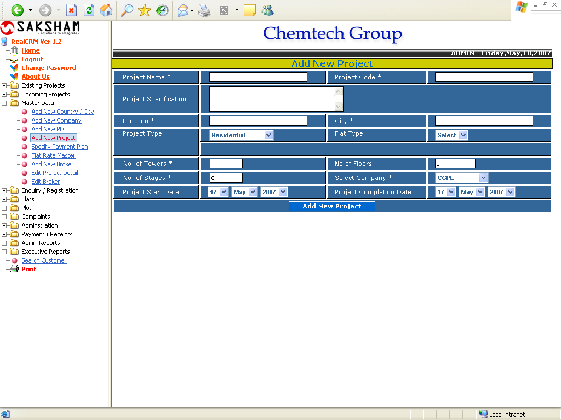

This form is used to Add New Project to database. User need to specify Project Name, Project Code, Project Specification, Location, City, Flat Type, No. of Towers, No of Floors, No. of Stages, Select Company, Project Start Date and Project Completion Date. Here in Flat type there are two options Flat or Plot. Using this Flat Type the user can select the type of Project.
Specify Payment Plan

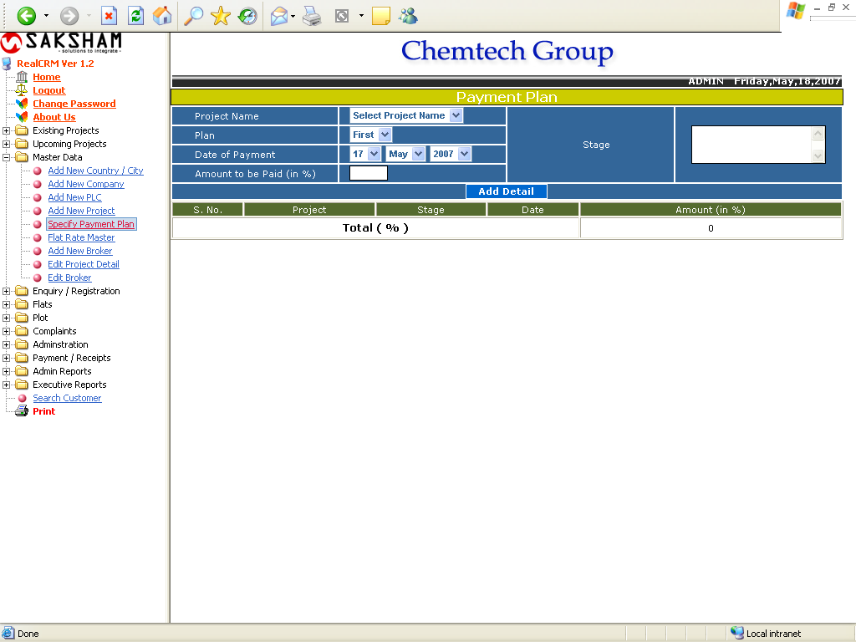

This form is used to specify Payment Plan of the Project. This from describes payment that customer need to pay on the different stages of the project. User need to select the Project Name, Plan, Date of Payment, Stage, Amount to be Paid in percentage.

Flat Rate Master

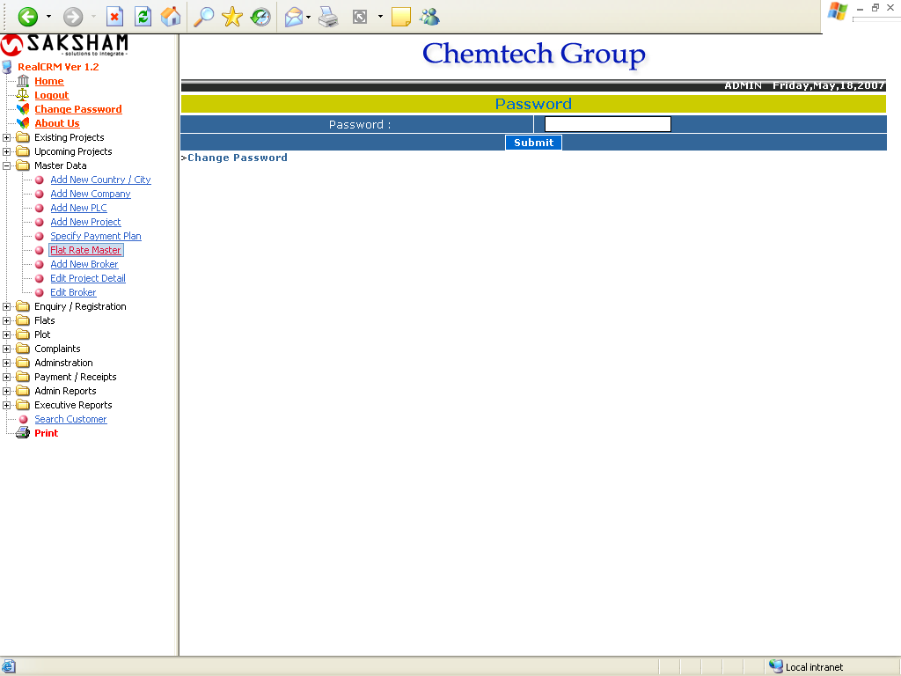

This is the Password protected area of this software. This form is used for adding new rates to the flats or plots in each project. The user must enter the Password, if it is correct the user can directly goes to the Rate Master and add new rates for the projects.

Rate Master

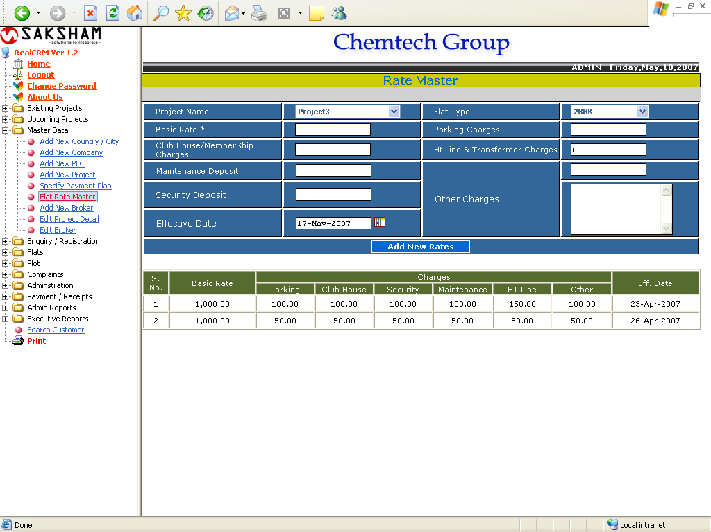

This form is used for add new rates of the Project. The user needs to select the Project Name, Flat type, and enter the Basic Rates and other all fields. Then select the Effective Date, click the Add New Rate button.

Change Password

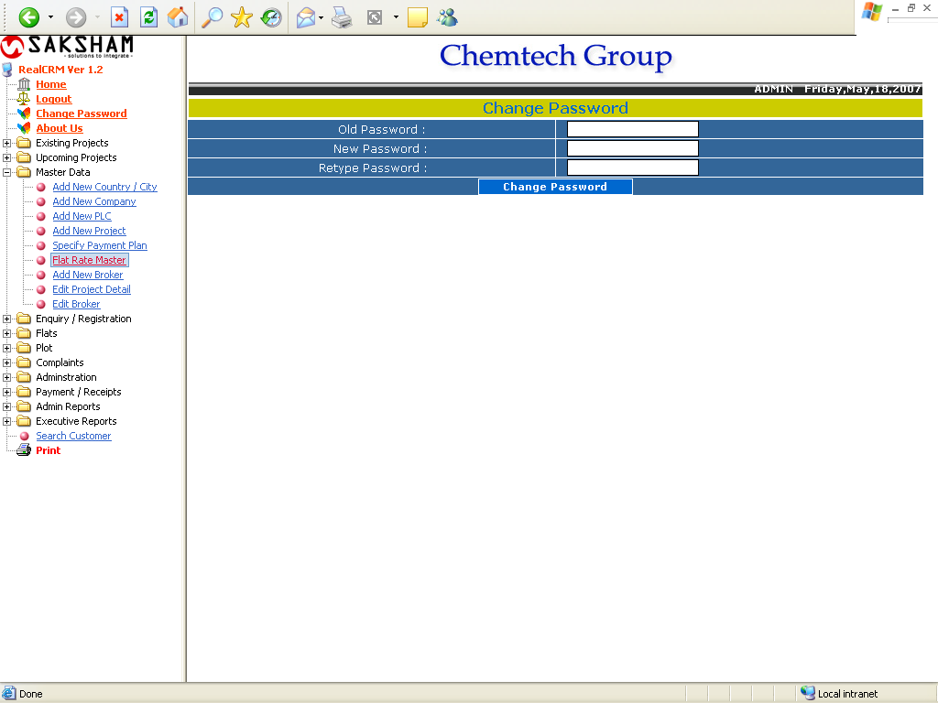

This form is used for changing the Password of the Rate Master. For changing the password, the must enter the Old Password, New Password and Retype Password. Then click the Change Password button.

Add New Broker

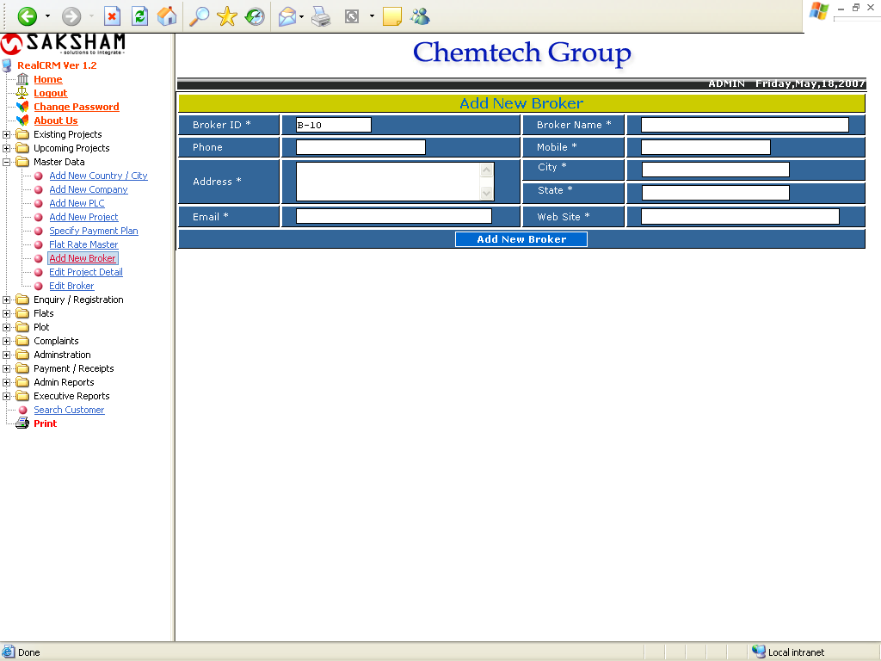

This form is used to Add new Broker. To add new broker all the mandatory filed must be filled. The Broker ID will come automatically. And after filling all the detail click on save button.

Edit Project Details

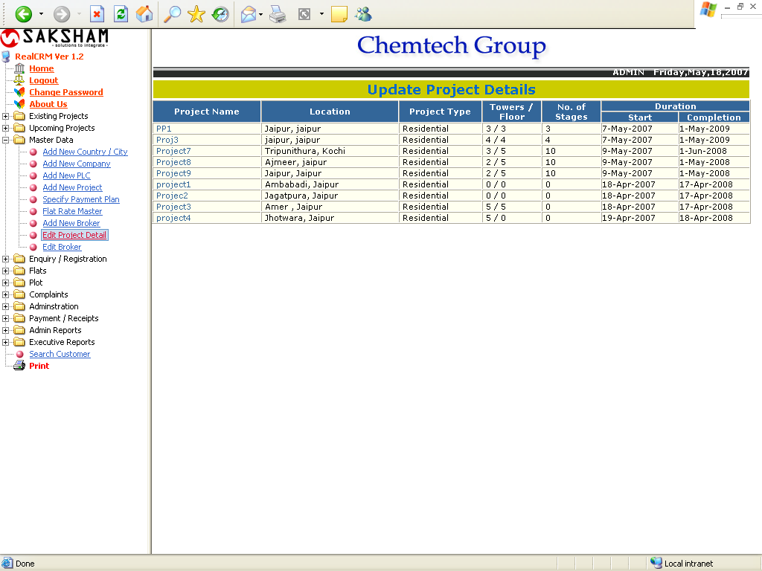

This form shows all project added previously. For Updating the Project Details, click on the Project Name to be wants to edit the details.
Update Project Details

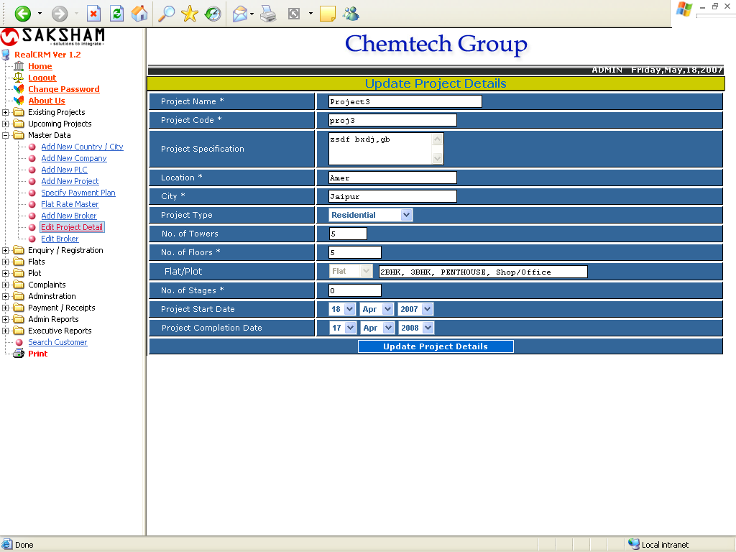

This form is used to view or update the selected project details. All the project details will come automatically. The user can’t edit the Project name and Project Code. If the selected project is flat, the Flat/Plot drop down box automatically set as Flat and the flat types will show along with this drop down box, it will be editable. The user can update the needed field and then click the Update Project Details. The following form will come.

Flat Details (Add Flat)

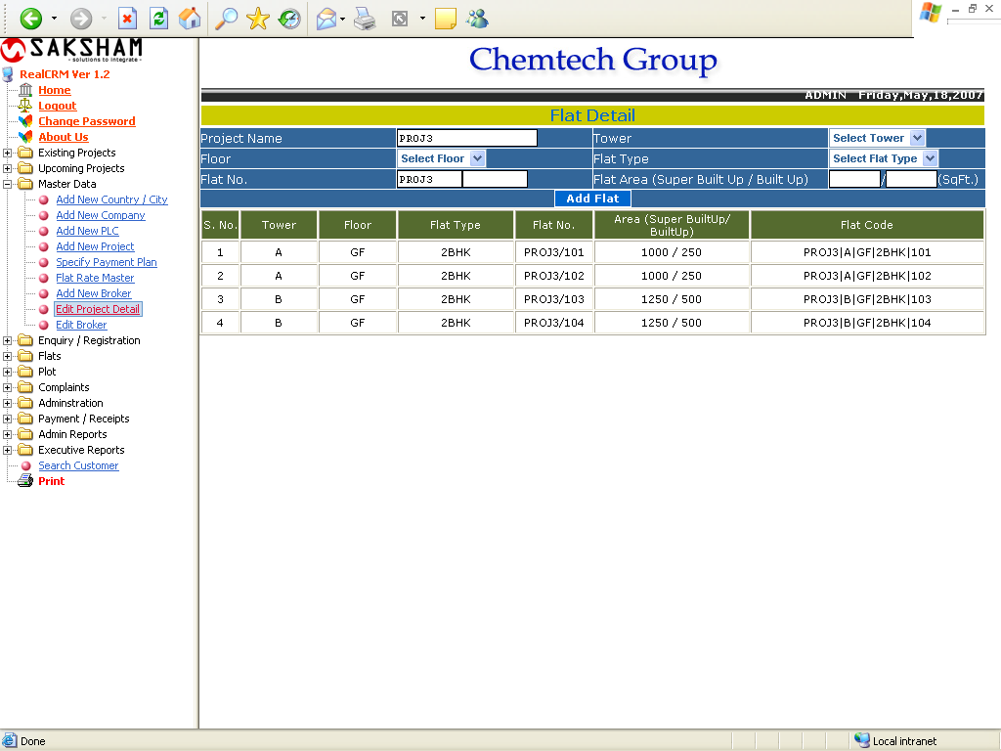

In this form the Project Name will come automatically. The user must select the Tower, Floor, Flat Type and enter flat No and Flat Area. Then click the Add Flat button.

Update Project Details (Plot)

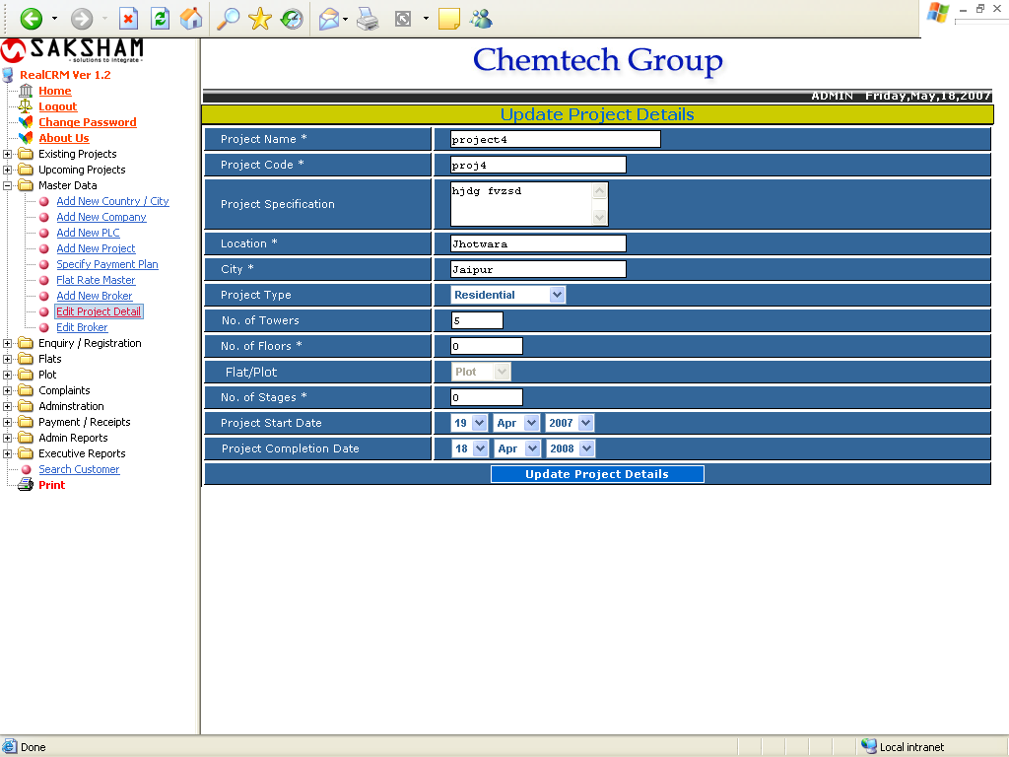

This form is used for updating the Plot type project details. The user can update the needed filed except the Project Name and Project Code.
Add New Plot

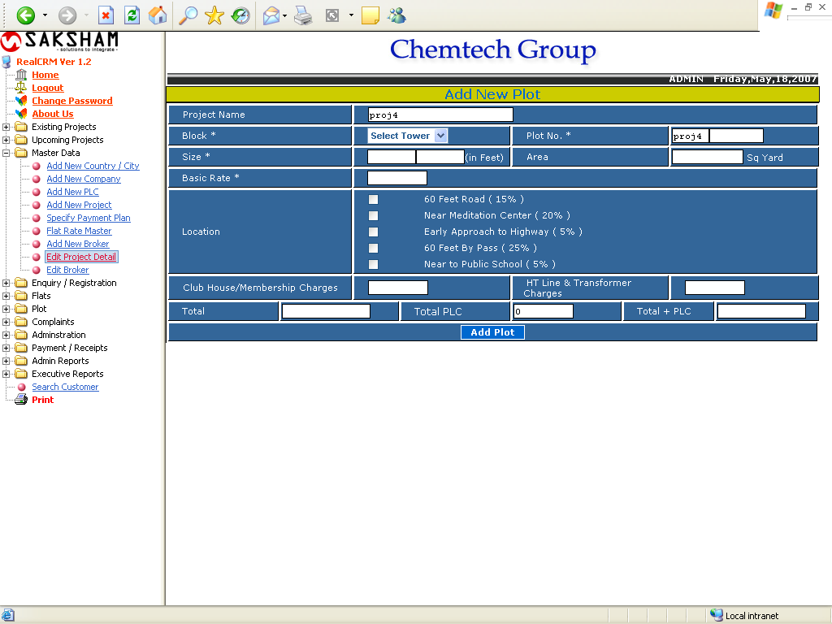

This form is used for Add New Plot details. The project Name will come automatically. The user can select the Block, enter the plot no and size the Area will come automatically based on the size of plot. Then enter the Basic Rate, select the PLC and enter the other relevant fields. After all the Total. Total PLC and Total +PLC will come automatically based on the entered data. Then click the Add Plot button for adding the details.

Edit Broker

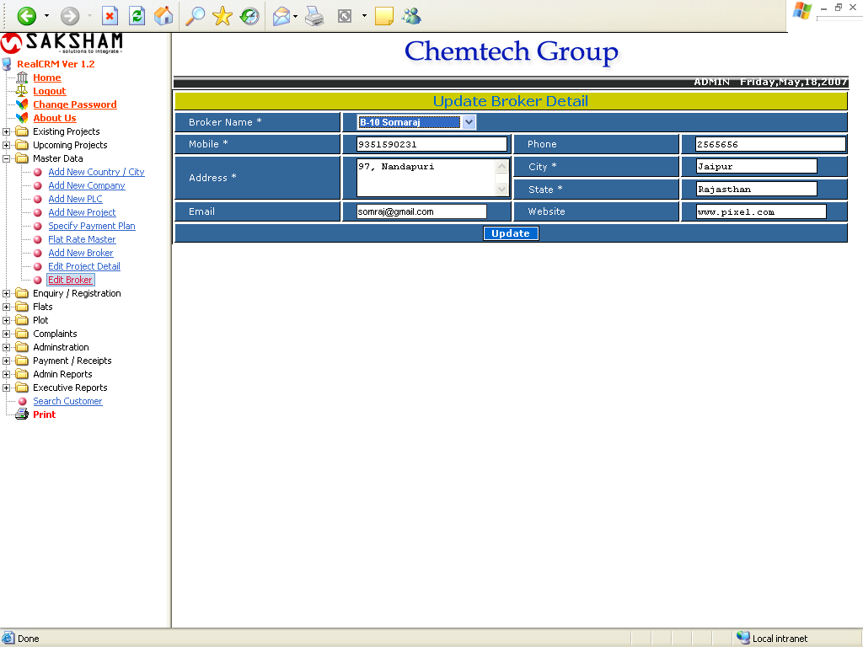

To edit the broker detail, simply select the broker name. After selecting the broker name all the information related to the selected broker will come automatically.

