Book Flats

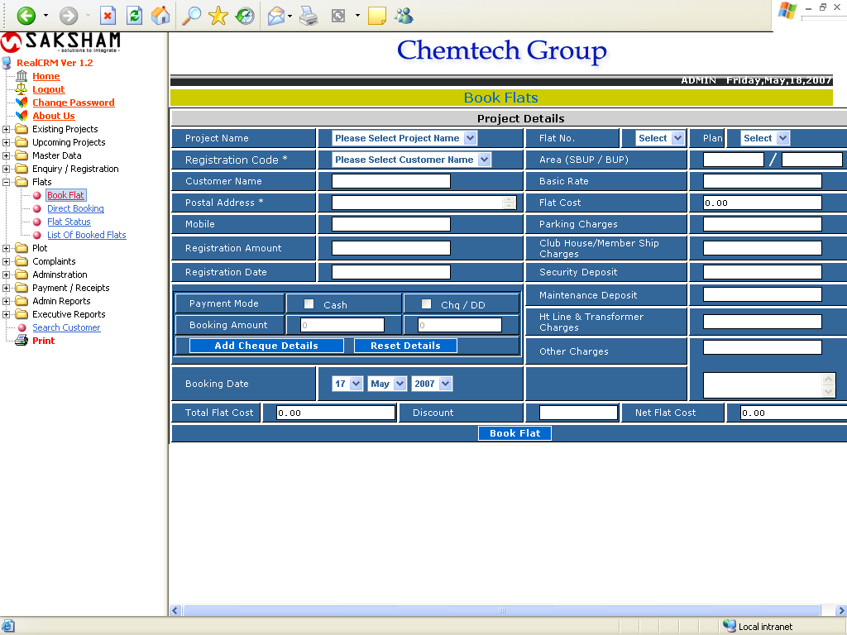

The above form is used for flat booking.
Select The Project Name, Flat No, Plan and Registration Code. The Customer and Flat Details will come automatically. The user must select one of the Payment Mode, then enter the Booking amount. In case of cheque or DD Click on Add Cheque Detail, The following Window will appear.
Book Flats

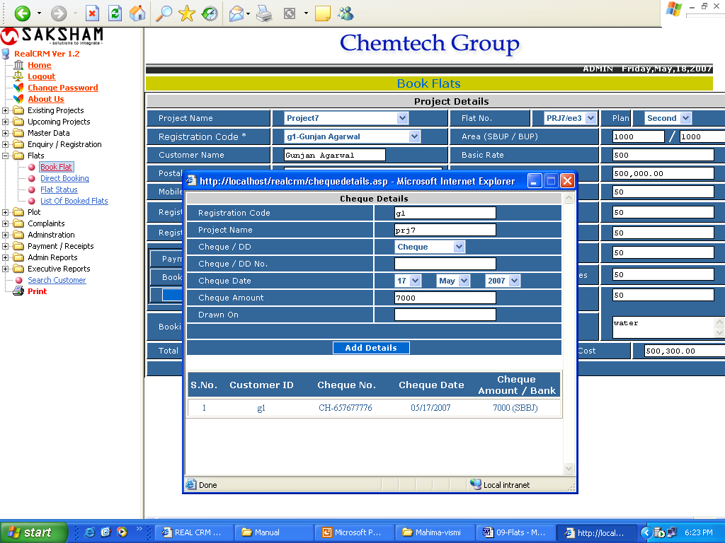

Enter the cheque detail and click on Add Detail. After adding all cheque detail close the window and click on Book Flat Button. Then the next form will appear.
Direct Flat Booking

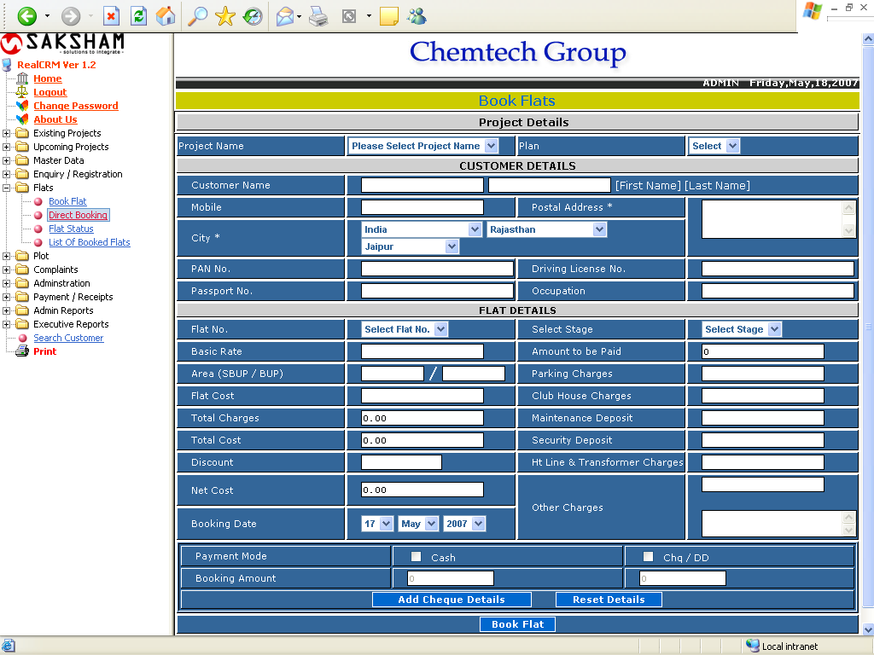

This form is used for Direct Flat Booking. The user must select the Project Details. Fill the Customer Details. In Flat Details, select the Flat No and Select Stage, the flat details will come automatically. If any Discount, enter the Discount Amount, it is a password filed, if the password is correct, then enter the discount amt in percentage. It will deduct from the Net Cost. The user must select any of the payment mode.
Flat Status

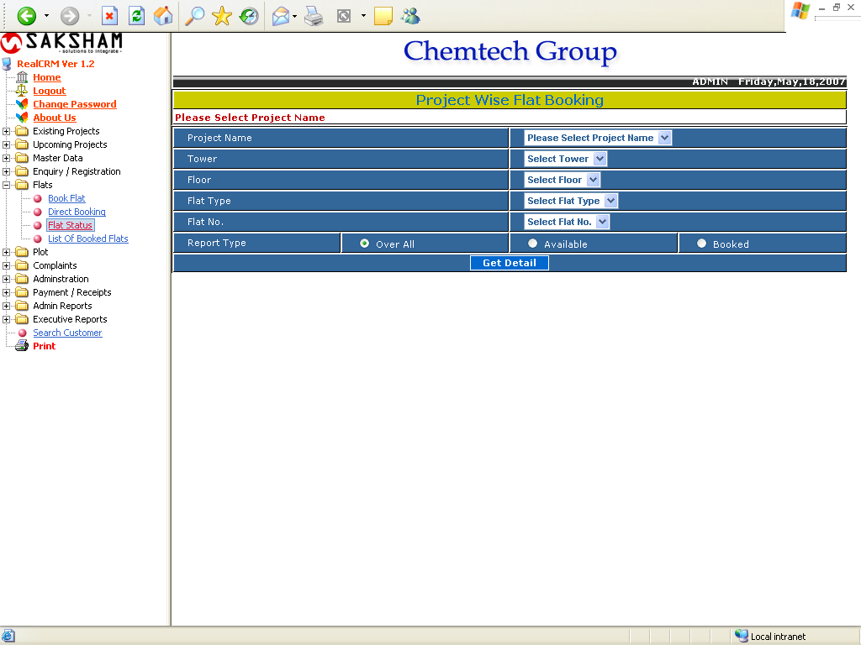
This form is used for getting the Project Wise Flat Booking Status. The user needs to select the Project Name, Tower, Floor, Flat Type, Flat No and Report Type. Then click the Get Details button, the following report will get.

List of Flats

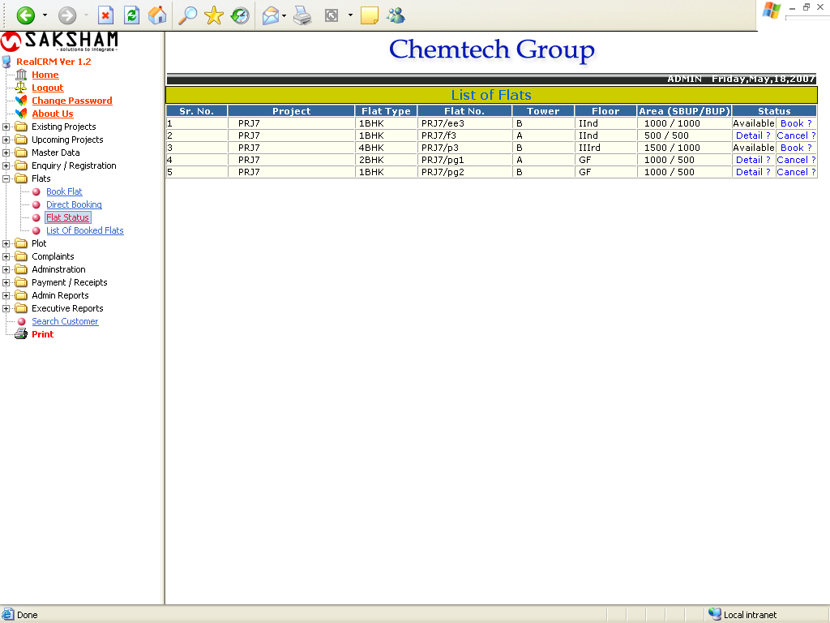

Using this report the user can Book the available flat or cancel the Booked flat. If the user needs the details of the Booked Flats, Just clicks the Detail link, the details of the Customer will get.

Customer Details

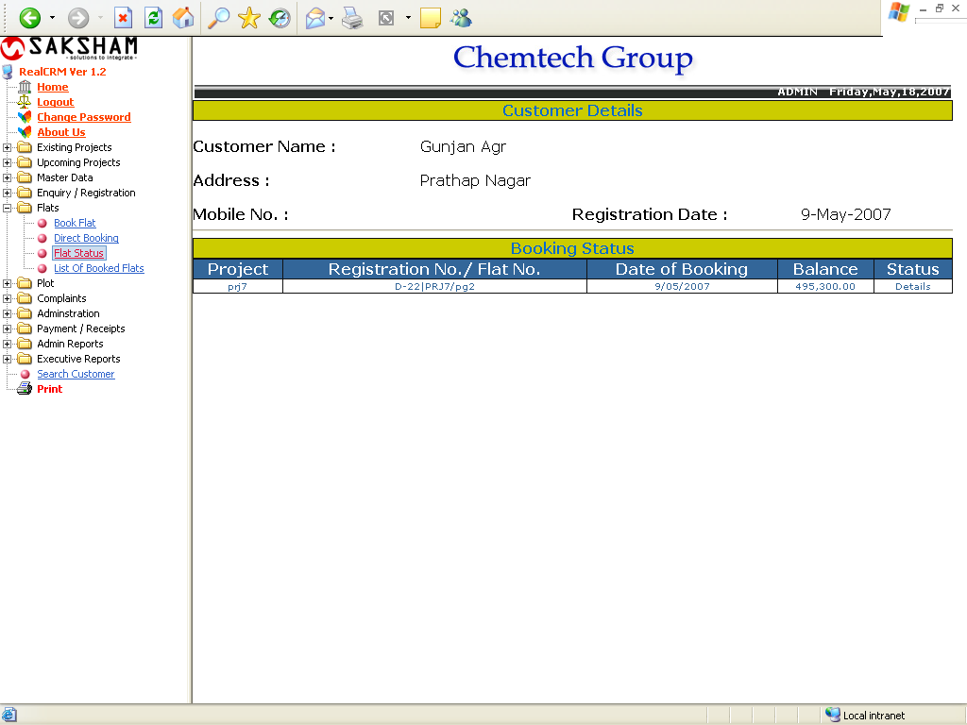

List of Booked Flats

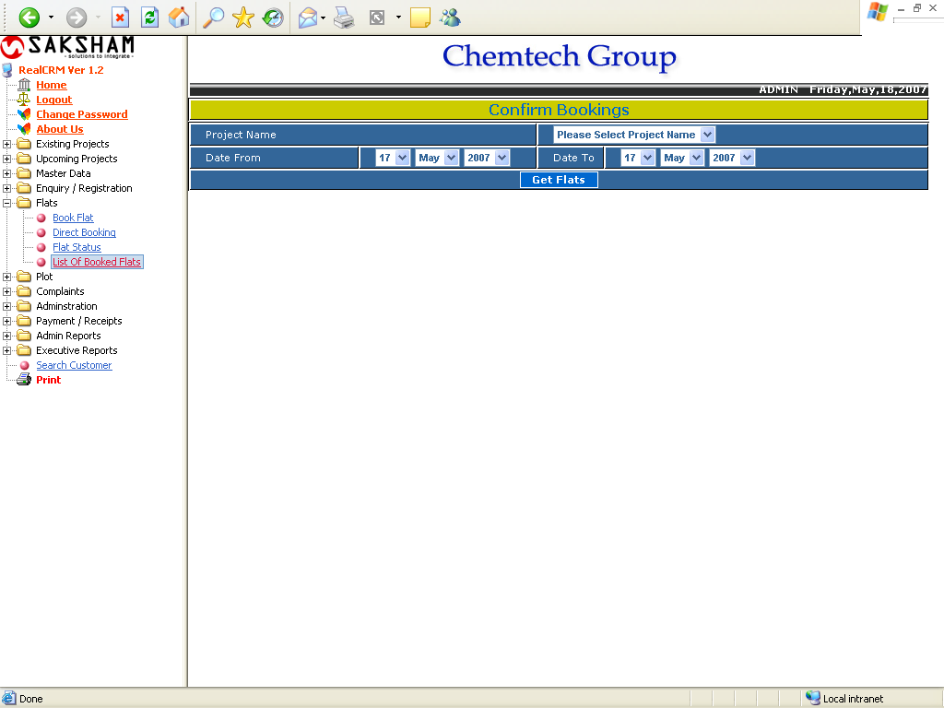

This for is used for getting the List of All Booked Flats. The following report will shows the flat details.

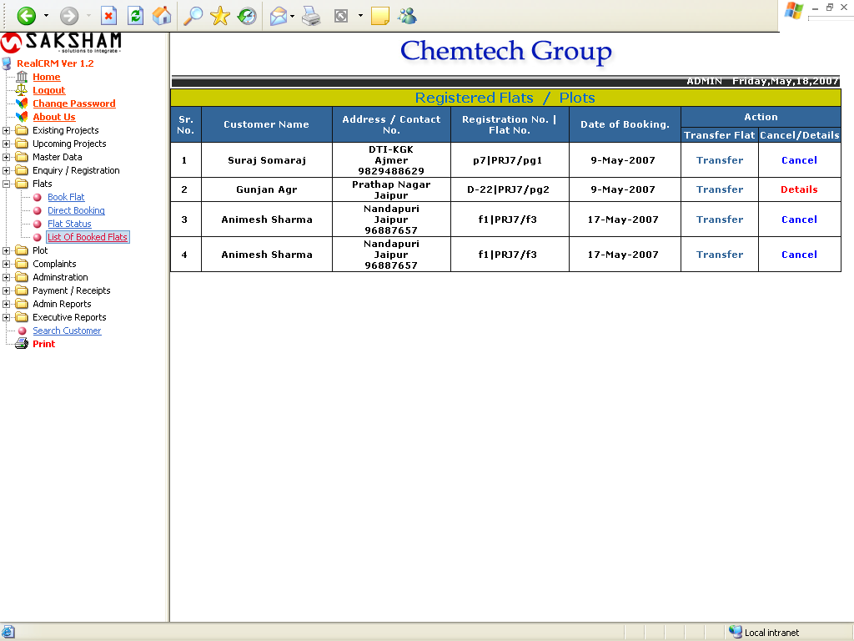

Using this Report the Customer can cancel the registered Flats/Plots and also Transfer the Registered flats form one Customer to another one.

Transfer Registered Flat

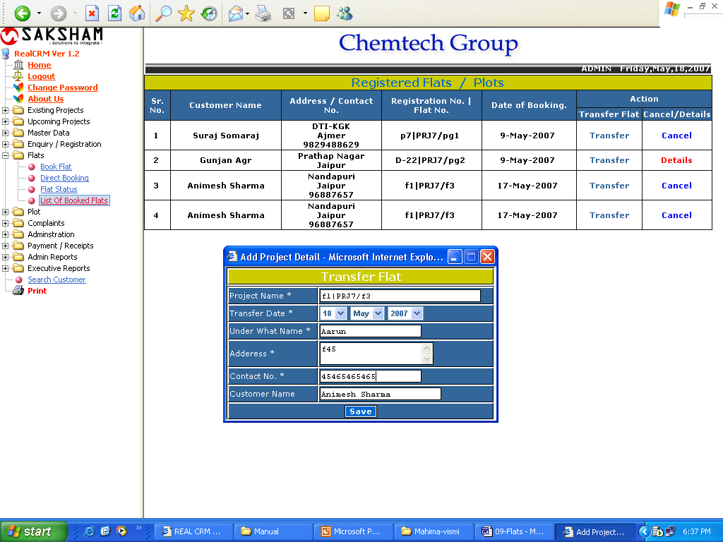

The flat transfer details will shows below.

Flat Transfer Details

