Complaints

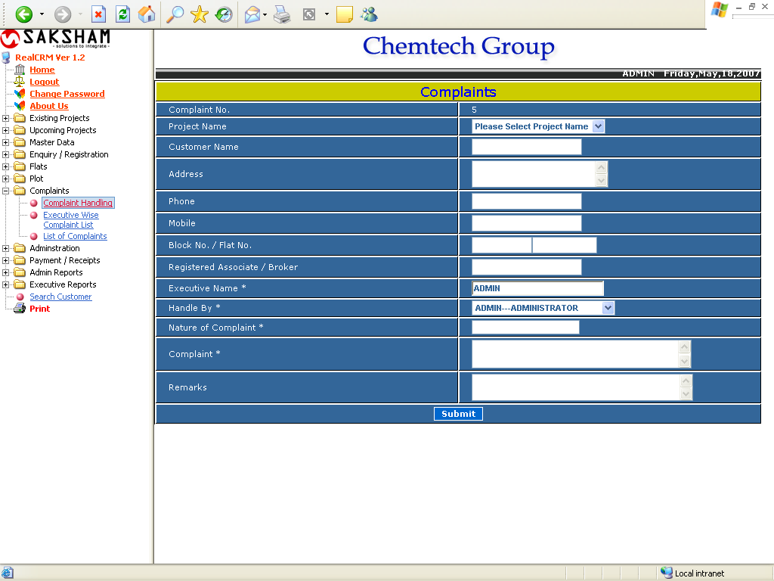

The above form is used to fill complaints. Enter customer detail, select the name of user who will handle the complain and enter complaint and click the button Submit.
Executive Wise Complaint List

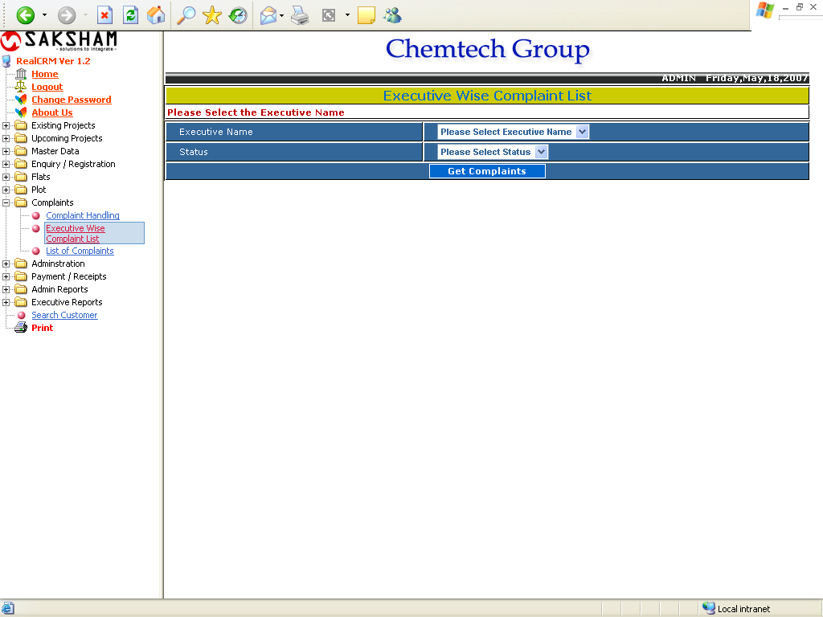

The above form Generates the report showing the Executive wise complaints as per the selected status (done, pending, all). The following form will appear after clicking on Get Complaints button.
Executive Wise Complaint List

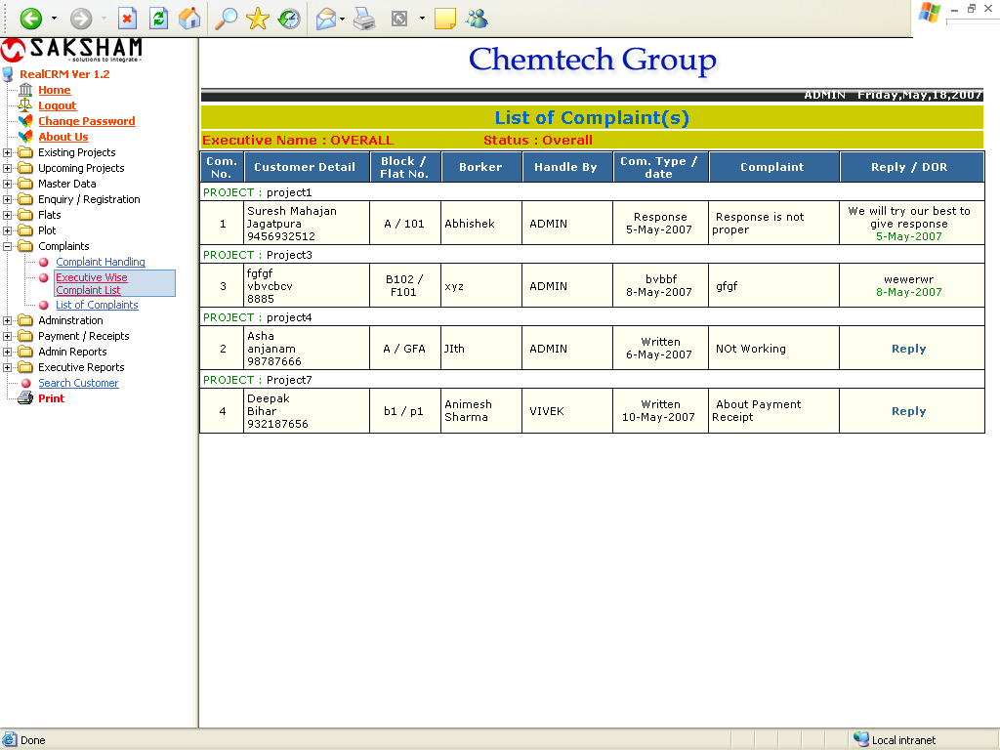

List of Complaints

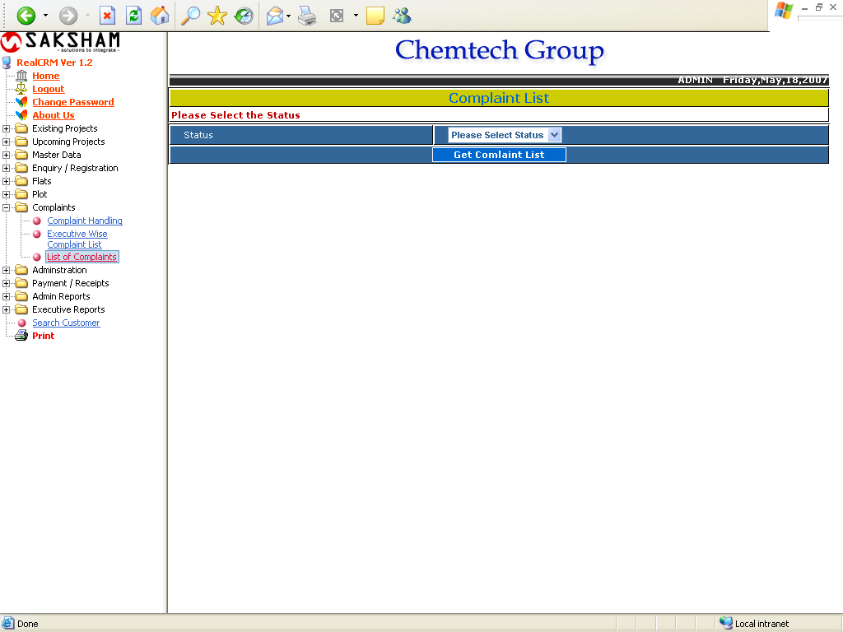

The above form Generates the report showing the complaints as per the selected status (done, pending, all). The following form will appear after clicking on Get Complaint List button.
List of Complaints

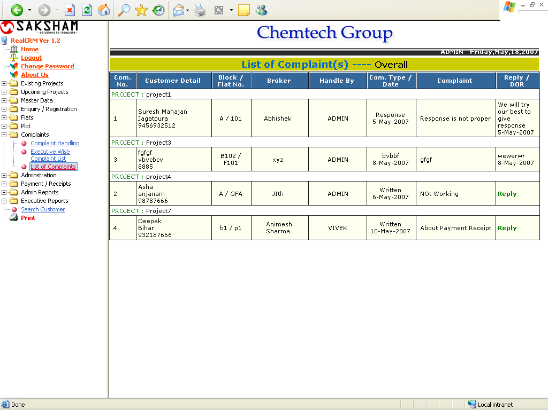

This report will shows the overall report of the complaint list. The user can reply to the complaints too.

