Add New User

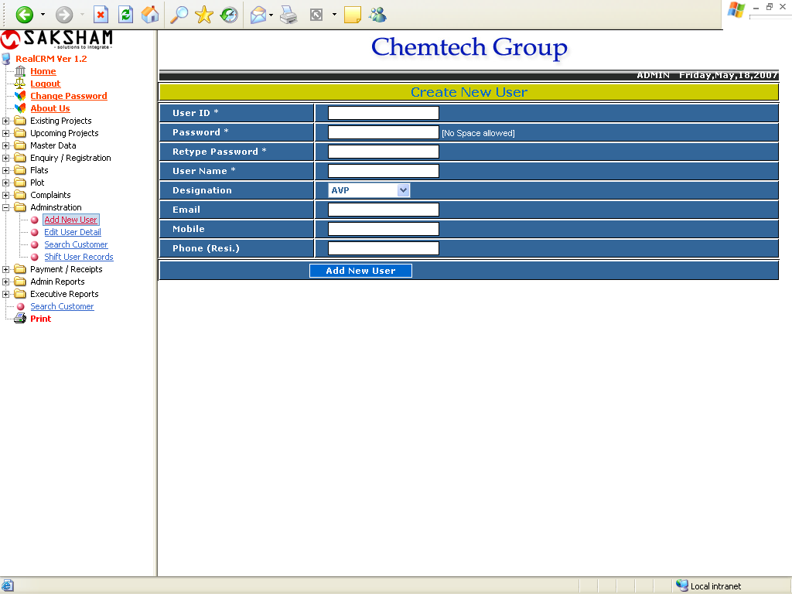

The above form is used for creating new User.
Enter all the required information and click on Add New User. If the Designation of the user is other the AVP the next for will appear to assign the right to user and in the case of AVP all rights will assign to the user automatically.

Assign Rights

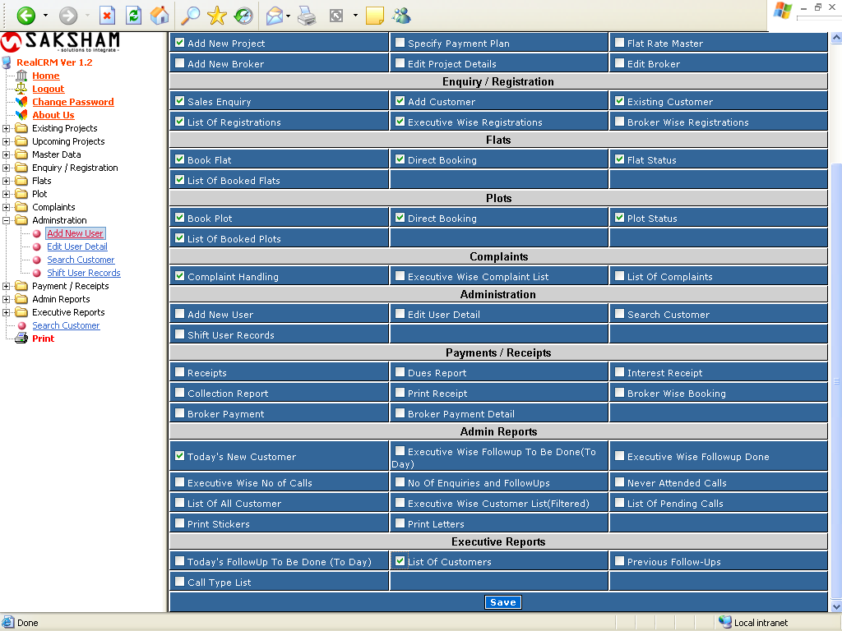

This form will comes automatically after adding user to assign the rights to the user.
Select The User from Drop down List Work Under which the user will work.
And select the rights module wise.

Edit User Details

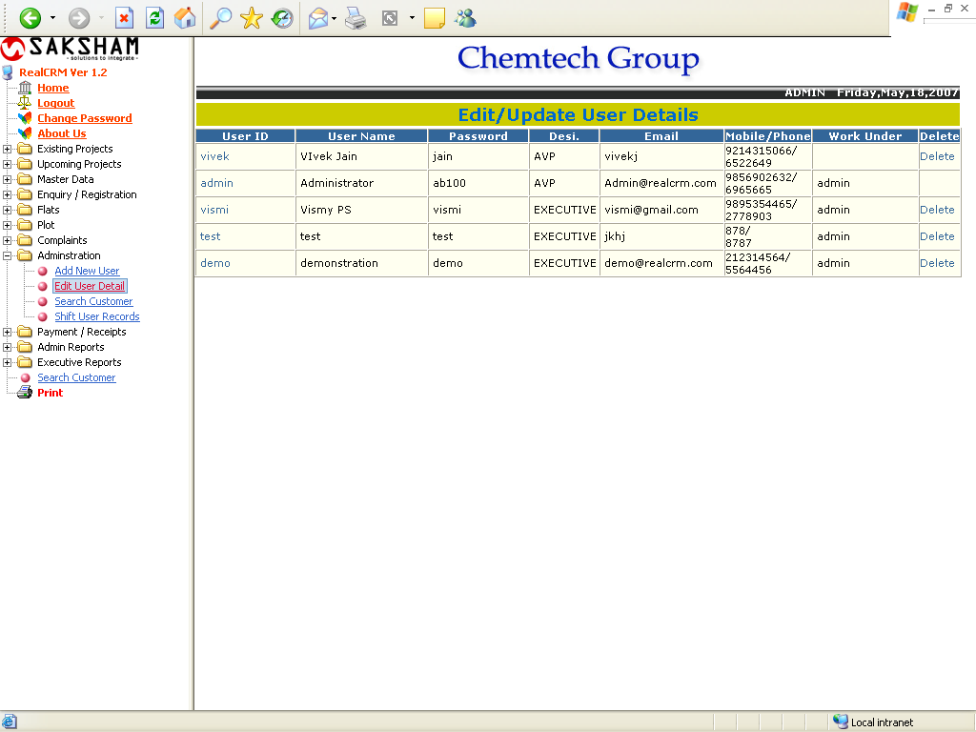

The above report shows the list of all Users.
To edit the user detail and rights click on User Id, and to delete the user click on delete.
The user which hasn’t made any enquiry, only this user can be delete. If the user clicks on the User ID, the following form will appear.

Edit/ Update User Details

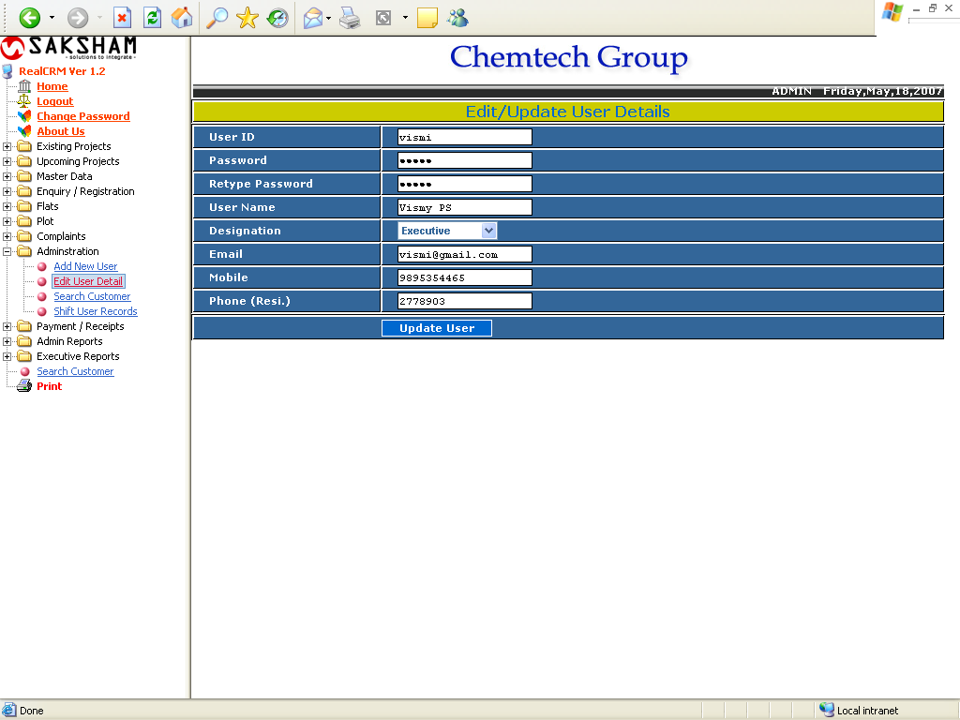

This form is used to Updating the User Details.
Search Customer

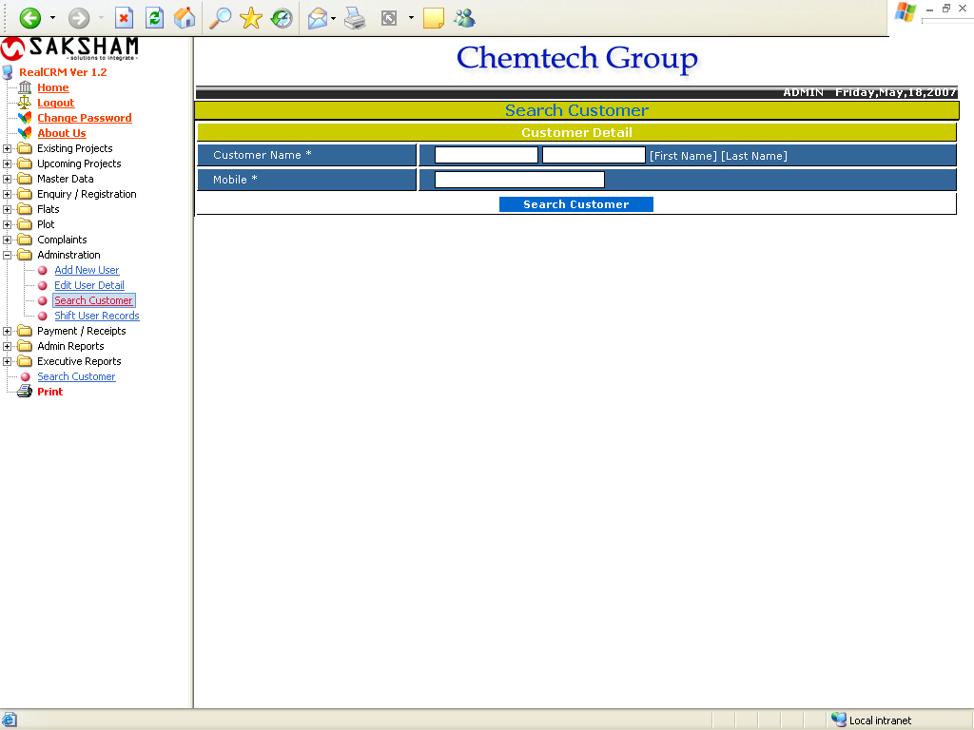

This form is used to search customer. Enter name of customer and mobile no. and click on Search Customer. The following report will appear.

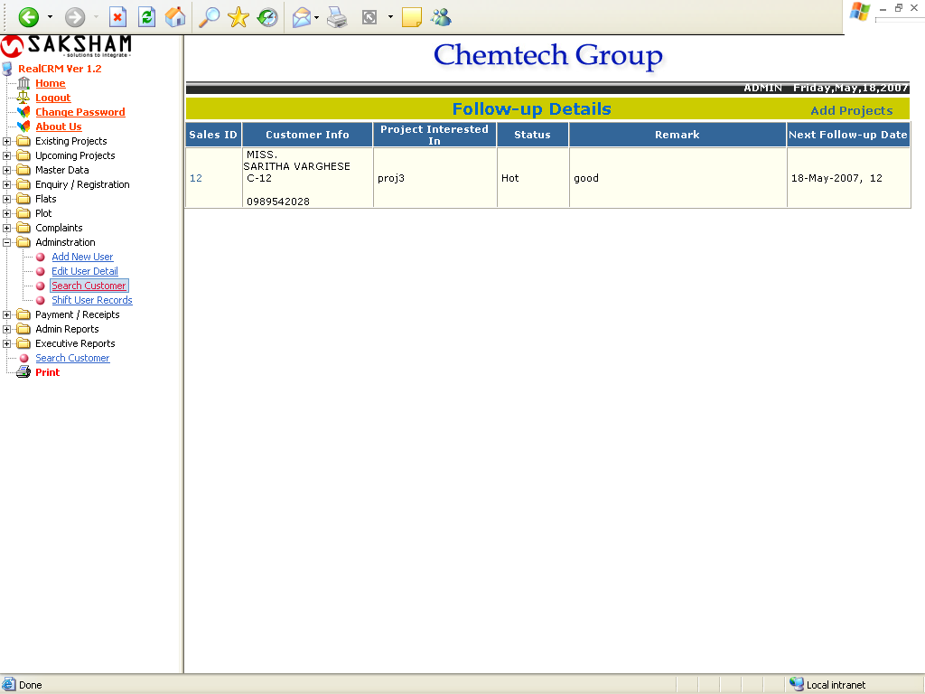

This report shows the follow up details of the searched customer. If the user clicks on the sales Id, the enquiry follow up form will get.

Enquiry Follow Up Details

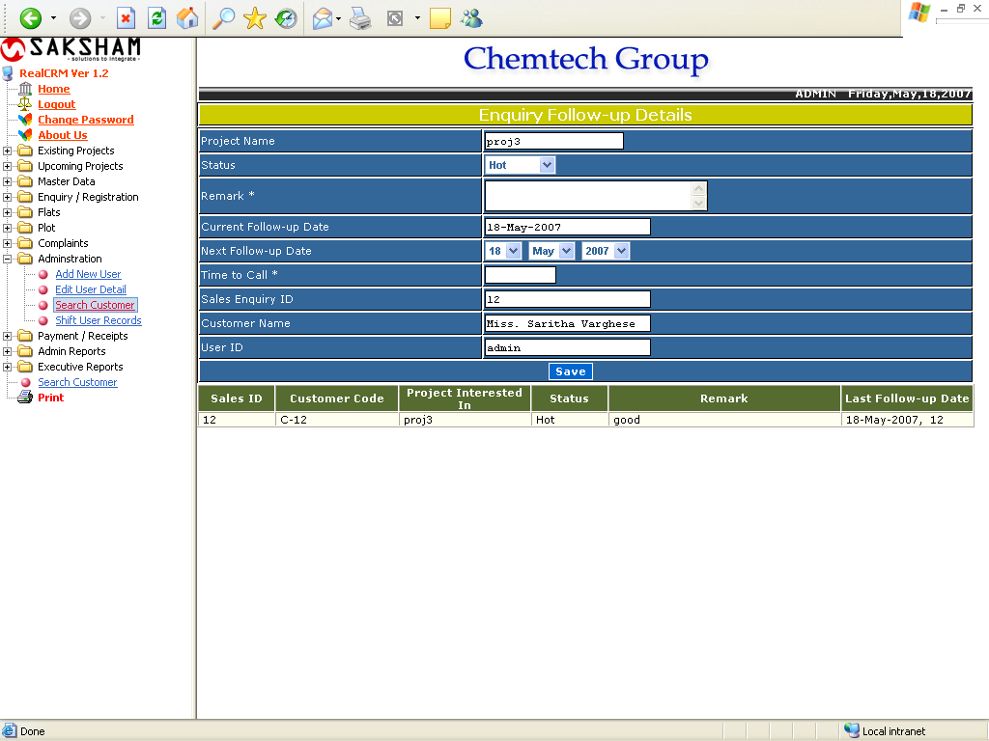

This form is used for filling the next follow up details of the Customer.
Shift User

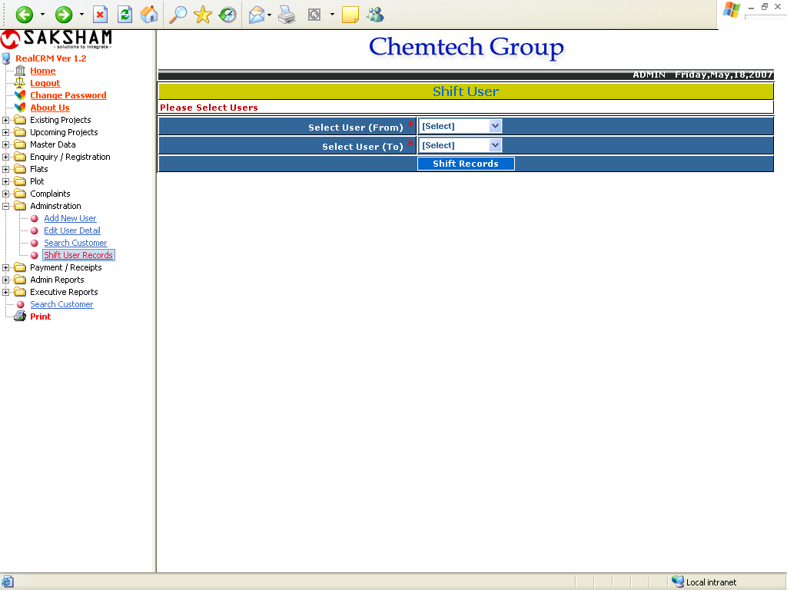

This form is used to Shift the records, enquiries, follow ups and bookings made by the user to another user. The user can be deleting after shifting to another user.

