Broker Booking Status

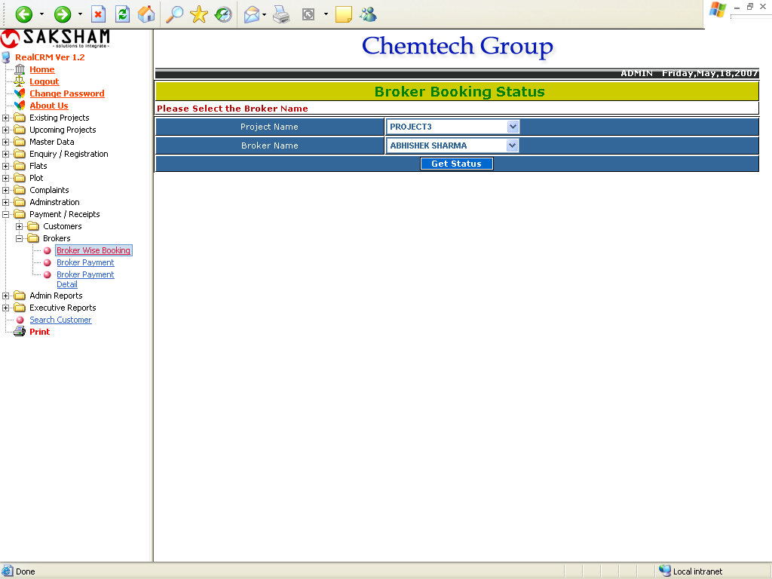

This form is used for getting the broker wise booking status of the selected Project. The report will shows below.

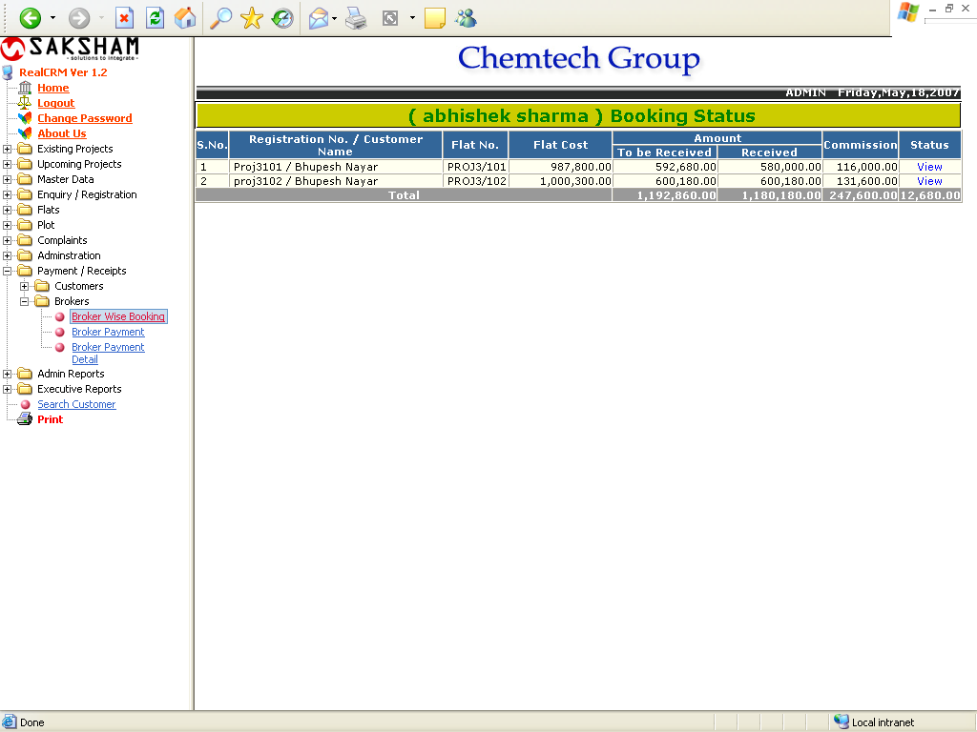

If we click on the View button, the user will get the following Customer Details report.

Customer Details

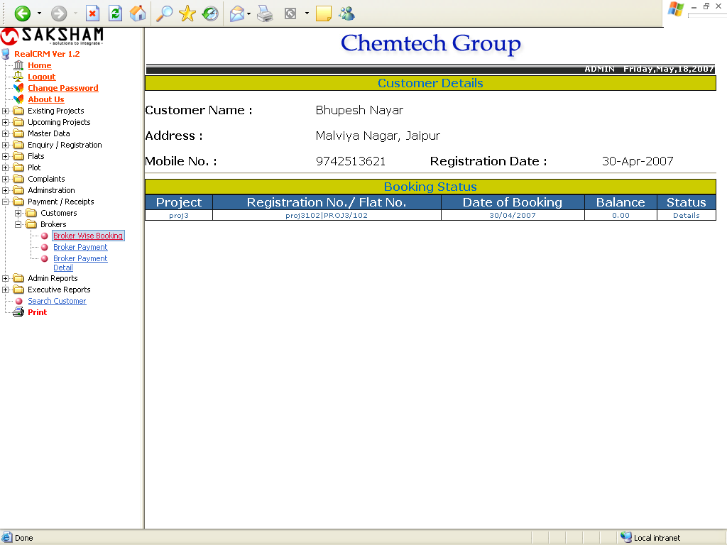

Broker Payment Status

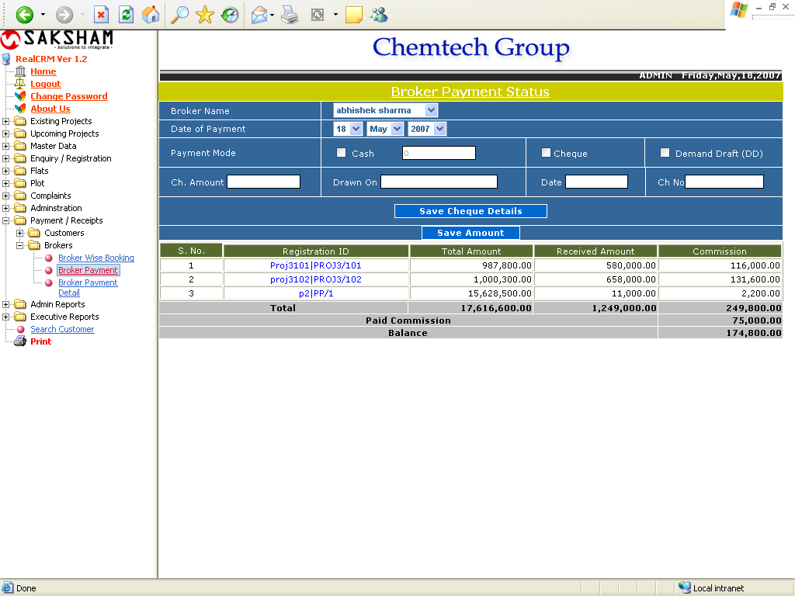

This form is used for getting the selected Broker payment status. The user can pay the amount of the selected broker through payment mode options.

Broker Payment Details

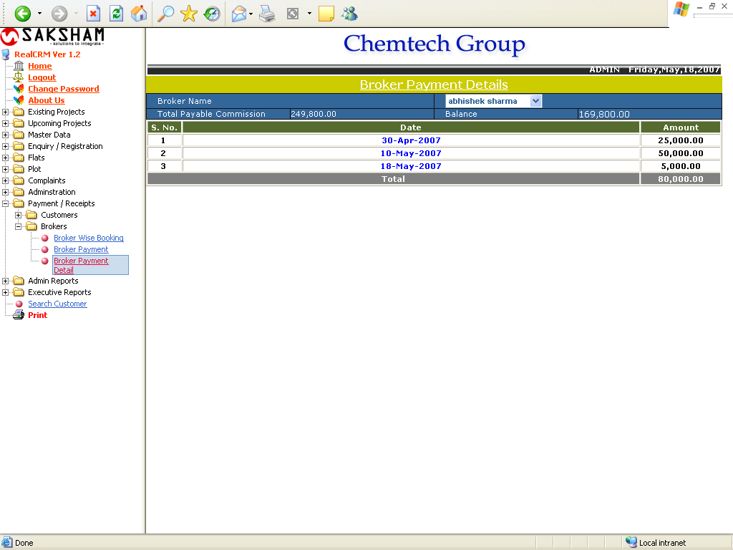

This form is used for getting the payment details of the selected broker.

