Payment Status

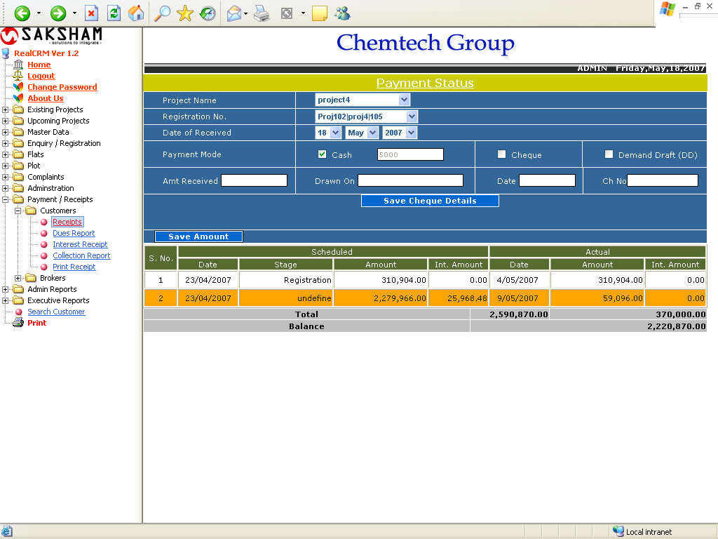

This form is used to Payment receipt after the Confirm booking.
To store the information of received amount, simply select the project and registration no. after selecting the registration no, the payment schedule of the selected registration no comes automatically below the form. Select the date of receipt and enter to amount in cash, cheque or dd. And click on Save amount. To enter the cheque detail fill the four fields with the related information and click on Save Cheque Detail. You can enter the multiple cheque details.

Dues Report

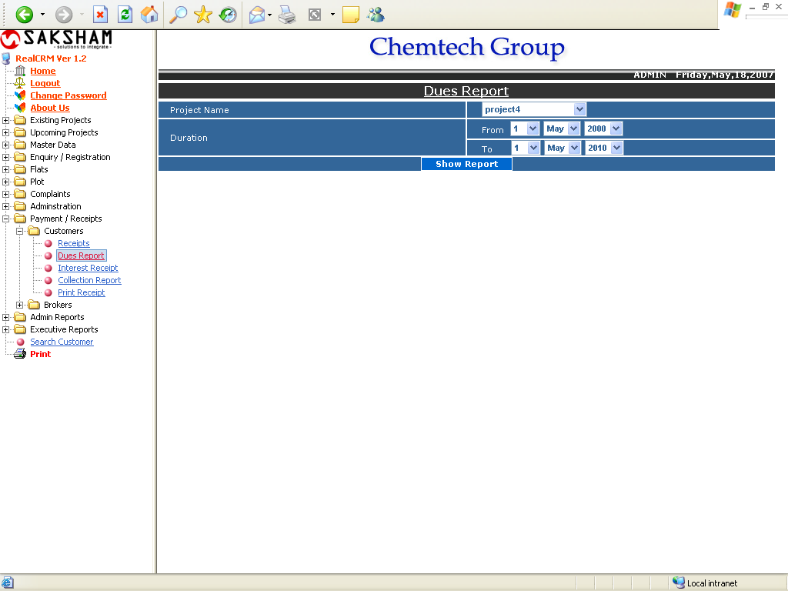

The above form is used to generate the due report for the selected duration and project.
The report shown below:
Dues Report

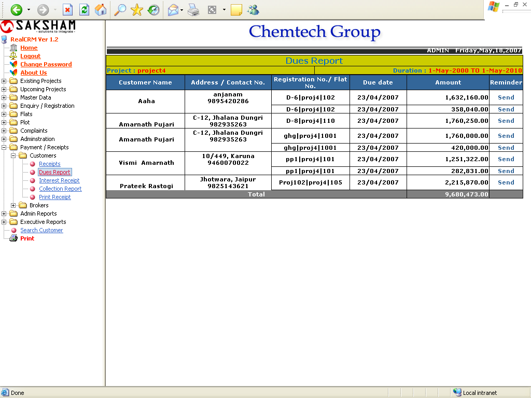

Interest Status

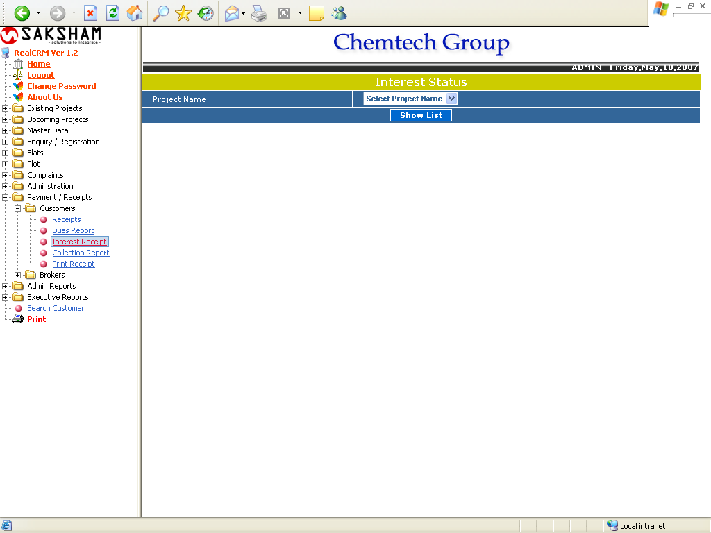

This form is used for getting the Project wise interest status report. The report will shows below.

Interest Status Due Report

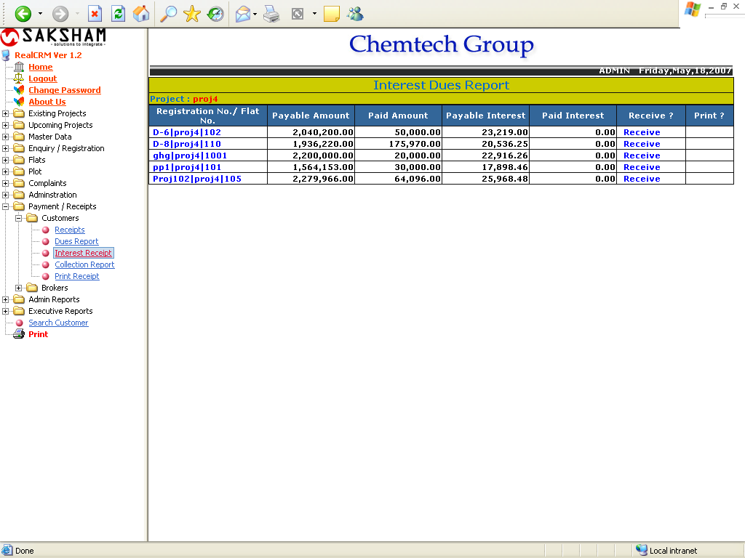

Collection Report

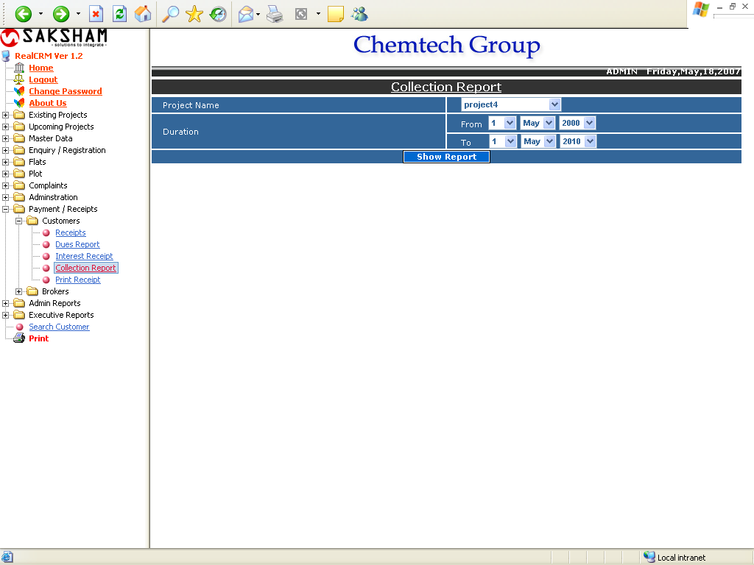

This form is used for getting the Project Wise Collection Report. The report will shows below.

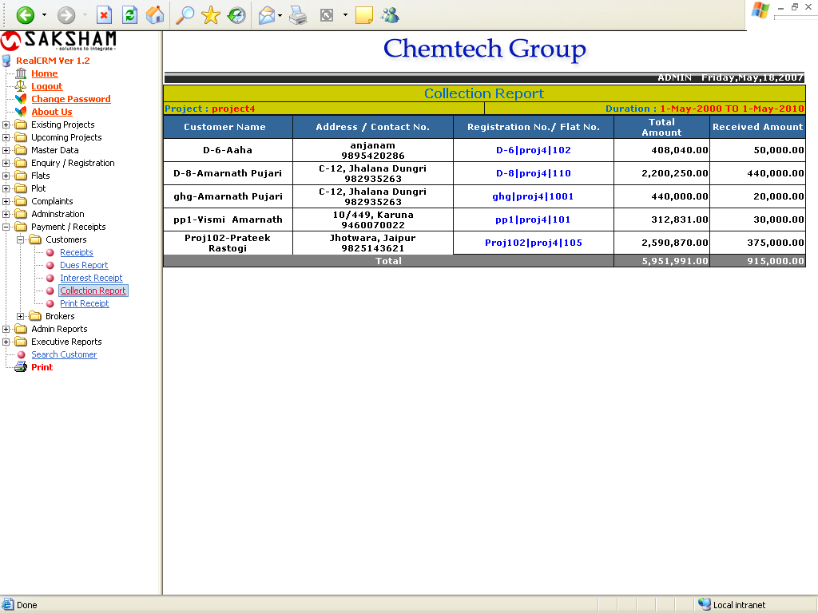

The user will click on the Registration No/ Flat No, a payment status report of the specified project will get. The report will appear below:

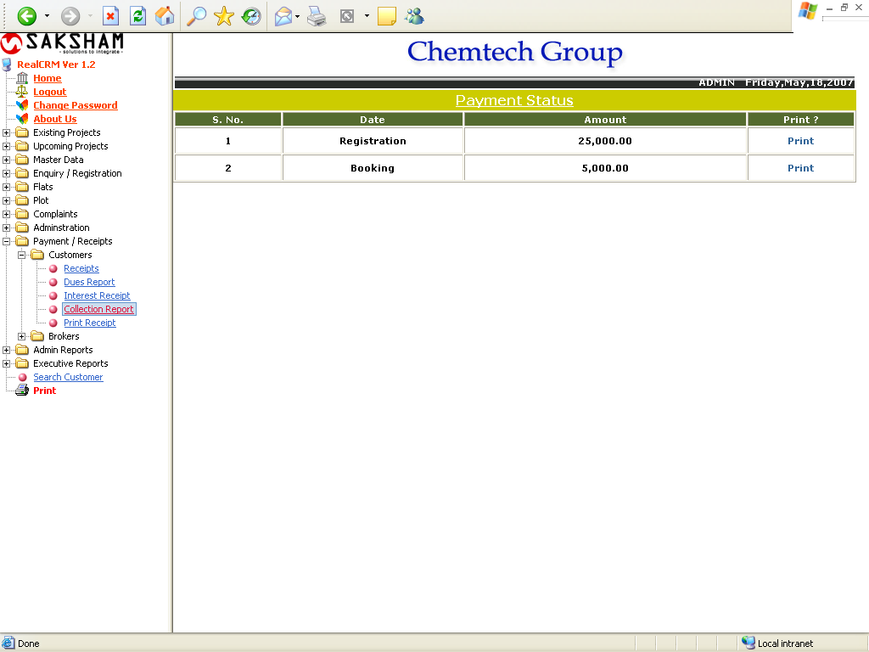

Print Receipt

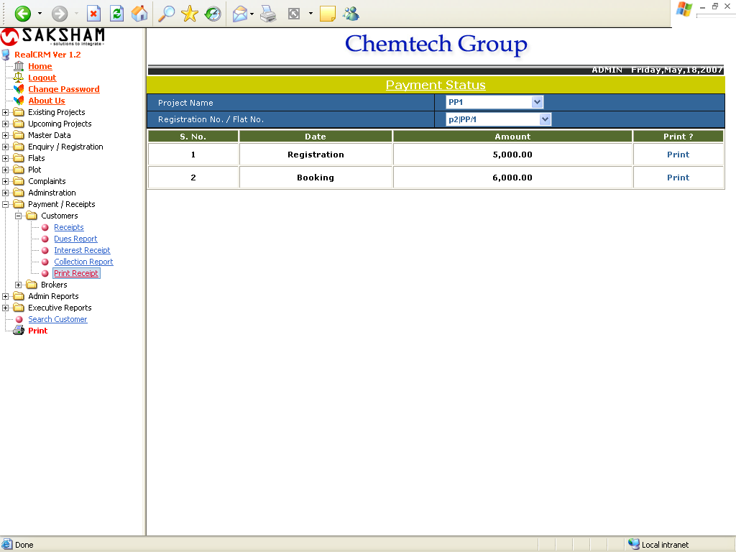

This is used for getting the payment status of the selected Project. The user can also print the payment receipt through this.

