Today’s New Customer

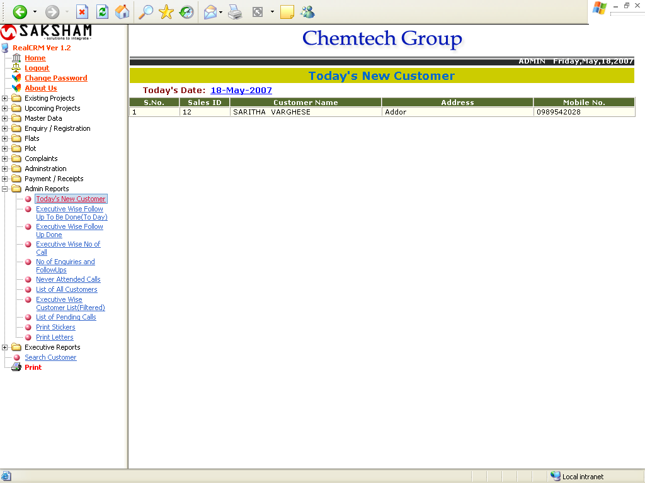

The above report shows the list of customers Added To-Day.
Executive Wise Today’s Follow Up (Morning)

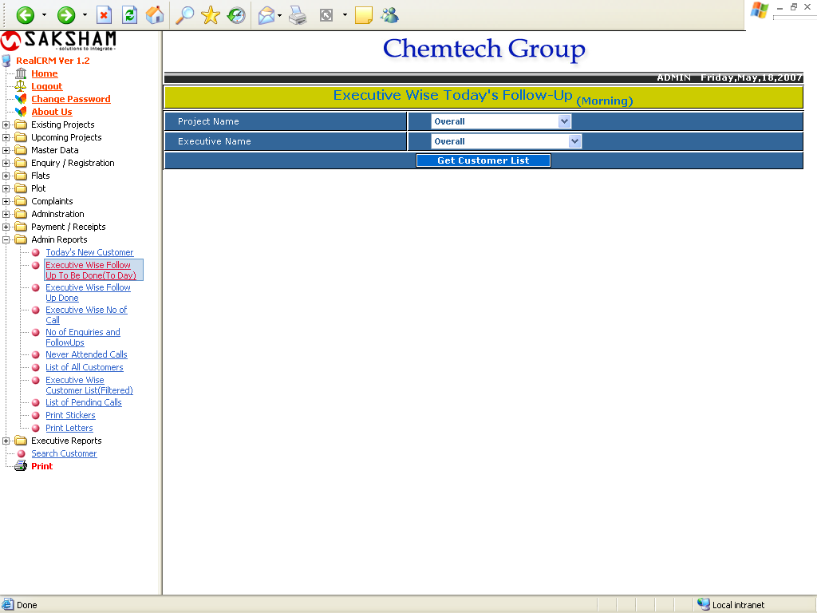

The above report show the follow up to be made To-Day. The report will shows below:

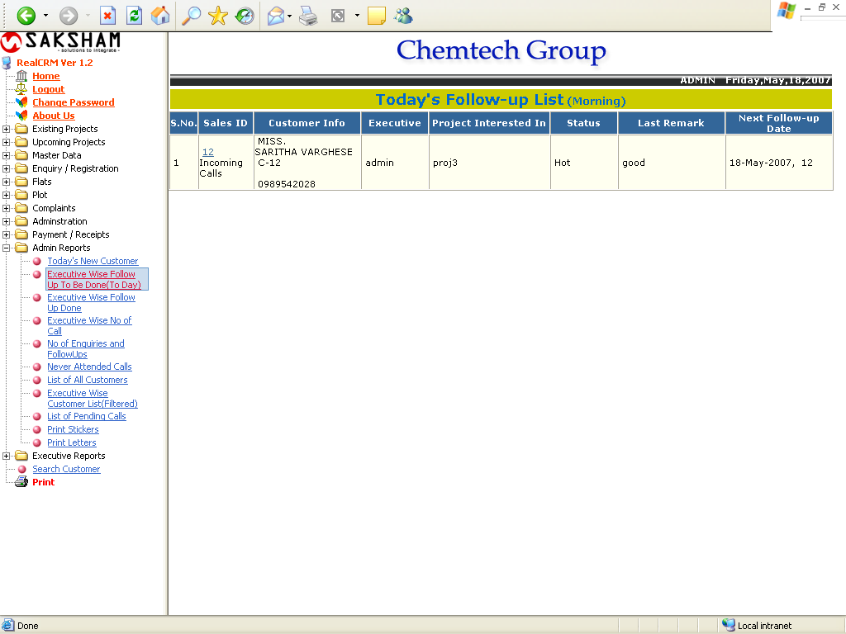

Executive Wise Today’s Follow Up (Evening)

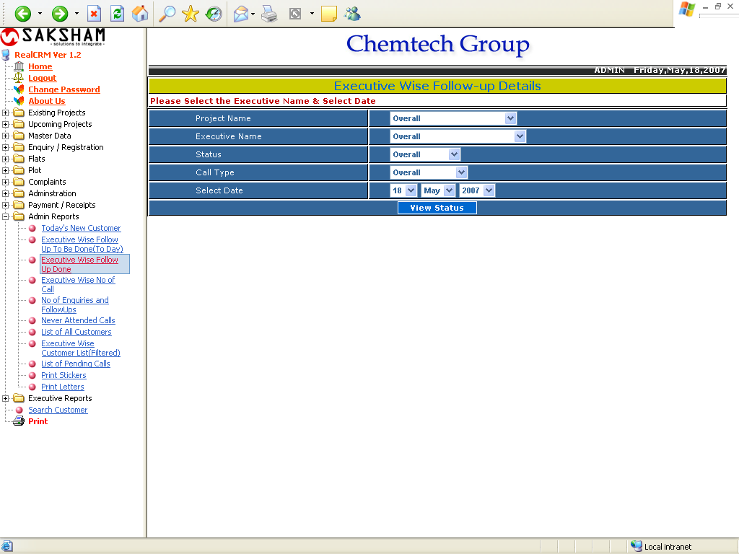

The report shows the follow up done on the select date.
Executive Wise Calls

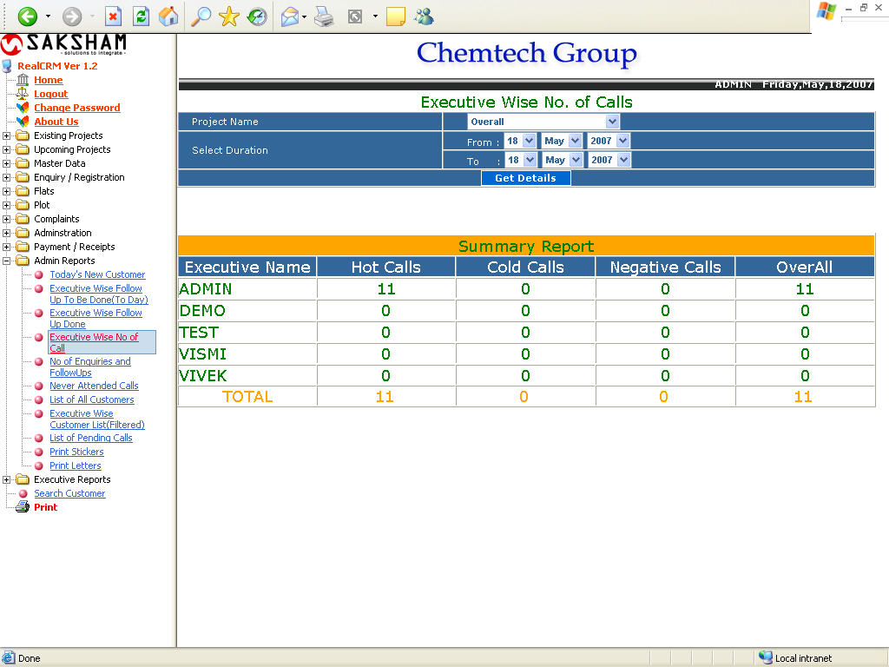

The above report shows the No of enquiries made by the each executive with all status.
Enquiries And Follow Up

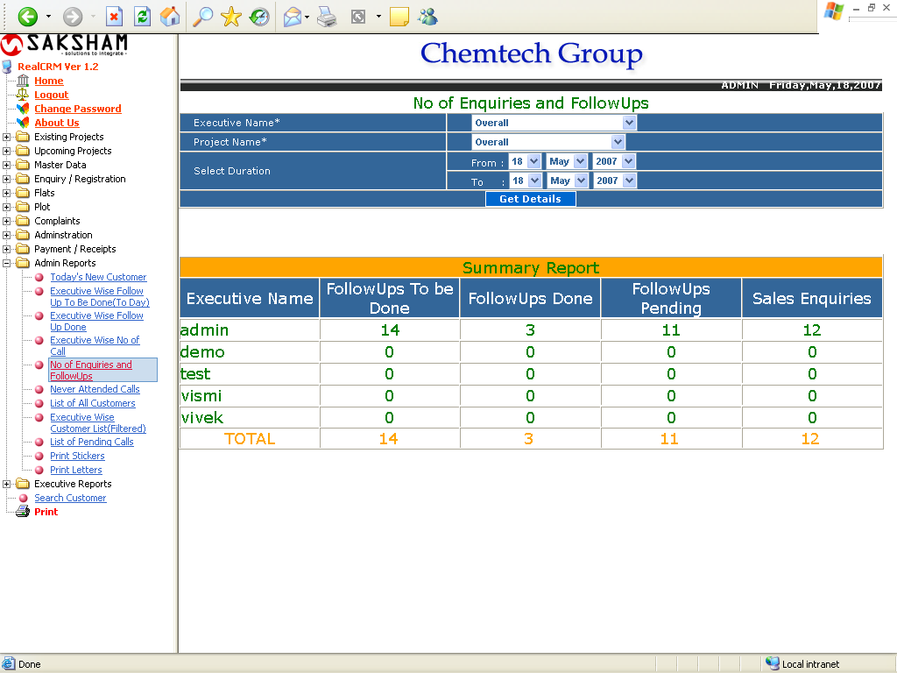

This report show the no of Sales enquiries and follow ups (to be done, done and pending) for the selected criteria.
Never Attended Calls

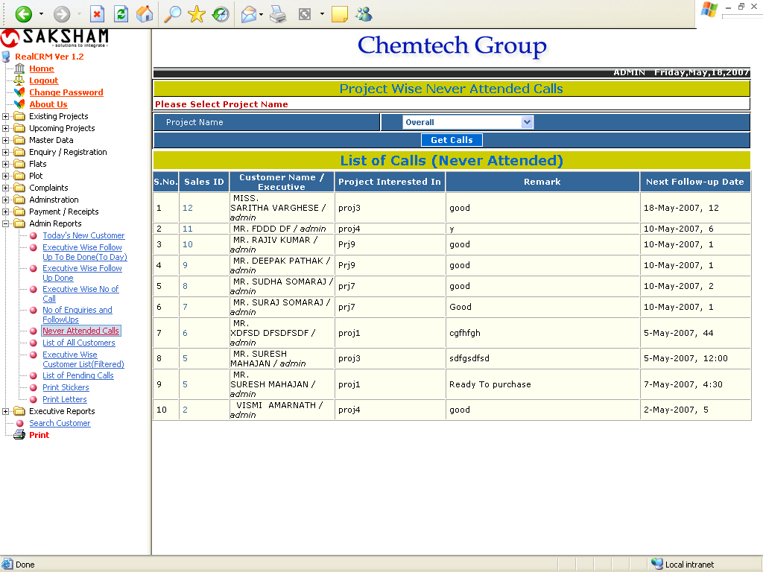

The above report show the list of calls which has not been attended yet.
List of All Customers

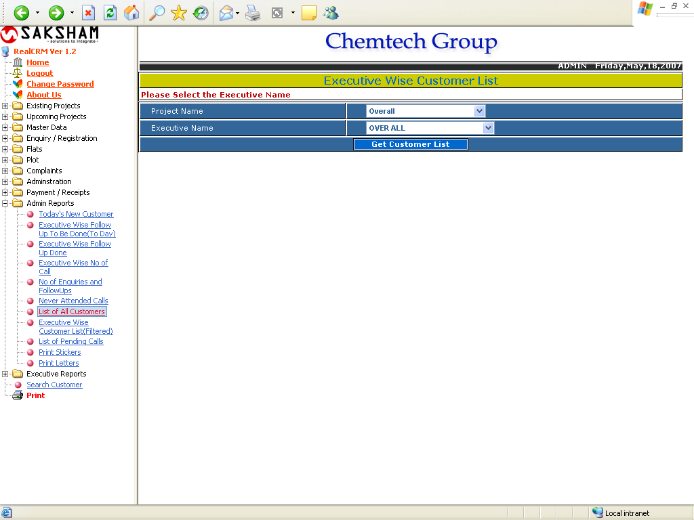

The above report Show the List of all customers for the selected project and executive. After clicking on Get Customer List the following form will appear.
List of All Customers

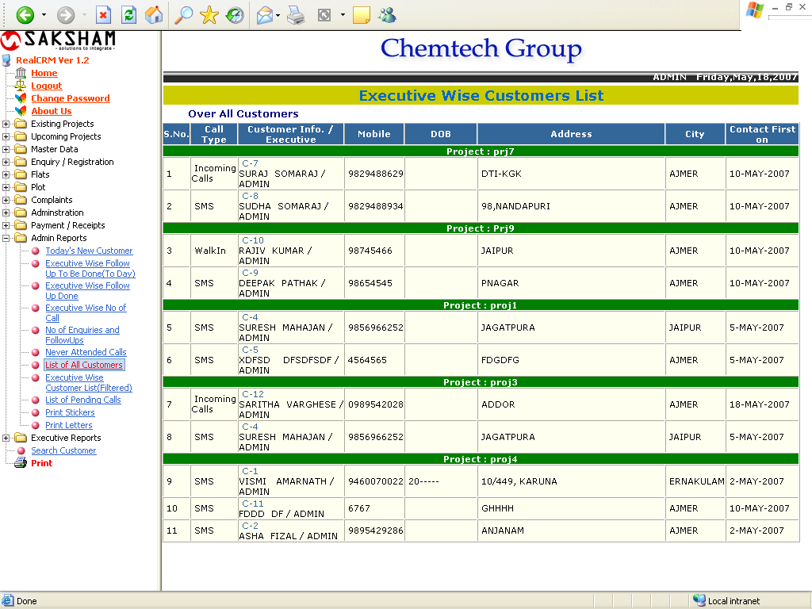

Executive Wise Customer List (Filtered)

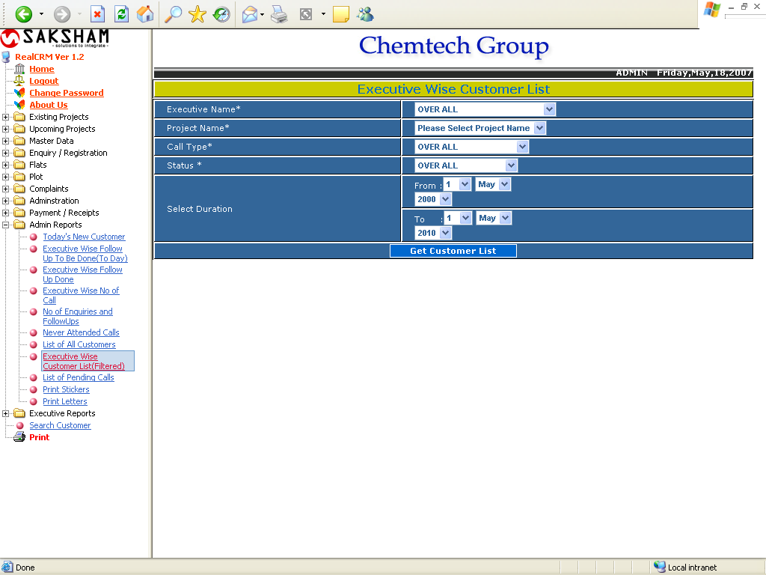

This form will generate the filtered customer list as per the selected criteria and duration and show the following report.
Executive Wise Customer List (Filtered)

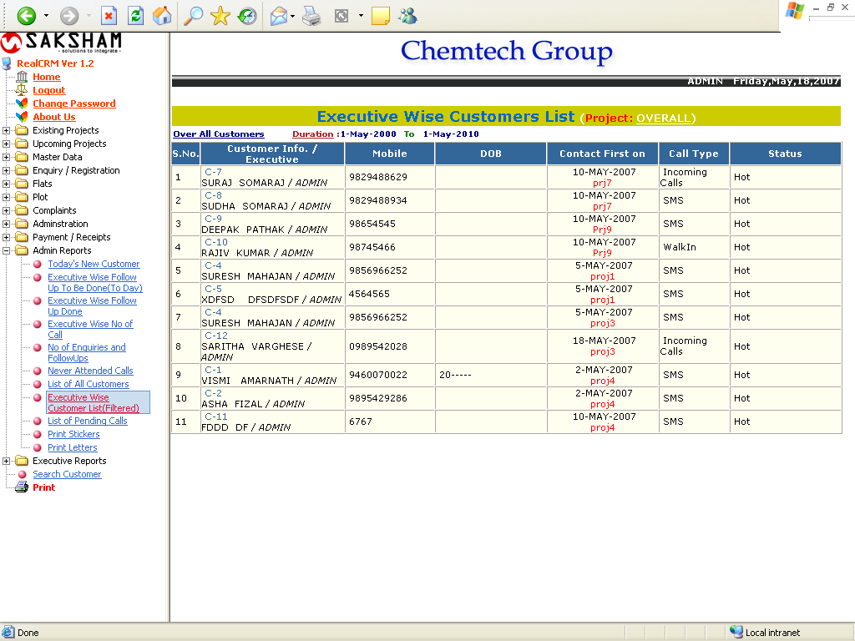

List of Pending Calls

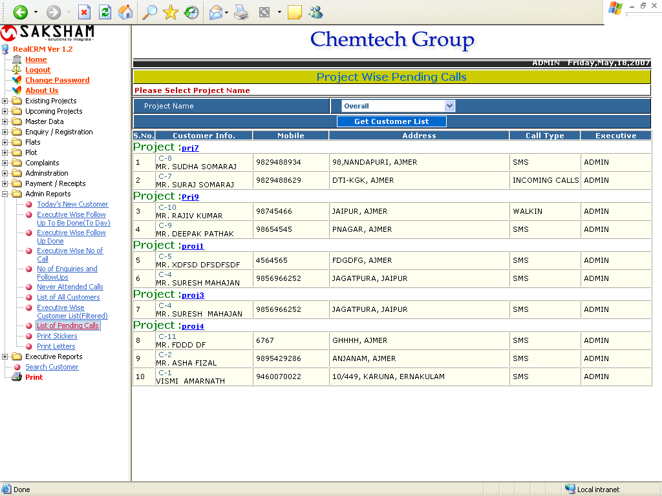

The above report show the list of all pending calls of the selected project.
Print Sticker

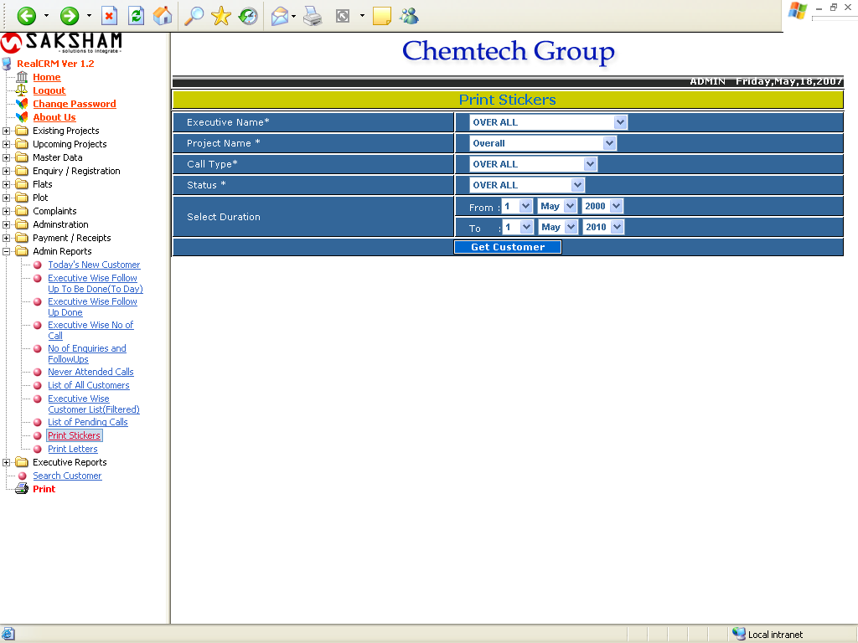

This report is used to generate the stickers for customers, having the customer’s basic details. The report will show below:

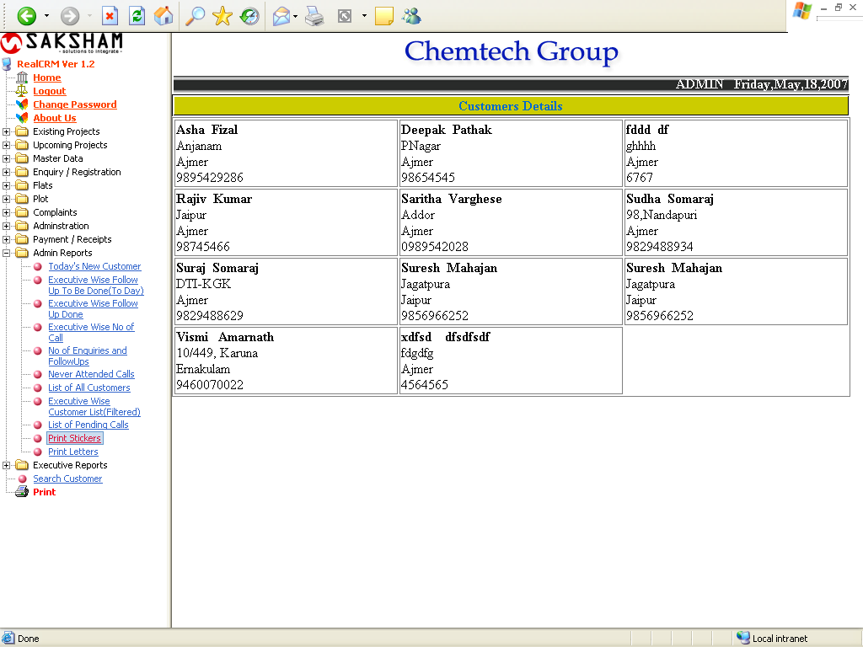
Print Letter

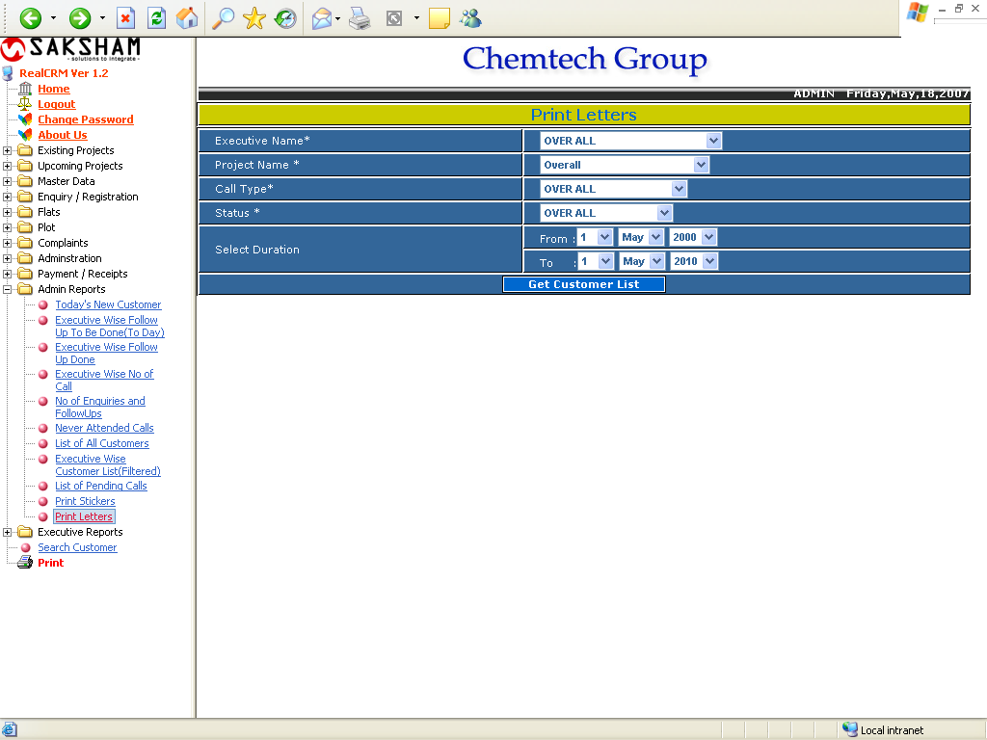

The above report show the list of customers as per the selected criteria and display the following report.
Print Letter

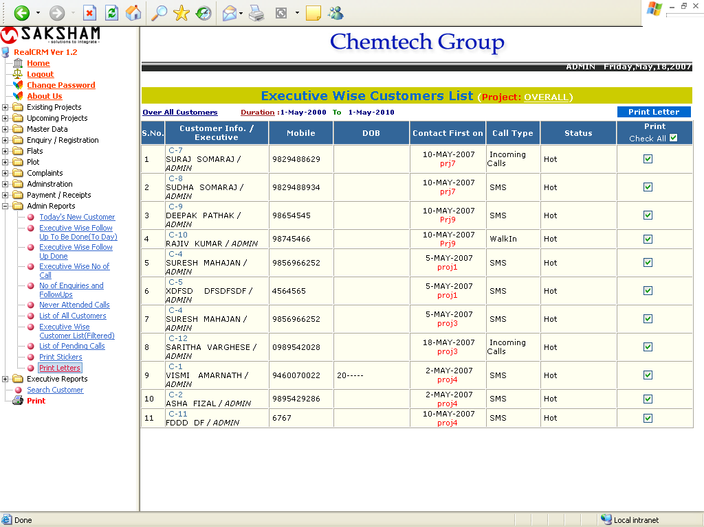

To dispatch the letter to the customer click on the check box corresponding the customer. And for selecting all customer, click on check box showing in the header column. And click on Print Letter.

