Search Customer

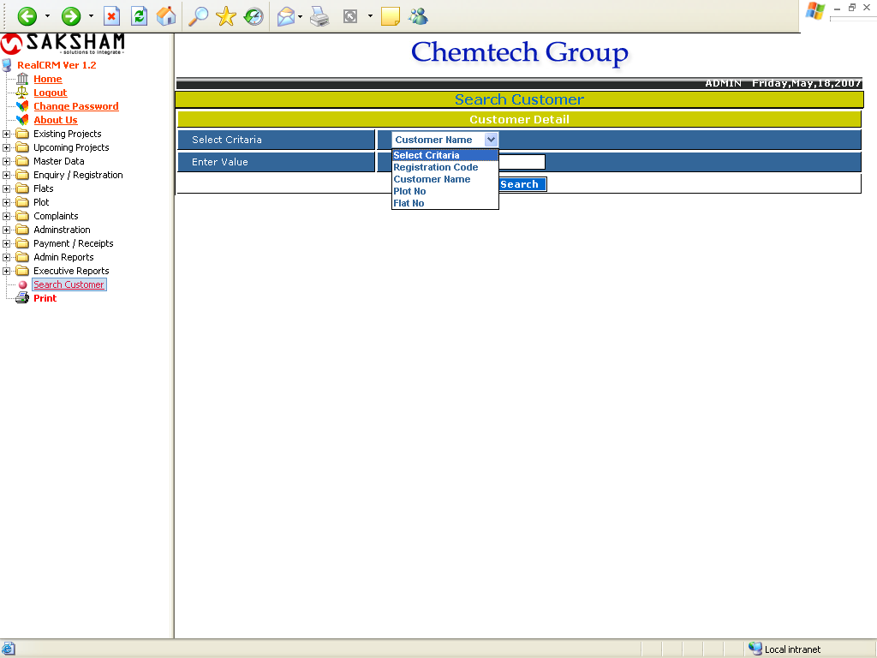

This is used for searching the customers. The user can use four criteria for searching customer, Customer Name, Registration Code, Plot No, Flat No. Then enter the value, Click on the Search button, the Customer List will get. It will shows below:

Customer List

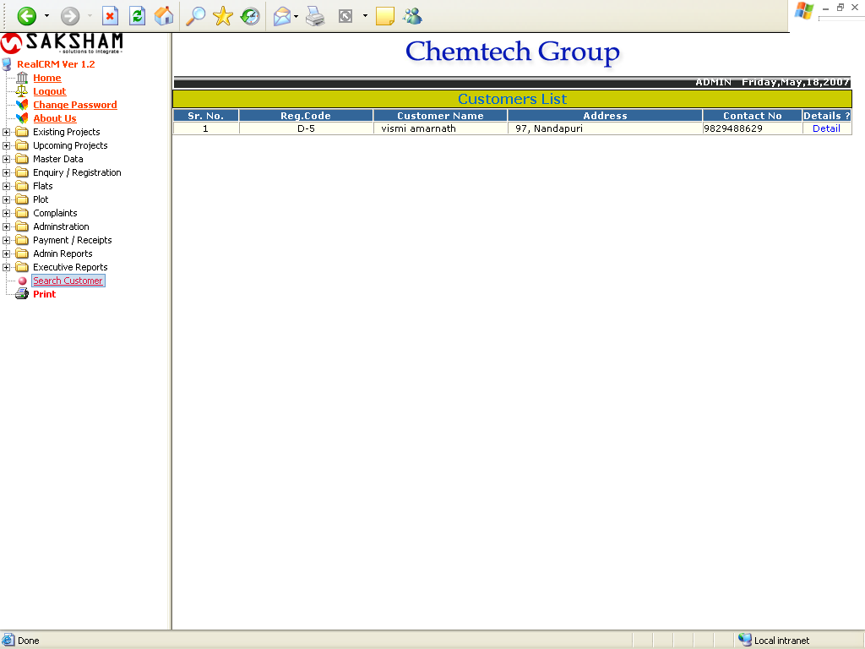

In this report the user clicks on the Detail button, the Customer Details report will get, it shows below:

Customer Details

