Today’s Follow Up (Morning)

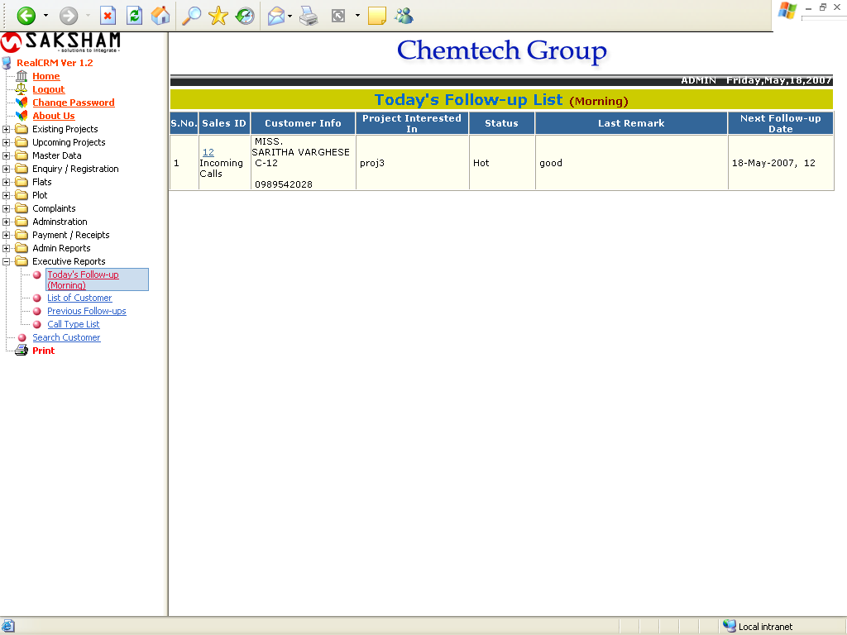

The above report shows the follow ups to be done to-day. If the user clicks on the sales ID, the enquiry follow- up Details from will appear, it will shows below:

Enquiry Follow- Up Details

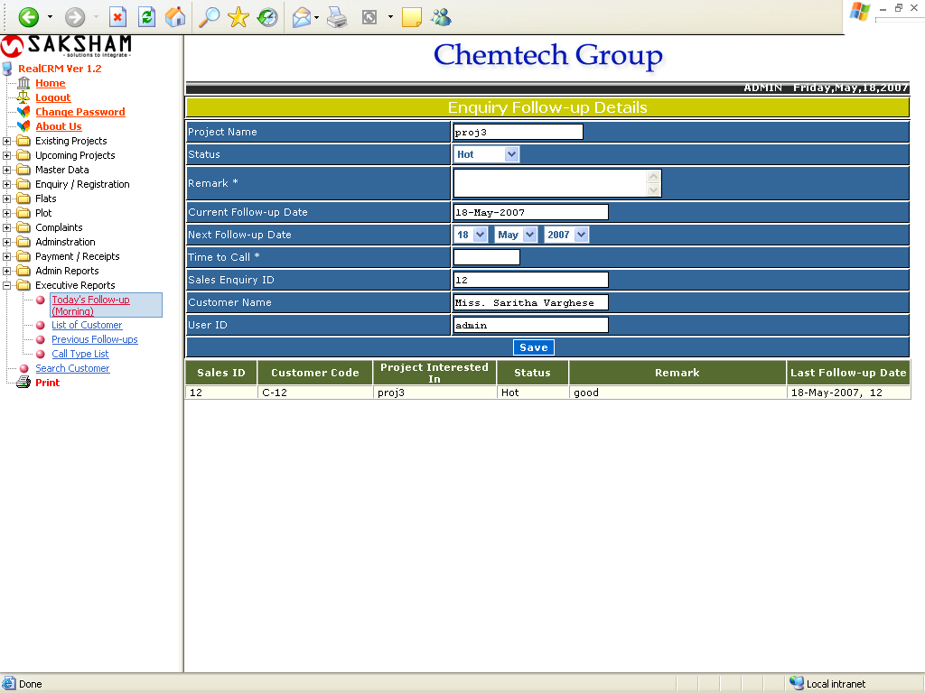
List of Customers

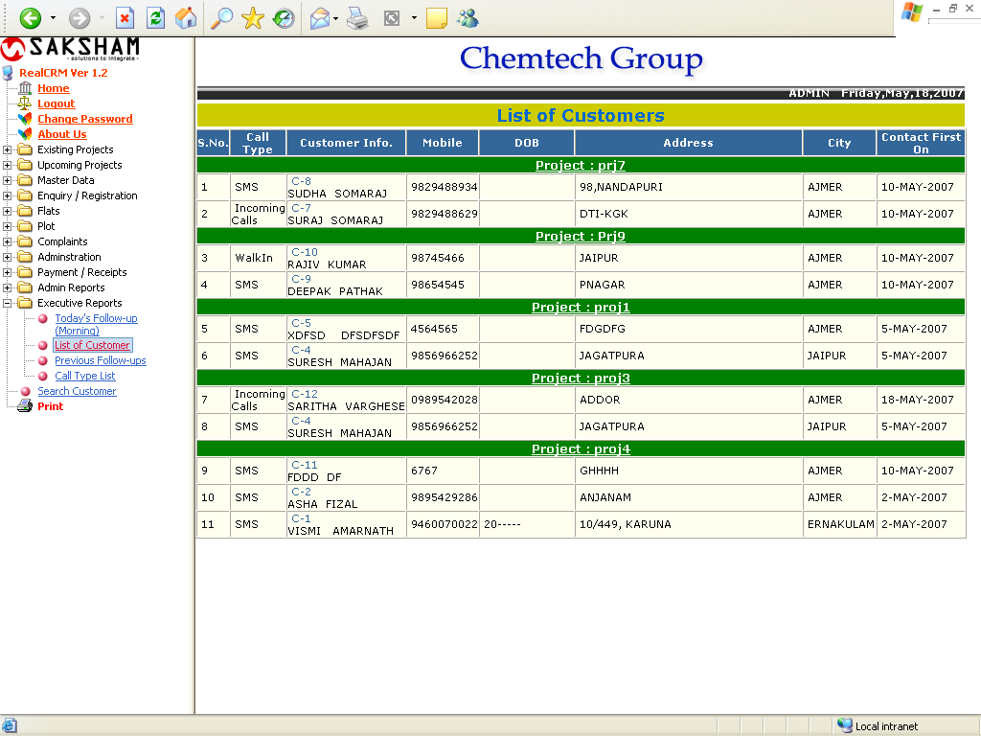

The above report shows the list of all customers project wise. If the user clicks on the Customer Info, the Sales Enquiry form will appear.

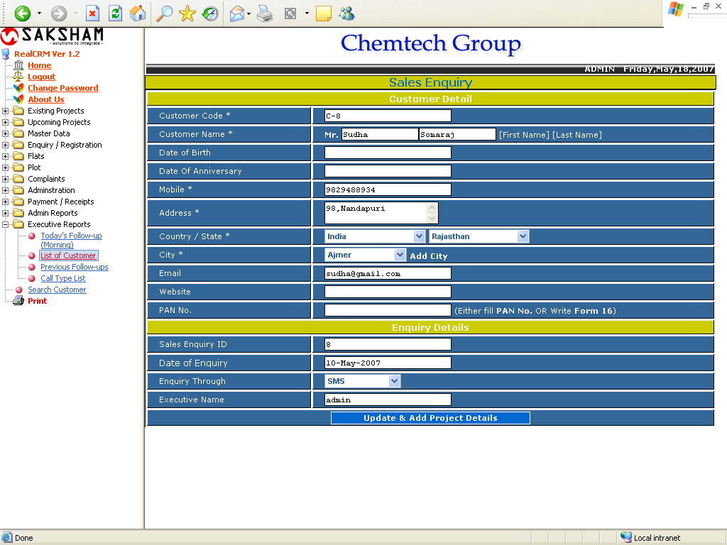
Pervious Follow Up

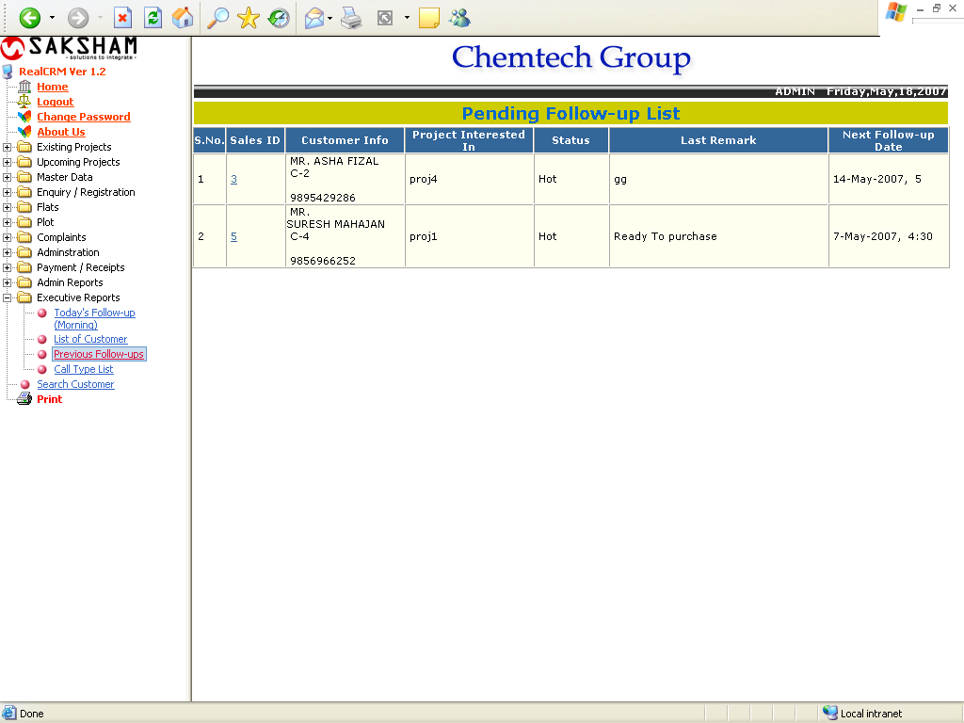

The above report show the last follow up date, remark and status.
Call Type List

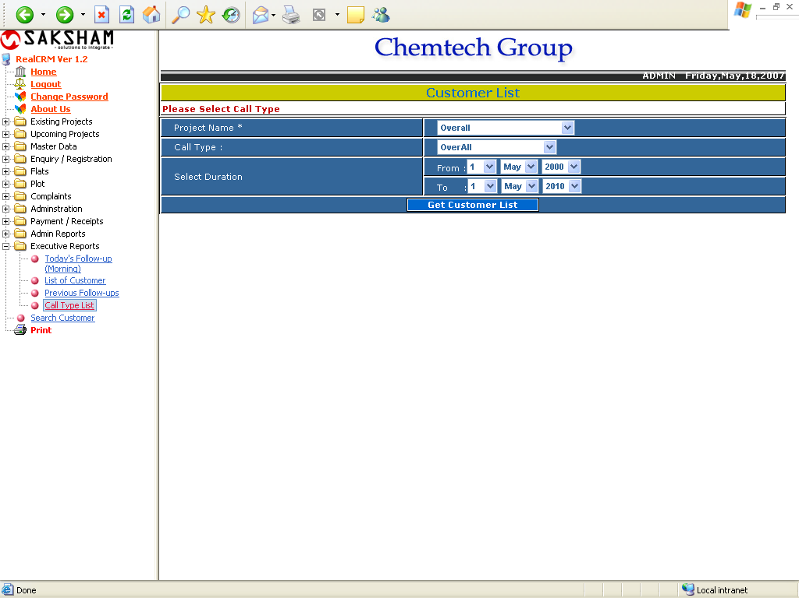

The above form generates the list of all customers filtered with project and Call type fro the select duration. The following report will comes after clicking on Get Customer List.
Call Type List

