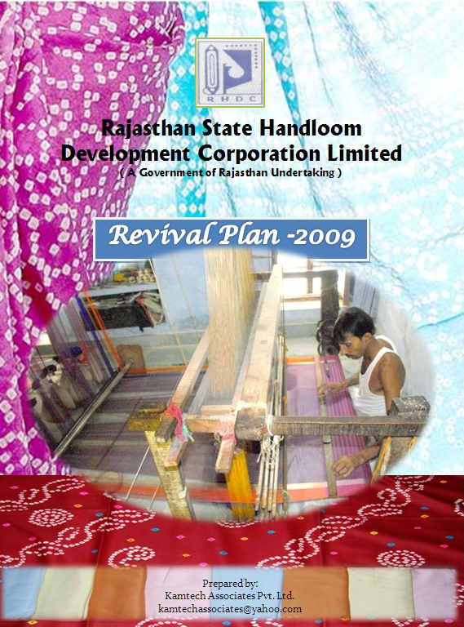



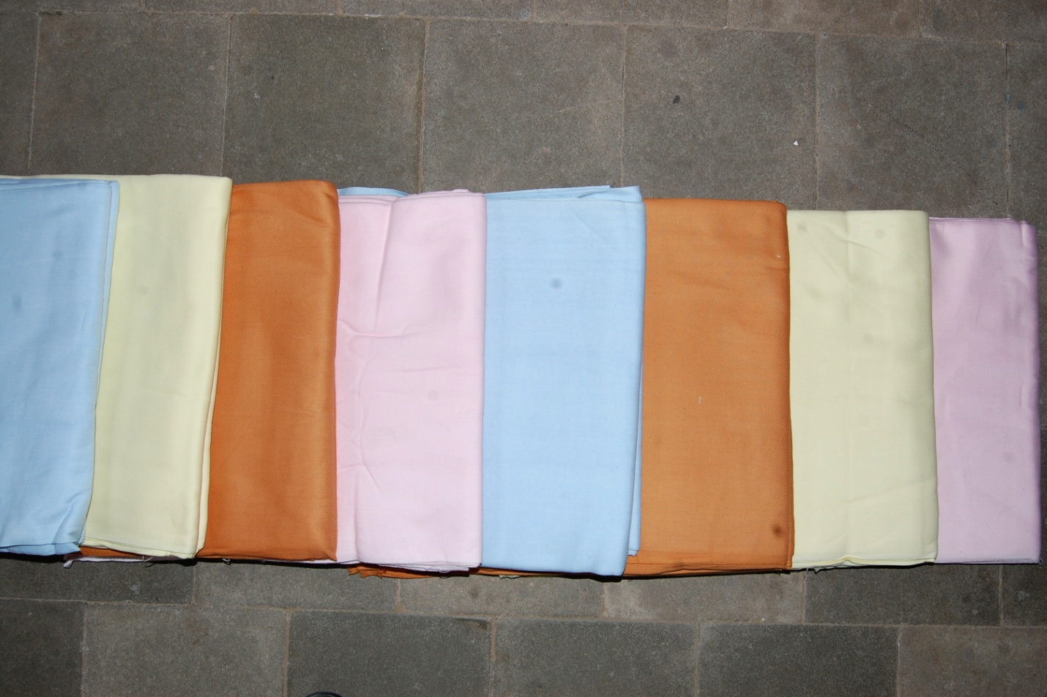
Rajasthan State Handloom Development Corporation Limited
(A Government of Rajasthan Undertaking)
Hathkargha Bhavan
Chomu House - Jaipur

Revival Plan -2009


Table of Content
S. No. | Topics | Page No.
1 | Executive Summary | 4
2 | About the Corporation | 11
2.1 | Prominent Units of the Corporation | 12
2.2 | Management and Employees | 12
2.3 | Share Holders of RHDC | 13
2.4 | Board of Director of RHDC | 13
2.5 | Details of Properties of the Corporation | 14
3 | Objectives & Achievements | 15
3.1 | RHDC Business Operations | 17
4 | SWOT Analysis | 18
4.1 | Livelihood Assets | 20
5 | Reasons For Losses | 24
6 | Suggested Revival Plan | 25
6.1 | Expectation from State Government | 26
6.2 | Future Steps by the Corporation (post Revival ) | 29
6.3 | Handloom Market | 38
6.4 | Impact after Revival Plan Implementation | 40
6.5 | Financial Projections After Implementation of Revival Plan | 41
6.6 | Global Market and Future | 46
7 | Handloom Products | 49

- Executive Summary
The handloom sector provides livelihood to millions of weavers and crafts persons in Rajasthan. The sector has grown over the decades due to its inherent strengths like flexibility of production in small quantities, non-intimidating nature of technology, and low level of capital investment. Rajasthan has several popular weaving clusters with traditional varieties of handloom cloth weaving.

Specific caste groups such as the Minorities and the Scheduled Castes (mostly BPL families) in Rajasthan are traditionally involved in handloom weaving which has been historically favoured by government action, receiving input subsidies and price supports. As per the census of Development Commissioner (Handlooms), the State has 1.32 lacs weavers families out of which 1.00 lac families are from rural areas. Around 85% are from SC families and the rest from Minorities. The State weavers produce traditional as well as modern products like Durries, Rugs, Khes, Kota Doria, Sarees, Loi, Dress materials, Towels, Printed Bed Sheets, Bandages, Pattus, Furnishings, Quilts, Uniform cloth, Blankets, etc.

Rajasthan State Handloom Development Corporation Limited ( RHDC) Jaipur, a Public Limited Company, registered under the Companies Act 1956, and promoted by the Government of Rajasthan, commenced business operations in March 1984. After the formation of this Corporation, the Rajasthan Hathkargha Pariyojana Mandal (operational since 1975), Export Oriented Handloom Production Project of Rajasthan Small Industries Corporation, and the Common Facility and Training Centres of Rajasthan Scheduled Castes and Scheduled Tribes Development Co-operative Corporation were all amalgamated into RHDC.

Since inception, the Corporation, inspite of minimum share capital and shortage of funds, has been successful in organizing the weavers in clusters and, today there are 34706 working handlooms spread all over the State and around one lac families are dependent on them. The Corporation provides marketing linkages support to them .
The Corporation till 2008-09, had accumulated losses of Rs.46.31 crores over the years and which can be mainly attributed to following reasons:

- Loss on account of establishment of a Process House in V.K.I Area, Jaipur. The commercial production in the process house began in 1988 but due to excess staff, lack of suitable technology and shortage of job work, it accumulated losses to the tune of Rs.12.00 crore and, in 1997, it was finally closed down following an experts committee report.
- Since inception, the Corporation has been looked at as the convenient place for adjusting the excess staff of the other Departments and Corporation like Rajasthan Land Development Corporation. On the one hand, the Corporation was over staffed and, on the other hand, majority of the staff were not experts in technology, marketing, financial and or business areas. Thus, the lack of suitable staff also contributed substantially in bringing about the losses on account of increasing administrative expenses. At one stage, the staff strength of the Corporation was 410.
- The Corporation did not receive the requisite Government budgetary support during 2000-01, 2001-02, 2002-03, 2003-04 and 2004-05.
- The Corporation had to undertake various promotional activities for the benefit of weavers for which there was no financial support available from the Government.
- The funds to be received from the Central Government and the State Government under various schemes implemented by the Corporation were usually received very late; thus putting the working capital finances under pressure and, the bank loan CC limit incurred heavy interest adding further to the losses.

It is to be highlighted and noted that in the various Departments of the State Government/ PSUs, handloom cloths/items worth more than Rs 70.00 crores are purchased annually. Should the Government instruct these Departments for extending purchase preference or routing the same through the Handloom Corporation, the Corporation will be able to survive and also, thousands of weavers across the State will stand to be benefitted.
All Government Departments/ Undertakings/ Institutions should be instructed to purchase their entire requirement of clothes from RHDC.
Looking at the fact that Corporation caters to the requirements of the weaker sections of the society. The Expenditure Reforms Commission, Government of Rajasthan, in 2005, recommended the following:

The Financial Results of last five years indicate that although, the Corporation operated under sub optimal levels under the shadow of closure, most of the losses are attributed to high administrative expenses on account of overstaffing and high interest payouts on Government loans, and are not truly business losses.

The Corporation has since considerably reduced the staff strength and, at present a total of 35 staff and two from deputation are on the rolls of the Corporation. The salary bill has come down approximately by 90%.

In future also, these expenses will be in control since some of the employees will retire and some may opt for voluntary retirement. A few may also go on deputation to the different Government Departments and Institutions.

In view of the above scenario, this Report outlines the revival plan and future projections post implementation of recommendations of the Expenditure Reforms Commission.

The Primary suggestion herein is to increase the paid up capital by converting the Government loan component and interest thereon accrued till date, thereby increasing the paid up equity of the Corporation from the existing Rs.615 lacs to Rs.4105 lacs ( covering the entire unsecured loan component of the Government and the interest accrued on amount). The amount of Rs.86.06 lacs which is a secured loan against inventory from Central Bank of India and which is under litigation in the DRT, will remain as such and can be reworked/negotiated with the bank after the revival plan is implemented.

The Corporation has properties (which are at present unproductive and not being used for any business operations) having market value of approx. Rs.1250.00 lacs. Part of these properties, mainly the Process House in VK I Area – Jaipur, can be leased out, after selling the plant and machinery which are outdated and deteriorating day by day.
(Amount Rs. in lacs)
S. No. | Description | Present | Proposed
1 | Paid up capital | 615.00 | 4105.00
2 | Outstanding Government Loans upto 31.03.2009 | 1616.19
3 | Interest Payable on Loans upto 31.03.2009 | 1873.68
 | Total Loan (2 + 3) | 3489.87 | Nil
4 | Estimated Market Value of Corporation Properties |  | 1250.00

Based on the past three years’ performance, the Corporation can continue the present activities of mainly supporting the weavers by way of providing the marketing support based trading.
The Corporation has posted the following Operational Profits for the last three years:
Year | Profit (Rs. in lacs)
- 2005-06 | 37.00
- 2006-07 | 51.20
- 2007-08 | 88.15
After the revival plan is implemented, the first year sales are projected at Rs.15.00 crores which is achievable in view of the current market scenario and the projected Government purchases of Rs.70.00 crores per annum, It is projected that there will be an annual 20% growth in sales. The table below gives the financial projections of the Corporation for 10 years, post revival plan implementation.
Estimated Projections (for 10 Years) |  |  |  |  |  |  |  |  |  |  |  | (Rs. In Lacs)
S. No. | Particulars | I |  | II | III | IV | V | VI | VII | VIII |  | IX |  | X
1 | Projected Revenue | 1500.00 |  | 1800.00 | 2160.00 | 2592.00 | 3110.40 | 3732.48 | 4478.98 | 5374.77 |  | 6449.73 |  | 7739.67
2 | Income from unused property lease | 25.00 |  | 26.25 | 27.56 | 28.94 | 30.39 | 31.91 | 33.50 | 35.18 |  | 36.94 |  | 38.78
3 | Sale proceeds from process house machinery | 45.00 |  | 0.00 | 0.00 | 0.00 | 0.00 | 0.00 | 0.00 | 0.00 |  | 0.00 |  | 0.00
 | Total Revenue | 1570.00 |  | 1826.25 | 2187.56 | 2620.94 | 3140.79 | 3764.39 | 4512.48 | 5409.95 |  | 6486.66 |  | 7778.45
4 | Cost of Operations
4.1 | Rent (on existing properties) |  | 5.25 | 5.78 | 6.35 | 6.67 | 7.00 | 7.35 | 7.72 | 8.11 | 8.51 |  | 8.94
4.2 | Postage & Communication |  | 1.00 | 1.10 | 1.21 | 1.33 | 1.46 | 1.61 | 1.77 | 1.95 | 2.14 |  | 2.36
4.3 | Power, Fuel & Water |  | 2.00 | 2.20 | 2.42 | 2.66 | 2.93 | 3.22 | 3.54 | 3.90 | 4.29 |  | 4.72
4.4 | Salary & Wages |  | 100.00 | 105.00 | 110.25 | 115.76 | 121.55 | 127.63 | 134.01 | 140.71 | 147.75 |  | 155.13
4.5 | Fringe Benefits @15% |  | 15.00 | 15.75 | 16.54 | 17.36 | 18.23 | 19.14 | 20.10 | 21.11 | 22.16 |  | 23.27
4.6 | Insurance |  | 0.50 | 0.45 | 0.41 | 0.36 | 0.33 | 0.30 | 0.27 | 0.24 | 0.22 |  | 0.19
4.7 | Repairs & Maintenance |  | 0.50 | 0.53 | 0.55 | 0.58 | 0.61 | 0.64 | 0.67 | 0.70 | 0.74 |  | 0.78
4.8 | Security contracts and other contracts |  | 5.00 | 5.00 | 5.00 | 5.00 | 5.00 | 5.00 | 5.00 | 5.00 | 5.00 |  | 5.00
4.9 | Other Admn. Exps. |  | 1.00 | 1.05 | 1.10 | 1.16 | 1.22 | 1.28 | 1.34 | 1.41 | 1.48 |  | 1.55
 | Sub-Total Cost |  | 130.25 | 136.85 | 143.83 | 150.89 | 158.33 | 166.17 | 174.42 | 183.12 | 192.28 |  | 201.94
5 | Cost of Products Sourced |  | 1350.00 | 1620.00 | 1944.00 | 2332.80 | 2799.36 | 3359.23 | 4031.08 | 4837.29 | 5804.75 |  | 6965.70
 | Total Cost |  | 1480.25 | 1756.85 | 2087.83 | 2483.69 | 2957.69 | 3525.40 | 4205.50 | 5020.41 | 5997.04 |  | 7167.64
6 | Profit Before Intt. & Dep. |  | 89.75 | 69.40 | 99.73 | 137.25 | 183.10 | 238.99 | 306.98 | 389.53 | 489.63 |  | 610.81
7 | Interest on Working Capital @13 % |  | 13.00 | 13.00 | 13.00 | 13.00 | 13.00 | 13.00 | 13.00 | 13.00 | 13.00 |  | 13.00

Estimated Projections (for 10 Years contd.) |  |  |  |  |  |  |  |  |  | (Rs. In Lacs)
S. No. | PARTICULARS | I | II | III | IV | V | VI | VII | VIII | IX | X
8 | Profit Before Depreciation. | 76.75 | 56.40 | 86.73 | 124.25 | 170.10 | 225.99 | 293.98 | 376.53 | 476.63 | 597.81
9 | Depreciation | 2.00 | 2.00 | 2.00 | 2.00 | 2.00 | 2.00 | 2.00 | 2.00 | 2.00 | 2.00
10 | Profit After Depreciation | 74.75 | 54.40 | 84.73 | 122.25 | 168.10 | 223.99 | 291.98 | 374.53 | 474.63 | 595.81
11 | Adjustment for accumulated losses | 50.00 | 50.00 | 50.00 | 100.00 | 110.00 | 120.00 | 130.00 | 140.00 | 150.00 | 160.00
12 | Profit Before Taxation | 24.75 | 4.40 | 34.73 | 22.25 | 58.10 | 103.99 | 161.98 | 234.53 | 324.63 | 435.81
13 | Taxation | 0.00 | 0.00 | 0.00 | 0.00 | 0.00 | 0.00 | 0.00 | 0.00 | 0.00 | 0.00
14 | Profit After Taxation | 24.75 | 4.40 | 34.73 | 22.25 | 58.10 | 103.99 | 161.98 | 234.53 | 324.63 | 435.81
15 | Accumulated Profit | 24.75 | 29.15 | 63.88 | 86.13 | 144.23 | 248.22 | 410.20 | 644.73 | 969.36 | 1405.17
16 | Profit After Taxation | 24.75 | 4.40 | 34.73 | 22.25 | 58.10 | 103.99 | 161.98 | 234.53 | 324.63 | 435.81
17 | Add : Depreciation | 2.00 | 2.00 | 2.00 | 2.00 | 2.00 | 2.00 | 2.00 | 2.00 | 2.00 | 2.00
Total (A) |  | 26.75 | 6.40 | 36.73 | 24.25 | 60.10 | 105.99 | 163.98 | 236.53 | 326.63 | 437.81
18 | Dividend on Share Capital | 0.00 | 0.00 | 0.00 | 0.00 | 50.00 | 100.00 | 110.00 | 115.00 | 120.00 | 125.00
Total (B) |  | 0.00 | 0.00 | 0.00 | 0.00 | 50.00 | 100.00 | 110.00 | 115.00 | 120.00 | 125.00
SURPLUS (A) - (B) |  | 26.75 | 6.40 | 36.73 | 24.25 | 10.10 | 5.99 | 53.98 | 121.53 | 206.63 | 312.81

2. About the Corporation
Rajasthan State Handloom Development Corporation Limited ( RHDC) Jaipur, a Public Limited Company, registered under the Companies Act 1956, and promoted by the Government of Rajasthan, commenced business operations in April 1984. After the formation of this Corporation, the Rajasthan Hathkargha Pariyojana Mandal (operational since 1975), Export Oriented Handloom Production Project of Rajasthan Small Industries Corporation, and the Common Facility and Training Centres of Rajasthan Scheduled Castes and Scheduled Tribes Development Co-operative Corporation were all amalgamated into RHDC.
The Corporation has been established for providing employment to handloom weavers, mainly to the weaker section of the society through:
- Training and skills upgradation to the weavers on modern looms and through modern weaving techniques.
- Providing Raw Materials and also marketing support of finished products to weavers.
- Preparing modern designs of weaving and printing and, making them available on commercial scale to the weavers.
- Undertaking Research and Development for weaving and printing and also popularizing the handloom cloths in various market segments.
The Corporation’s Head Office is situated at Chomu House, C-Scheme, Jaipur (on Rent), and the entire administrative and financial control of all units and regional offices are managed from the Head Office.
The Corporation has six regional offices located in following cities:

- Jaipur
- Bikaner
- Jodhpur
- Ajmer
- Kota
- Udaipur

2.1 Prominent Units of the Corporation are as follows:
S. No. | Name of Unit | District
1 | Rajasthali, M.I. Road, Jaipur | Jaipur
2 | Indira Bazar, Jaipur | Jaipur
3 | Handloom Haveli, M I Road , C-Scheme - Jaipur | Jaipur
4 | Amer ( Jaipur ) | Jaipur
5 | Alwar | Alwar
6 | Jodhpur | Jodhpur
7 | Jalore | Jalore
8 | Ajmer | Ajmer
9 | Udaipur | Udaipur
10 | Bhilwara | Bhilwara
11 | Kota | Kota
12 | Hindaun City | Karauli
13 | Bikaner | Bikaner
14 | Ahmedabad | Ahmedabad (Gujarat)

Ajmer, Udaipur, Kota and Jaipur handloom units are getting good customer response. Others are facing stiff competition from the private shops and showrooms.

2.2 Management and Employees
To control the financial and administrative load, corporation has decided to close the unviable units and has implemented number of schemes to reduce number of employees such as “VRS”, transferring or giving on deputation its employee’s services to other departments/.institutions etc. In the past as per the state Government directive the employees on deputations have been absorbed by these departments.

Over all management of the Corporation is being looked after by a Supertime scale IAS officer deputed by Government of Rajasthan and one Assistant Accounts Officer from Rajasthan Accounts Service.
The Corporation is having sufficient staff for smooth handling of work-load including a General Manager who is having vast technical expertise and support of 22 technical and 13 non-technical staff. Of the total 37 employees, 14 are based at The Corporation Headquarters and the other 23 are posted at the other units. As per requirement, one or more employees are deputed at the units for purchases, collection and sales of handloom cloths. They are also responsible to provide information to weavers about various government schemes and welfare programmes and implement the same. It is highlighted that 107 employees of the Corporation are on deputation in various Government Departments/ Undertakings and, The Corporation is making efforts for the permanent adjustment of these employees in the Departments where they are working on deputation.

2.3 Share Holders of RHDC
The distribution of shares of RHDC is as follows:
S. No. | Name | No. of Share
1. | Honorable Governor of Rajasthan (Through Finance Secy.) | 59194
2. | Smt. Usha Sharma, Chairman, RHDC | 2
3. | Shri Rajeshwar Singh, MD, RHDC | 1
4. | Shri Rohit R. Brendan | 1
5. | Shri Surendra Kumar Solanki, DS, Fin. Exp.-2 | 1
6. | Smt. Shakuntla Singh, DS, Ind. Gr.-2 | 1
7. | RSIC Ltd., Jaipur | 500
8. | R.S.C.D.C., Jaipur | 1800
 | Total | 61500

2.4 Board of Directors of RHDC
S. No. | Position in the Board | Current Designation | Name
1. | Chairman | Chairman, RHDC | Smt. Usha Sharma
2. | Member | MD, RHDC | Shri Rajeshwar Singh
3. | Member | MD, RAJSICO | Shri Rohit R. Bredan
4. | Member | Sr. Additional Director (Industries)
5. | Member | MD., Bunkar Sangh | Smt. Pramila Surana
6. | Member | Dy. Secretary, Finance (Exp-2), Ind. Department GOR | Shri Surendra Kumar Solanki
7. | Member | Dy. Secretary, Industries (Gr. -2) GOR | Smt. Shakuntla Singh
8. | Member | Dy. Director Weavers Service Center GOI | Shri S.V. Mathur
2.5 Details of Properties of the Corporation:
The Corporation is having prime properties in Rajasthan as well as in other States of India including Gujarat, West Bengal and UP. Some of them are at very prestigious locations such as at Panch Batti Jaipur, Raja Park Jaipur and at Kota. The Corporation is also having process house at V.K.I., Jaipur, valued at Rs.900 Lacs approx; the details of the properties are as under:
S.No. | Details of Properties | Estimated Market Value (in Lacs)
1. | Process House, V.K.I., Jaipur (Plot measuring 8535 sq.mt.) including Buildings, Plants, Machineries, etc. | 900.00
2. | Show room & Display Buildings  - Rajapark, Jaipur (Area 17.48 sq.mt.) 10Lacs  - Malviya Nagar, Jaipur ( Area 120 sq.feet ) 15 Lacs  - Indra Bazar , Jaipur ( Area 600 sq.feet) 125 Lacs  - Handloom Haveli, Paanch Batti, Jaipur  (Area 52.25 sq.mt.) 20 Lacs  - Alwar (Area 150 sq.feet) 20 Lacs  - Kota (Area 900 sq.feet) 350 Lacs  - Udaipur ( Area 200 sq.feet) 10 Lacs  - Bhilwara ( Area 11.11sq.yards) 8 Lacs  - Ajmer (Area 300 sq.feet) 15 Lacs  - Jalore ( Area 300 sq.feet) 10 Lacs  - Kolkata –(Area 393 sq.feet) 30 Lacs  - Ahmedabad –(Area 490 sq.feet) 15 Lacs  - Kanpur (Area 431 sq.feet) 15 Lacs | 328.00
3. | Available Cloth and Yarn Inventory | 40.00
4. | Others ( Loom, Miscellaneous equipment/ vehicles ) | 4.00
 | Total | Rs.1272.00 Lacs

3. Objectives & Achievements
The Handloom textiles constitute a timeless part of the rich cultural Heritage of Rajasthan. The element of art and craft present in state handlooms makes it a potential sector for the upper segments of market, domestic as well as global. However, the sector is beset with manifold problems such as obsolete technologies, unorganized production system, low productivity, inadequate working capital, conventional product range, weak marketing link, overall stagnation of production and sales and, above all, competition from power loom and mill sector. As a result of effective Government intervention through financial assistance and implementation of various developmental and welfare schemes, the handloom sector, to some extent, has been able to tide over these disadvantages.

Since inception, the Corporation, inspite of low share capital and shortage of funds, has been successful in organizing the weavers in clusters and today, there are 34706 working handlooms all over the State and around one lac families depend on them. The Corporation provides market linkages support to them through marketing.

More than 13,348 weavers have been benefitted by various skills development training programs organized by the Corporation and approximate Rs.124.64 Crores worth of handloom products/cloths have been sold. Benchmarked achievements are as given in the table:
S. No. | Description | Amount/Qty.
1. | Distribution of yarn ( Raw Material) to weavers | Rs.25.00 Crores
2. | Production of handloom cloths | Rs.61.00 Crores
3. | Wages Payments to weavers | Rs.6.29 Crores
4. | Weavers benefitted from the various skill development training programs | 13348
5. | Establishment of modern looms | 3316
6. | Construction of weavers work shed | 2256
7. | Sale of handloom cloths | Rs.124.64 Crores

For the benefit of the weavers, the Corporation has successfully implemented a number of Government schemes such as :
- Janata Cloth Scheme
- Woolen Handloom Development Project
- Project Package Scheme
- Marketing Rebate Scheme
- Market Development Assistance Scheme
- Hank Yarn Incentive Scheme
- Dwakara Scheme
- Special Package Scheme
- Free lance Designer Scheme
- Work Shed Scheme

3.1 RHDC Business Operations
4. SWOT Analysis

Payment to Weavers/ Weavers Co-operative Societies and Others

Exhibitions and Fairs

Retail sale at Unit
Collection of Sale proceeds from Units / HO
Whole sale Supply to Government Departments
Distribution of Products for Sale

Collection
at
RHDC units Store /HO Store

Sourcing of Handloom Products
(from Handloom Weavers, Handloom Co-operative Society and Other Handloom Agencies)

Handloom forms a part of the heritage of Rajasthan and exemplifies the richness and diversity of the State. Taking into account the present status of handloom industry in the State, an attempt is made to analyze the problems and prospects of this traditional industry by using the SWOT Analysis.
Strengths
- Its rural base, low capital investment and employment intensive nature of production not only help in providing livelihood to large number of people in the rural non-farm sector but also strengthen its survival in the age of computerized weaving technology.
- It is eco-friendly in nature and inflicts no harm to health.
- It prevents distress migration of rural artisans to the cities by providing work in the village itself.
- It provides productive employment to the women, old and destitute in their households (in the preparatory work) and thus serves an important social purpose, at virtually no cost to the government.
Weaknesses
- The inherent weakness of handloom industry is low productivity.
- The sector is weak and needs protection from the government by giving rebates/concessions periodically during the festive seasons.
- It is relatively more manual; thus the higher wage component of handloom products as compared to the power loom products affects their commercial viability.
- It grapples with problems like non-availability of good quality yarn, low technology, lack of market intelligence and poor marketing facilities.
- Another important weakness of the handloom industry is related to poor capacity of the weavers to switch over to new products and designs according to consumers’ tastes and preferences on short notice in comparison with power loom products.

Opportunities
- Good design and colour combination in the finished products are done in accordance with the customer’s choice with the increasing skills of weavers.
- The products made by the handloom weaving are durable for longer period.
- Diversification to products like sarees, bedsheets, pillow cover, furnishing materials and window curtains will have wide scope for marketing within the country as well as in foreign countries.
- It provides employment opportunities to the low skilled and semi skilled workers from SC, minorities and weaker sections in rural areas.
- There is increasing export potential of items made by the handloom weavers, due to use of eco-friendly and natural colours.
Threats
- In a free market economy, the handloom products will have to compete with machine made fiber with millions of design and colour combinations.
- Government encouraging organized textiles sector by various schemes like TUF, for making them competitive post WTO in international markets, may not be helpful to increase the long term growth opportunities in handloom weaving sector.
- In spite of having excellent skills, the handloom weavers are languishing in poverty and they are unable to exploit the markets in their favour.
- Marketing of the handloom products is much more difficult without Government support and subsidies.
- Phasing out of the multi-fiber arrangement (MFA) and functioning of the World Trade Organization (WTO) are likely to pose new challenges for the handloom industry.
- Removal of controls as required under MFA and WTO will increase competition between developing economies and the developed economies.

4.1 Livelihood Assets

Handloom sector is important from the point of view of its size and employment potential for the state of Rajasthan. Besides, the products of handloom sector have their own cultural heritage, artistic intricacies and uniqueness.

These characteristics are the strong points that could be leveraged in creating niches in national and international markets.
It is observed that rural Rajasthan possesses expertise to manufacture textiles, handicrafts and other traditional products that have unique features on account of their special human skills. One of the effective ways to leverage the unique identity of a product is to obtain various Geographical Indication which provides legal protection to producers against illegal entities and conveys an assurance of quality, distinctiveness and its geographic (place of) origin.

Data on Handloom sector, including production, producing clusters, designs, trade, etc. are available in a scattered form all over the State and no efforts have yet been made for their systematic consolidation and rationalization. The Corporation can leverage these strengths in establishing the niche markets achieving the social objectives of the state Government by considering these as livelihood assets:

4.1.1 Human Asset: Weaving is a special skill which only certain communities living in certain specific places in Rajasthan possess. It is traditional and usually handed down from parents to their wards. As human beings they have certain special skills which can be considered as human asset. Where it is weaved at the household level, it is still viewed as a family occupation.

In a weaver’s family, almost every one possesses the skill of weaving or some skill that is relevant to weaving. The skill level and the entrepreneurship vary even within the weaving communities. Some are conventional and saturated into the same old tradition while others are enterprising and are on the lookout for better designs that are market worthy and technologies that are less in drudgery.

4.1.2 Physical Asset: Loom is the major productive physical asset with the handloom weavers.

Some of them have it in their own residential houses; others depend on the ones made available to them either by the Handloom Cooperative Society or at the factory of master weavers. For those who work at home it requires a minimum space of 10 X 10 sq.ft. This is mostly their living place as well. There are at least six major types of looms in Rajasthan, as mentioned below:-

- Fly Shuttle Pit Loom
- Throw Shuttle Pit Loom
- Fly Shuttle Frame Loom
- Semi Automatic Handloom/Paddle Loom
- Dobby Handloom
- Jacquard Handloom
The cost of fabricating each loom ranges between Rs.6000/- to Rs.25,000/-

4.1.3 Financial Asset: Finance is a major problem for the individual weavers who are independent.

They need money to buy yarns. They need money even to buy the second feed of yarn for initiating pre-loom processes while the first lot is still on-loom. Moreover, they are usually indebted to traders and money lenders. However, for those who work under cooperative fold and for those who work for master weavers, yarn supply would be taken care of by cooperative society and the master weavers respectively.
Weavers have little financial asset as such. They seem to have more liabilities rather than assets, Even for changing the design, each time they need to change the accessories and which means additional cost.

4.1.4 Social Asset: For the weavers of Rajasthan, RHDC is playing a major role for uplifting their social asset by providing market supports, technical guidance and benefits of other Government welfare schemes.

It is a cost-effective mode of textile production primarily because of low capital cost and more labour input; with growing unemployment, this sector provides a great opportunity.

Thus the need of the hour is to adopt the following:-
1. Produce cloth of good quality at acceptable price, to meet the growing needs of the people.
2. Increase and contribute to the provision of sustainable employment and economic growth.
3. Compete with confidence for increasing the share in the global market.
For achieving the Livelihood Assets objective the strategic thrust should be:-
1. Technological up-gradation
2. Enhancement of productivity
3. Quality consciousness
4. Strengthening of quality of raw material
5. Product diversification
6. Increase in exports and innovative marketing strategies.
7. Financing arrangements
8. Maximising employment opportunity
9. Integrated human resource development
The handloom industry has been able to maintain its own identity. This is due to the fundamental fact that it has an organisational structure which is very different from the mill sector. It is unique in its individuality and in the production of quality goods which maintain their own identity. For example, the Kota Doria Sarees, Towels, Tie and Dye, Block Printing Furnishings have uniqueness in terms of craftsmanship and finish which cannot be compared with the mill sector. It may be pointed out that the handloom industry has a great potential for the utilization of human resources. It is necessarily a labour-intensive industry. In a state like Rajasthan, with considerable man power and a high rate of unemployment, any investment, that can utilize idle human resources, should be supported by Government interventions. The handloom sector can have a great role to play in this direction.

In order to overcome the lacunas and to help all stakeholders in the Handloom sector, including policy makers, to access information relating to the Handloom sector and the business opportunities, the Corporation should set up a centralized Handloom Resource Centre with the following issues of concerns for making its sustainable business model:

- The infringement of a handloom product threatens its overall existence. Hence the issue should be addressed urgently for the betterment of the poor producers.
- The infringers should be identified and brought to the rule of law for protecting the product.
- Marketing is a big problem for the stakeholders. Even if they are interested to market the product directly to the exporters and big buyers, they are unable to do it due to the lack of knowledge of the potential markets. Hence, marketing issue should be taken care of.
- Design development and product diversification is also equally important for catering to changing preferences of the consumers. Hence, training programme should be arranged for the same.

- Reasons for Losses
The Corporation, till 2008-09, had incurred Rs.46.31 crores loss over the years which can be attributed to the following main reasons:

- Loss on account of establishment of a Process House in V.K.I Area, Jaipur. The commercial production in the process house began in 1988 but due to excess staff, lack of suitable technology and shortage of job work, it accumulated losses to the tune of Rs.12.00 crore and, in 1997, it was finally closed down following an experts report.
- Since inception, the Corporation has been looked at as the convenient place for adjusting the excess staff of the other Departments and The Corporation like Rajasthan Land Development Corporation. On the one hand, the Corporation was over staffed and, on the other hand, majority of the staff were not experts in technology, marketing, financial and or business areas. Thus, the lack of suitable staff also contributed substantially in bringing about the losses on account of increasing administrative expenses. At one stage, the staff strength of the Corporation was 410.
- The Corporation did not receive the requisite Government budgetary support during 2000-01, 2001-02, 2002-03, 2003-04 and 2004-05.
- The Corporation had to undertake various promotional activities for the benefit of weavers for which it did not receive adequate administrative and financial support from the Government.
- The funds to be received from the Central Government and the State Government under various schemes implemented by the Corporation were usually received very late; thus putting the working capital finances under pressure and, the bank loan CC limit incurred heavy interest adding further to the losses.
- Suggested Revival Plan
There are 66738 working weavers and 34706 handlooms spread over the State of Rajasthan. About 738.77 lacs sq. meter cloth is woven on the handlooms in the State. 85% of the weavers are from scheduled castes and remaining belong to Minority Communities. A large number of weavers are Below Poverty Line (BPL).
The economic condition of the weavers is not very sound as the average daily earning per weaver is about Rs.40 and which is also one of the reasons for their younger generation to opt out of their ancestral profession.
The Corporation has a crucial role in supporting livelihood for disadvantaged weavers of the State. Financial results for the last 5 years of the RHDC indicate that although, the Corporation worked under sub optimal levels, under shadow of closure, yet most of the losses have been are on account of high administrative expenses due to over staffing and also the interest payable to the State Government on term loans; and not really business losses.
Following expeditious steps are suggested for the State Government for strengthening the Corporation as well as for the upliftment of weavers.
For any industry, “ the man and the machine” is the combination of quality and production. The new challenges and opportunities presented by the changing global environment; particularly the initiation of the process of gradual phasing out of quantitative restriction on imports and lowering of tariff levels; integration of the world textile and clothing markets by the end of 2004; and the need for a focused approach to maximize opportunities and strengths is urgently required in the situation.
[
The need of the hour is to adopt the following:-
1. To produce cloth of good quality at acceptable prices, to meet the growing needs of the people.
2. To increase contribution to the provisions of sustainable employment and economic growth.
3. To compete with confidence for increasing the share in the global market.
For implementing the above objective, the strategic thrust should be as under:-
1. Technological up-gradation
2. Enhancement of productivity
3. Quality consciousness
4. Strengthening of Quality of Raw materials
5. Products diversification
6. Increase in exports backed by innovative marketing strategies.
7. Financing arrangements
8. Maximizing employment opportunities
9. Integrated human resource development
6.1 Expectation from State Government:
- Financial Support
Government should convert its existing loans into equity, so as to improve its financial health in the balance sheet and enable it to get commercial loans. The Expenditure Reform Commission strongly endorses this proposal as it would benefit a large number of people from poorer strata of the society in the long run.
- It is to be highlighted and noted that in the various Departments of the State Government/ PSUs, Handloom cloths worth more than Rs 70.00 crores are purchased annually. All purchases should be necessarily routed only through Handloom Corporation. Direct purchasing from other sources should be permissible only if the Handloom Corporation is not in a position to supply as per the required demand. Only after the NOC by R H D C, the Government Departments should be allowed to purchase from other sources.

All Government Departments / Undertakings/ Institutions should be directed to purchase the entire cloths/furnishings and other items as per their requirement from State Handloom Development Corporation only. By adopting this procedure of purchase/ procurement, the Handloom Corporation will stand to have an assured market.

- In fact, the Expenditure Reform Commission, Government of Rajasthan, recommended that loans, (along with interest therein), given to the Corporation should be converted into equity so that The Corporation can recover from the losses in the form of accruing interest of near about Rs. 2.00Crores annually, and also become economically independent.

- The Corporation’s 107 employees are providing their services against the vacant posts in the various departments/institutions on deputation. The Government should merge their services in these respective departments so as to, minimize administrative expenses.

- The Corporation’s head office building is on rent; the annual rent being Rs.5.0Lacs approx. Hence it is imperative that a minimum required office space should be provided rent free in a government institution for the Corporation’s headquarters.

- Disposal of properties
The Corporation has properties, which are at present unproductive and are not used for any business operations and having a market value of approx. Rs.1250.00 lacs. Some of them, including the Process House in VK I Area – Jaipur may be leased out after selling the plant & machinery which is obsolete and is deteriorating day by day.

Alternatively the Government should allow disposing off such properties which are not required for the Corporation’s business in the immediate future. This action should be taken up on a war footing.

The following showrooms are also lying closed:-
1. Rajapark, Jaipur.
2. Malviya Nagar, Jaipur.
3. Bhilwara.
4. Kolkata.
5. Kanpur.
All these showrooms should be disposed off or leased out at the earliest and it is estimated that quite a substantial revenue amount can accrue from such disposal or leasing out of owned properties.

The financial restructuring will thus also include, increasing the shareholding by conversion of outstanding Government loan and interest accrued thereon; increasing the financial competitiveness of the Corporation to with-stand the market vis-à-vis the private players like FAB India, SOMA and others.
The Corporation will ensure increased productivity from its existing human resource strength through implementation of suitable performance measurement.
Once the financial restructuring plan is implemented by the Government, the Corporation will act purely as a commercial organization for the development of new markets and provide technological support to the weavers to equip them with necessary and updated inputs for fulfilling the market needs. The Corporation will also work on market oriented packaging; explore export markets and branded retail segments; and increase its market competitiveness thus benefitting the weavers through value additions.

6.2 Future Steps by the Corporation (post Revival)
Since the establishment of the Corporation in the year 1984 and until recently, the main working methodology has been, that the Corporation would utilize its capital to buy yarn from the market and supply it to weavers spread across the State on the basis of job work. After that, these job based products were marketed at the Corporation’s level after completion of the dyeing & printing processes.
Hence it became necessary to make practical changes in the above procedure. The Corporation realizes the need of being a catalyst to enable weavers / artisans to work fast by operating as a facilitator. It is imperative that the Corporation’s working methodology be modified to achieve these targets:-
- The Corporation is to function as a bridge between the weaver/artisan & buyers. For this, the Corporation will identify the needs and remove the difficulties of the weavers/artisans. It will also consider the other parties, the needs of the buyers, the daily changing market trends, receive market information and coordinate trade between the weavers & buyers.

- The Corporation will try to maintain this heritage of traditional art/ skills of the weavers/ artisans of the State who have been involved in this since generations. The Corporation will also take steps to get recognition for Rajasthan’s famous traditional cloths and products of kota doria, block prints and natural (vegetable) colours.
- Traditional clothes design and development work should be further diversified also as per modern fashion, so that there can be an increase in export as well as fashion market and earnings of the weavers.

- The Corporation will assist/guide the weaver’s/ artisans to locate the buyers for their traditional, newly developed & fashionable cloths.

- The Corporation will organize exhibitions and events in famous and big cities every year to portray the States’ traditional cloths and provide financial grant to weavers/artisans/institutions for display of their products. This will result into high level market promotion to reach out to people at all locations.

On the basis of the above subjective points, the following schemes/programs is to be implemented on priority and supported with the financial aid to be provided by the State/Central Governments:

- Design development programs
- Diversified handloom products
- Cloths of new design with different colour combinations

- Technical up-gradation programs
- Quality improvement in the products.
- Dyeing facilities based on modern technologies shall be established.
- Production shall be as per consumer preferences.
- Productivity Improvement (cluster approach)

- Market Promotion Programmes
- Direct Export avenues shall be explored.
- Direct interaction with consumers will help in manufacturing products according to their requirements.
- Brand Image-building.
- Exposure Visits of the Marketing SHGs to Exhibitions, Trade Fairs, etc.
- Business Meets to be organized.
- Periodical Designers Meets for products improvement.

- Exhibitions & Dissemination of information on products/ processes

- Barter and Sales tie ups with other States Handloom Corporations for the display of Rajasthan Handloom products at their sales outlets in Delhi and other important Metropolitan marketing centres like Mumbai, Bangalore, Hyderabad and, if possible, in the adjoining SAARC countries.

- In order to improve the business capacities of producer companies, publicity of the products through the following activities are also proposed to be undertaken under the revival plan : -
- Hoardings.
- Advertisements in News Paper and Magazines
- Publicity through Electronic Media.
- Brochures, Catalogues, Hand bills.
- Web portals and Online advertisements.
- Documentary Films.

- Implementation of Central & State Government’s Handloom Development related Schemes.
- Establishment of Credit Linkages with Financial Institutions
- Development and promotion of Craft sTourism.
- Franchise Marketing Arrangements
- E- marketing and SMSs
- Special Gifts and Mementos based Sales arrangements
- Special Outlets in the Malls for products display
- Mobile Carts outlet based sales arrangements

- Design Development Program:- In the textiles sector, designs play the most important role. Day to day new designs are the first priority and interest of the buyers. Worldwide, awareness towards fashion is increasing at a fast pace and it has made competition for the Handloom Industry more intense since it is an unorganized sector.
This is also the reason why products of the Handloom industry, despite being good face sales problems even when they are available at affordable prices, whereas non-handloom fashion designer products get sold quickly even at high prices.

In future the Corporation must work in the following fields for design development:
- Western garments :- Skirts (Kota Doria/ Cotton), Capris , Shorts, Toppers, Wraparound s, Kurtas,Trousers.
- Sarees / Dupattas :- Designer weaving sarees in new patterns of Kota Doria zari/color, Dupattas, Artistic sarees & Dupattas in vegetable color, Bagru print, Aakola Print, Dabu Print, Indigo Print, Block Print etc.
- Dress Material:- vegetable color block prints, Badmeri print, Sanaganeri block print, cotton dress material in fashionable color pattern/ shades,self-woven designer clothes, cotton bandhej clothes etc.
- Garments:- Pure cotton, Ladies Salwar suits, Gents kurtas, payjamas, shirts in all sizes etc. of different-different designs, patterns, weaving designs, natural colours & fashionable designs
- Made-ups:-Bed-Covers, Cushion Covers, Curtains, Table Mats, Napkins and weaving design cotton bed-covers, curtain cloth, badmeri, achrak, indigo, dabu, bagru, sanganeri printed bed covers, bed covers in katha work, mirror work, appliqué work in fashionable colours/ patterns made up of Kota doria textiles
- Other products:- Traditional pattu, aasan, rugs, mats, super-fine khes, jajam, cushion covers, diwan set, masnad cover etc.

For the design development related to the above areas, the Corporation headquarters, along with its own skilled technical personnel, shall hire professional designers on contract basis from the market and work towards continuous development in various areas of the design work in which regional weavers, artisans, printers and other people associated with this business will work together so that they can conveniently make use of the above facilities and increase their business independently.
- Technical up-gradation program:
Technology up gradation in Handloom sector is scarce. As a result when competing with other mill and power loom sectors, Handloom sector is lagging behind. Hence, weavers / artisans & craftsmen of the handloom sector do not get much profits.

The following are to be implemented through the Corporation in the State vide technical up-gradation program for weavers in the weavers’ intensive sectors:

- Up-gradation by improvement in Weaving Technology.
- Up-gradation by Product Diversification .
- New patterns, Variety of shade combinations and Designs.
- Use of Various types of threads & colours.
- Printing on textiles to be done as per the contemporary fashion and market demands, as also the national & international forecast of various colours/shades .
- Visit of weavers, artisans and craftsmen to prestigious & well developed weaving, dyeing, printing areas to evaluate the locally employed business systems and provide them technical information for up-gradation.
- Up-gradation by improvement in weaving, dyeing, printing tools.

Based on the above, necessary training will be provided in intensive weaving areas & workshops will be arranged for 20 to 25 weaver groups that are associated with weaving, dyeing, printing, selling, etc. On demand, demonstrations will also be arranged for technical up-gradation.

The weavers, artisans & related people will thus be benefitted so that they are able to face the market competition independently, move ahead and earn more income. Under this program, there will be a provision of giving an appropriate daily Honorarium to the participating weavers/ artisans so that, workers doing a good job, get encouraged & take full benefit of this plan.

- Marketing & promotion programme:- The biggest problem faced by the handloom sector is that the weavers and artisans’ products are not sold on time and when sold, are at unreasonable prices. It is notable that the difficult situation in the handloom sector is due to use of traditional methods for production of hand-made products. Also, weavers remain busy in production so, they do not get the opportunity to reach out to the market and to the appropriate buyers. This is the reason why they do not get full value for their hard work, art & products. While the power sector & mills sector use advanced production systems so the cost of their clothes is reduced and due to proper marketing their clothes get sold at high prices. This competition has become a major problem for the handloom sector’s development. Due to this difficulty in handloom sector weavers’/ artisans’ average income has gone below the minimum wages level.

Looking at the above situation and, in order to provide proper marketing promotion incentives and for the Corporation’s bright future; the following marketing strategy is to be employed for handloom products marketing for the State’s Handloom weavers/ artisans .

3.1 Marketing through the Sales Outlets/units: - For access of various types of handloom products of weavers at reasonable price to consumers, the Corporation has opened sales outlets/ units at 13 different centres in the State and one in Ahmedabad (Gujarat).

As is prevalent in the current system, more emphasis will be given on the sales/promotion in the home market by modernizing all the present sales centres and providing special sale discounts on big festivals.
3.2 Sales through Fairs & Exhibitions: - Special Handloom Exhibitions such as “National Handloom Expo”, “Mini Handloom Expo”, “International Trade Fair, New Delhi” and others are organized every year by the Government of India. In the same way, every year, fairs & exhibitions must be organized by the state government, through the district industry centers in the main districts of the State. The Corporation will increase participation in fairs & exhibitions in the coming years in order to increase the promotion and sales of handloom products by reaching out to remote areas.
Other than the above, on the occasion of big festivals, the Corporation will offer special sale discounts to increase the sales and market of the handloom products thereby making them more popular.
3.3 Sales through mobile unit:- There are only 13 functional units operated by the Corporation in the State & they are only in the main market areas and reach out to limited consumers. The people of rural areas, villages & towns do not get to see &/or purchase the handloom items which are available at affordable prices. The Corporation will try to make maximum sales of handloom cloths at reasonable prices through mobile units in the State for the benefit of the common public & especially for the economically weaker sections of the society.
3.4 Bulk Sales through the medium of Branded Stores:- Today, Handloom Clothes are considered to be a fashion statement amongst specific sections of the society. Modernization has converted smaller shopping centres into Malls. People who are fond of handloom products available in big branded stores & malls feel proud in wearing handmade clothes made by using the traditional ways but stitched in new designs & patterns. This is the reason why branded stores purchase handloom products in bulk from outside the State also.
In the coming years, the Corporation will try to promote sales by supplying products to the Branded Stores & Companies outside the State, based on their requirements, by developing business relations with them.
3.5 Facilities for Interstate Barter Sale:- Rajasthan’s traditional artistic clothes especially Kota Doria Sarees, Block Printed Natural Coloured, Printed clothes, Khes, Bandhej Clothes etc. are very popular in other states as well as abroad ( South Asian Countries, Middle East).
The popularity of these clothes can be gauged by the fact that for every domestic as well as international tourist coming to the State, the purchase of traditional clothes is a major attraction. Tourists from other States purchase clothes worth over Rs. 100 Crores every year which proves that Rajasthan’s Handloom clothes are in great demand among the populace of the other states.
Under the proposed facilities, the Corporation will try to do business as per the barter system guidelines with the various States’ Handloom and Handicrafts businessmen. This will provide the concerned Handloom Institutions of the State the opportunity to be able to sell Rajasthan State’s Handloom clothes in bulk at affordable prices through their showrooms. This will increase the sales of the Institutions of the related States & the Corporation’s business will also increase manifolds.
Similarly, the Corporation will also be able to purchase saleable handloom textiles such as silk handloom textiles; woolen textiles; etc. that can be sold at value added prices after coloring, dyeing, printing etc. in Corporation showrooms, fairs, exhibitions etc. and hence help increase business. By these business transactions business of the Corporation will increase substantially as projected @20% per annum.
3.6 Sales System through the exporters:- Handloom exports is a major foreign exchange earner. Every year handloom clothes worth millions of rupees are exported around the globe. Rajasthan’s traditional handmade artistic clothes as of vegetable color, block printed cotton clothes, etc. are exported in a big way. As such, looking to the demands of the exporters, there’s a big demand of handloom clothes in the form of raw materials. Exporters purchase clothes woven on handlooms by the weavers and institutions, prepare it by coloring, designing & using fashionable patterns at their level and then finally export the value added produce.
Since, the Corporation is working with extremely limited resources & limited manpower, direct export to foreign countries is practically not possible as of now. But, the Corporation can tie up with big export houses and, via business deals, get weavers to produce export quality clothes and supply the same, thereby increasing the turnover. By this initiative, not only the Corporation’s business will increase, but the global textile sales will also have a favorable impact on the Corporation’s credibility and image.
  - Organizing Exhibitions and Dissemination of Information: - Handloom products, in spite of being, good, attractive and available at appropriate/ affordable rates, do not get sold on time due to lack of dissemination and awareness of the importance of these textile products.
Textile products of big companies/ textile mills are usually being disseminated by modern resources and they get sold very quickly at higher prices. Dissemination for Handloom sector is minimal in comparison to mills.

For this reason, marketing of handloom textile products is difficult and higly competitive. Usually Handloom textile industries operate in the levels of micro and small-scale production. Implementation of these works is mainly done at artisans and weavers level or more or less at institutional level. Practically, marketing becomes impossible for weavers/artisans as also for small organizations due to basic facilities and resources. The master weavers are skilled in production .However, they do not have adequate skills or information on marketing and also are unable to give time for marketing.

On the contrary those who try to put in marketing efforts have an adverse impact on production. Hence, in the coming years, the Corporation will work to increase the popularity of these clothes by participating in fairs/exhibitions; by organizing exhibitions at the Corporation’s level; and by marketing the handloom cloths through advanced means. For this, work will be done on the following points/ subjects:
- Market Promotion/ Dissemination by participating in the exhibitions being organized at national level in the various metros.
- Organizing “Theme based exhibitions” at the Corporation’s level in the major cities of India.
- By participating in the State’s division/district level fairs through the medium of the Corporation’s units and organize festival sale discounts for market promotion.
- Dissemination through the medium of print media, electronic media, posters, banners, pamphlets etc.
- Dissemination by advertising on big hoardings on National/ State highways, Airports, Railways, Bus Stations, Main Markets etc.
- Dissemination by means of organizing fashion shows & fashion competitions.
- Dissemination by making important persons its “Brand Ambassador”
- Dissemination by supplying & showcasing handloom clothes in prestigious trains like Palace on Wheels, Royal Rajasthan on Wheels & Tourism Industry’s prestigious hotels, motels etc.

6.3 Handloom Market:
The Handloom sector plays a very important role in the State’s economy. It is providing direct employment to over 66738 weavers families engaged in weaving and further more than one lac persons directly or indirectly allied with this sector.

As per the National Handloom Survey 1995-96, there are 34706 working handlooms in Rajasthan producing 738.77 lacs sq. m cloth annually. An average daily 6 Sq meter cloth is produced by a handloom and the average productivity of each weaver is 3.1 sq.m. in a day. Jaipur, Badmer, Jodhpur, Sawai Madhopur, Kota, Bharatpur, Nagaur are the major districts for the handloom sector.

The sector contributes nearly 10% of the total cloths produced in the State and also adds substantially to export earnings. Handloom is unparalleled in its flexibility and versatility, permitting experimentation and encouraging innovations. The strength of Handlooms lies in introducing innovative designs, which cannot be replicated by the Power loom sector. Thus, Handloom forms a part of the heritage of Rajasthan and exemplifies the richness and uniqueness of Rajasthan and the artistry of the weavers. The size of the handloom market is Rs. 9675 Cr yearly and 4,76,507 Sq meter is required and for which there is an assured demand. The market details are as given in the following table , as compared to demand and market, the production is much less and an assured market is available for the Handloom sector.
Rajasthan Handloom Market Size - Annual
Market | Value (Rs. In Crores ) | In lacs sq. m
Domestic Market | 1200 | 59102
Other States Market | 850 | 41864
GOR Department | 125 | 6156
Export Market ( Average) | 7500 | 369385
Total | 9675 | 476507

Exports of Handloom registered an average yearly growth of 15.5% in last 3 years.

Various Cloths requirements in the Rajasthan Government Departments are as given in the following table. Most of them are the regular products which are produced by the weavers.
S. No | Departments | Items Purchased | Approx. Purchase Value (Rs. in crore)
 | Education Department | Durri floor, Durri Patti, Duster, etc. | 3.00
 | Medical & Health Department | Bed Sheet, Apron, Blanket, Gauge, dressing bandage, curtain cloth etc. | 10.00
 | Panchayti Raj & Rural Development Deptt. | Durri floor, Durri Patti, Duster, etc. | 2.00
 | Transport Department | Durri floor, Durri Patti, Duster, bags, Uniform cloth etc. | 2.00
 | Tourism Department | Uniform Cloth, Blanket, Bed sheets, Tapestry, Towel, Pillow, Bed, Cushion etc. | 3.00
 | Forest Department | Uniform, Durri, Towel etc. | 2.00
 | Police Department | Uniform Cloth, Towel, Blanket, Durri, Bedsheets etc. | 10.00
 | Prisons ( Jail) Department | Uniform Cloth, Blanket, Bed Sheets, Towels etc. | 2.00
 | Public Health Engineering Deptt. | Uniform Cloth, Duster, Durri, Tapestry etc. | 5.00
 | Urban Development Department | Uniform Cloth, Durri, etc. | 10.00
 | Social Justice and Empowerment Department | Bed Sheets, Blanket, Woolen Sheets, Durri, Quilt etc. | 1.00
 | Public Works Department | Uniform Cloth, Blanket, Towel, Tapestry, etc. | 2.00
 | Tribal Area Development | Uniform Cloth, Bed sheets, Quilts, Pillow, Blanket, Khes Durri etc , | 5.00
 | Agriculture Department | Uniform Cloth, Seeds, Duster, Towel, etc. | 3.00
 | Irrigation Department | Uniform Cloth, Towel, Durri, Tapestry, etc. | 2.00
 | Others Government Institutions | Uniform Cloth, Towel, Durri, Tapestry, Bed sheets, Khes, Quits, Bandage etc. | 8.00
Total |  |  | 70.00

6.4 Impact after Revival Plan Implementation
The Corporation is currently facing financial crunch and unable to help weavers and the Handloom sector. After the revival plan implementation, it will be able to assist the weavers to compete globally by adoption of modern designs, latest fashions trends, colours and innovative practices. Moreover, the decision to provide financial support to the Corporation would be a boon for the Handloom sector to improve for the domestic and export markets.

The Corporation will pay regular dividend to the Government commencing from the fourth year after the revival plan in implemented in lieu of the loan converted to equity. The Corporation looking to its inherent strength can increase the sales turnover every year by 20%. The Corporation will operate on working capital limit of Rs.100.00 lacs which can be obtained from any Nationalized Bank and/ or Financial Institutions.

After the implementation of revival plan, following will in turn help in the up-liftment of the Corporation and the weavers. This will increase the weavers’ daily wages and profits as they will be directly linked with the consumers and the exporters. This increase in income will also help in bringing back many of the weavers into their original profession who had migrated to other professions as they would now earn adequately in the profession of their ancestors. This whole process will result into revival of Handloom sector in the State.

Following are some benefits after the implementation of the Revival Plan:
- Protection of a Heritage traditional art and the associated BPL families
- More Income generation for weavers and improvement in living standards
- Reduce migration from Villages
- Attachment & bonding of youth with this unique Heritage Art
- Enhancing the designs, printing and marketing capacities of the Handloom sector
- Creating an environment of mutual trust between the Corporation and weavers.
- Strengthening of the Corporation ( RHDC)
- Reducing the cluster disarticulation (i.e. lack of linkages among the different cluster players).
- Developing a definite product image and also new products in home furnishing, diversified range of readymade garments in line with current market demand and Brand Building
- Technology and skill up-gradation of weavers and Handloom sector
- Direct selling mechanism will be developed
- Production will be undertaken as per consumers preferences.
- Direct Export avenues will be developed.
- More market linkages and Market platform will be established.
- Direct interaction with consumers will help in manufacturing products according to their needs.
- Latest technology including Dobby and Jacquard shall be used which will automatically increase the level of income and production.
- Weavers will transform into entrepreneurs, rather than remaining low level Artisans.

6.5 Financial Projections Analysis after Implementation of the Revival Plan:
The projections after the loans are converted to equity have been worked out for period of ten years and which are given hereunder. The Corporation will pay regular dividend to the Government commencing from the fourth year after the revival plan is implemented in lieu of the loan converted to equity. The Corporation, looking to its inherent strength can increase the sales turnover every year by 20%. The Corporation can look at the working capital limit of Rs.100.00 lacs and which may be obtained from any Nationalized Bank or Financial Institutions.

The last three years financial positions based on the audited balance sheets of the Corporation is summarized below:
S. No. | Particulars | Amount As At 31.03.08 (in Rs) | Amount As At 31.03.07 (in Rs) | Amount As At  31.03.06 (in Rs)
 | LOAN FUNDS
 | SECURED LOANS
 | Form The Bank of Rajasthan Ltd. In cash
 | Credit a/c against Govt. Guarantee and
 | Hypothecation of yarn stock with weavers.
 | From Central Bank of India, In Cash Credit | 8606329.48 | 8606329.48 | 8606329.48
 | a/c against hypothecation of stock in Trade.
 | TOTAL "A" | 8606329.48 | 8606329.48 | 8606329.48
 | Unsecured Loans
I | From Government Of Rajasthan
i | For Process house | 16500000.00 | 16500000.00 | 16500000.00
ii | For Woolen Project | 12498100.00 | 12798100.00 | 12798100.00
iii | For Project package | 14133000.00 | 14133000.00 | 14133000.00
iv | For Special package scheme | 680000.00 | 680000.00 | 680000.00
v | For Modernisation of Looms | 1892500.00 | 1892500.00 | 1892500.00
vi | For Working Capital | 500000.00 | 500000.00 | 500000.00
vii | For Soft Loan | 54250000.00 | 54250000.00 | 54250000.00
Viii | For Dwacra Products | 2500000.00 | 2500000.00 | 2500000.00
ix | For state renewal fund | 36639597.00 | 32732405.00 | 30932341.00
x | For Rajasthan Bank against Govt. Guarantee | 10785726.00 | 10785726.00 | 10785726.00
xi | For Decree cases | 1150000.00 | 1150000.00 | 1150000.00
II | Yarn Bank Scheme from R.S.C.D.C. Jaipur | 10000000.00 | 10000000.00 | 10000000.00
III | Loan from Nabard Drip Scheme | 89866.00 | 89866.00 | 89866.00
IV | Interest accrued & due | 187368789.56 | 168799763.56 | 150323685.56
 | Total "B" | 348987578.56 | 326811360.56 | 306535218.56
 | GRAND TOTAL "A + B" | 357593908.04 | 335417690.04 | 315141548.04

The analysis of the three years balance sheets reveals that although the unsecured loan from the Government remains the same, the interest accrued is increasing every year due to the compounding interest calculating basis.
The bank loan which is secured against mortgage of goods remains the same and the bank has initiated proceedings against the Corporation in DRT. There is option for the Government to either waive off the unsecured loan or convert it into equity. Thus, the annual increasing burden of interest on the Corporation will reduce and it can be revived, The Corporation has been in operational profits during the last three years as indicated above.
Once the loan is converted into equity, the Corporation will become financially viable and operational; thus not jeopardizing the future of thousand of weavers of Rajasthan who will stand benefitted by the Corporation and will re-establish their livelihoods.
The projections given in the table below for next ten years after the revival plan implementation by the Government; an annual sales increase of 20% has been considered for the Corporation to achieve starting from Rs.15.00 crores in the first year itself. The lease income from the unused properties like Process House in VKI area is considered as Rs.25.00 lacs per annum to be increased at @5% per annum. The junk machinery of process house can be sold off as scrap and it is estimated that at the present day price, approx Rs.45.00 lacs can be recovered from such sales. The cost of operations considers all the expenses like rent, salaries, postage and communication, power and fuels, and other direct or indirect administrative expenses. Considering a working capital limit of Rs.100.00 lacs, provision for Rs.13.00 lacs interest is made in the projection before working out the profitability from the operations.

After the revival plan is approved by the Government the following estimation
Estimated Projections (for 10 Years) |  |  |  |  |  |  |  |  |  | (Rs. In Lacs)
S. No. | Particulars | I | II | III | IV | V | VI | VII | VIII | IX | X
1 | Projected Revenue | 1500.00 | 1800.00 | 2160.00 | 2592.00 | 3110.40 | 3732.48 | 4478.98 | 5374.77 | 6449.73 | 7739.67
2 | Income from unused property lease | 25.00 | 26.25 | 27.56 | 28.94 | 30.39 | 31.91 | 33.50 | 35.18 | 36.94 | 38.78
3 | Sale proceeds from process house machinery | 45.00 | 0.00 | 0.00 | 0.00 | 0.00 | 0.00 | 0.00 | 0.00 | 0.00 | 0.00
 | Total Revenue | 1570.00 | 1826.25 | 2187.56 | 2620.94 | 3140.79 | 3764.39 | 4512.48 | 5409.95 | 6486.66 | 7778.45
4 | Cost of Operations
4.1 | Rent (on existing properties) | 5.25 | 5.78 | 6.35 | 6.67 | 7.00 | 7.35 | 7.72 | 8.11 | 8.51 | 8.94
4.2 | Postage & Communication | 1.00 | 1.10 | 1.21 | 1.33 | 1.46 | 1.61 | 1.77 | 1.95 | 2.14 | 2.36
4.3 | Power, Fuel & Water | 2.00 | 2.20 | 2.42 | 2.66 | 2.93 | 3.22 | 3.54 | 3.90 | 4.29 | 4.72
4.4 | Salary & Wages | 100.00 | 105.00 | 110.25 | 115.76 | 121.55 | 127.63 | 134.01 | 140.71 | 147.75 | 155.13
4.5 | Fringe Benefits @15% | 15.00 | 15.75 | 16.54 | 17.36 | 18.23 | 19.14 | 20.10 | 21.11 | 22.16 | 23.27
4.6 | Insurance | 0.50 | 0.45 | 0.41 | 0.36 | 0.33 | 0.30 | 0.27 | 0.24 | 0.22 | 0.19
4.7 | Repairs & Maintenance | 0.50 | 0.53 | 0.55 | 0.58 | 0.61 | 0.64 | 0.67 | 0.70 | 0.74 | 0.78
4.8 | Security contracts and other contracts | 5.00 | 5.00 | 5.00 | 5.00 | 5.00 | 5.00 | 5.00 | 5.00 | 5.00 | 5.00
4.9 | Other Admn. Exps. | 1.00 | 1.05 | 1.10 | 1.16 | 1.22 | 1.28 | 1.34 | 1.41 | 1.48 | 1.55
 | Sub-Total Cost | 130.25 | 136.85 | 143.83 | 150.89 | 158.33 | 166.17 | 174.42 | 183.12 | 192.28 | 201.94
5 | Cost of Products Sourced | 1350.00 | 1620.00 | 1944.00 | 2332.80 | 2799.36 | 3359.23 | 4031.08 | 4837.29 | 5804.75 | 6965.70
 | Total Cost | 1480.25 | 1756.85 | 2087.83 | 2483.69 | 2957.69 | 3525.40 | 4205.50 | 5020.41 | 5997.04 | 7167.64
6 | Profit Before Intt. & Dep. | 89.75 | 69.40 | 99.73 | 137.25 | 183.10 | 238.99 | 306.98 | 389.53 | 489.63 | 610.81
7 | Interest on Working Capital @13 % | 13.00 | 13.00 | 13.00 | 13.00 | 13.00 | 13.00 | 13.00 | 13.00 | 13.00 | 13.00

Estimated Projections (for 10 Years contd.) |  |  |  |  |  |  |  |  |  |  |  |  |  |  |  |  |  | (Rs. In Lacs)
S. No. | PARTICULARS | I |  | II |  | III |  | IV |  | V |  | VI |  | VII |  | VIII |  | IX |  |  | X
8 | Profit Before Depreciation. | 76.75 |  | 56.40 |  | 86.73 |  | 124.25 |  | 170.10 |  | 225.99 |  | 293.98 |  | 376.53 |  | 476.63 |  |  | 597.81
9 | Depreciation | 2.00 |  | 2.00 |  | 2.00 |  | 2.00 |  | 2.00 |  | 2.00 |  | 2.00 |  | 2.00 |  | 2.00 |  |  | 2.00
10 | Profit After Depreciation | 74.75 |  | 54.40 |  | 84.73 |  | 122.25 |  | 168.10 |  | 223.99 |  | 291.98 |  | 374.53 |  | 474.63 |  |  | 595.81
11 | Adjustment for accumulated losses | 50.00 |  | 50.00 |  | 50.00 |  | 100.00 |  | 110.00 |  | 120.00 |  | 130.00 |  | 140.00 |  | 150.00 |  |  | 160.00
12 | Profit Before Taxation | 24.75 |  | 4.40 |  | 34.73 |  | 22.25 |  | 58.10 |  | 103.99 |  | 161.98 |  | 234.53 |  | 324.63 |  |  | 435.81
13 | Taxation | 0.00 |  | 0.00 |  | 0.00 |  | 0.00 |  | 0.00 |  | 0.00 |  | 0.00 |  | 0.00 |  | 0.00 |  |  | 0.00
14 | Profit After Taxation | 24.75 |  | 4.40 |  | 34.73 |  | 22.25 |  | 58.10 |  | 103.99 |  | 161.98 |  | 234.53 |  | 324.63 |  |  | 435.81
15 | Accumulated Profit | 24.75 |  | 29.15 |  | 63.88 |  | 86.13 |  | 144.23 |  | 248.22 |  | 410.20 |  | 644.73 |  | 969.36 |  |  | 1405.17
16 | Profit After Taxation | 24.75 |  | 4.40 |  | 34.73 |  | 22.25 |  | 58.10 |  | 103.99 |  | 161.98 |  | 234.53 |  | 324.63 |  |  | 435.81
17 | Add : Depreciation | 2.00 |  | 2.00 |  | 2.00 |  | 2.00 |  | 2.00 |  | 2.00 |  | 2.00 |  | 2.00 |  | 2.00 |  |  | 2.00
Total (A) |  | 26.75 |  | 6.40 |  | 36.73 |  | 24.25 |  | 60.10 |  | 105.99 |  | 163.98 |  | 236.53 |  | 326.63 |  |  | 437.81
18 | Dividend on Share Capital | 0.00 |  | 0.00 |  | 0.00 |  | 0.00 |  | 50.00 |  | 100.00 |  | 110.00 |  | 115.00 |  | 120.00 |  |  | 125.00
Total (B) |  | 0.00 |  | 0.00 |  | 0.00 |  | 0.00 |  | 50.00 |  | 100.00 |  | 110.00 |  | 115.00 |  | 120.00 |  |  | 125.00
SURPLUS (A) - (B) |  | 26.75 |  | 6.40 |  | 36.73 |  | 24.25 |  | 10.10 |  | 5.99 |  | 53.98 |  | 121.53 |  | 206.63 |  |  | 312.81
Total (B) |  |  | 0.00 |  | 0.00 |  | 0.00 |  | 0.00 |  | 50.00 |  | 100.00 |  | 110.00 |  | 115.00 |  | 120.00 | 125.00
SURPLUS (A) - (B) |  |  | 26.75 |  | 6.40 |  | 36.73 |  | 24.25 |  | 10.10 |  | 5.99 |  | 53.98 |  | 121.53 |  | 206.63 | 312.81
The projections reveal that the State Government stands to gain by income through dividend on share which seems to be regular at the end of fourth years onwards, besides it will generate surplus after adjusting the previous year’s losses.

6.6 Global Market and Future:
Textile market today is globally worth more than $400 billion and is growing every year. As a result, the recent globalization of the textiles trade has opened up highly demanding and evolving requirements for outsourcing in textiles.

During the last quarter of the previous century as depicted from Global Trade Analysis Project (GTAP) model, the share of developing countries in world textile exports improved from 15 to 50 per cent. Costs remain the driving factor in the post quota world but now the advantage will be greater as retailers are bound to raise the bar higher on the responsiveness and flexibility from their suppliers.

A variety of fabrics are used worldwide in different applications such as apparel, household textiles and furnishings, medical equipment, industrial and technical products. Recent studies have highlighted that fabric weaving alone expends around 28 million tons of fiber every year. This figure is parallel to more than half of the global textile market. It is predicted that global production will grow by 25% between 2009 and 2015, to reach more than 35 million tons and Asia is one of the key regions for growth.

6.6.1 National Scenario
The Indian textile industry occupies a most important and unique place in the economy of the country by virtue of its contribution to the industrial output, employment generation and foreign exchange earnings. The industry with 8.90 million hectares of land for cotton cultivation. 2886 spinning mills having a total capacity of 36.08 million spindles, 4.40 lakh roters, 38.91 lakh handlooms, 17.62 lakh power looms (registered only), 2324 processing units, 30,000 garment making units, etc. possesses the largest installed capacity in the global level.

The textile industry provides employment to nearly 108.73 lakh people and currently accounts for 8 percent of the G.D.P., 20 percent of the industrial production and 35 percent of the export earnings.
Despite this commendable growth, the industry is now passing through unprecedented crisis caused by haphazard structure of establishment excess spinning and weaving capacities, use of obsolete plant and machinery, outdated technology for production, sub-standard quality of inputs, high cost of production, very low machine and labour productivities, outdated labour laws, low earnings of workers, etc.

The Indian Textile Industry is therefore, becoming uncompetitive and incapable of facing the challenges of globalisation and WTO regime. At the same time, several third world countries have made much headway and achieved appreciable progress in restructuring the textile industry by timely implementation of appropriate technology upgradation and modernisation programmes. This has enabled several developing countries to make the textile products globally competitive both in quality and price.

6.6.2 Challenges in Post-MFA Period
The barriers and quantitative restrictions of Multi-Fibre Agreement (MFA) in the import and export of textile items by third world countries was completely removed by the end of 2004. Consequently, there is a good chance that the Indian market will be flooded with textile products of superior quality at lower prices, produced by technologically advanced developing countries.

Large-scale rejections of exports have already been started for textile products with “Made in India” labels. Unless adequate precautionary measures are taken immediately on a war footing, the Indian textile products will become liable to be rejected by our own people.

Visualising this, the Government of India has launched innovative schemes such as “Textile Modernisation Fund Scheme (TMFS), Technology Up-gradation Fund Scheme (TUFS), etc. which have been promised in the National Textile Policy 2000. The progress of implementation of these schemes is not upto the expected levels. Therefore, the restructuring of the textile and handloom industry in India effecting positive changes in the existing system, is the need of the hour.

In line with the trends the Rajasthan State Handloom Corporation once restructured and revived, will stand to gain and it will also strengthen other stake holders in the handloom sector in the State. It will increase and contribute to the provision of sustainable employment and economic growth of weavers and can also achieve/ work towards following objectives:
1. Technological up-gradation
2. Enhancement of productivity
3. Quality consciousness
4. Strengthening of Raw material base
5. Products diversification
6. Increase in exports backed by innovative marketing strategies.
7. Financing arrangements
8. Maximising employment opportunities
9. Integrated human resource development

7. Handloom Products
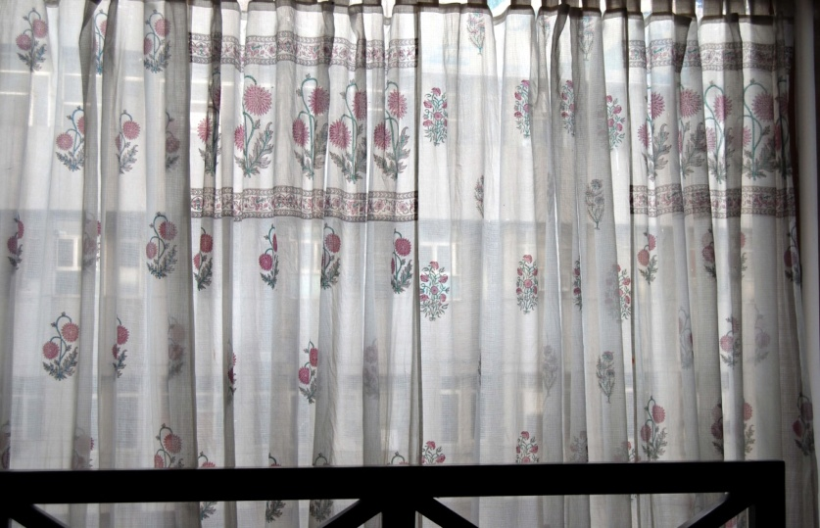
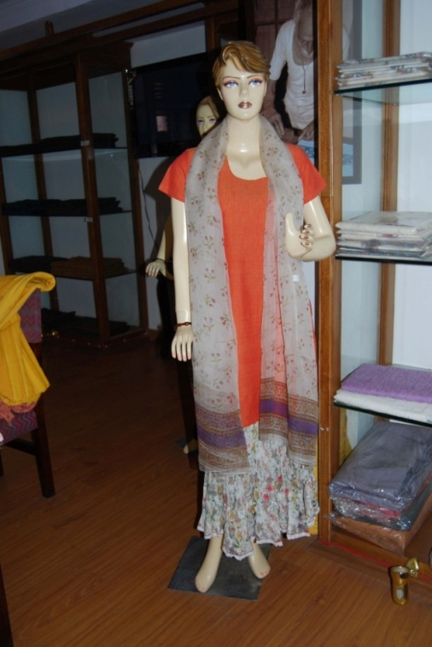
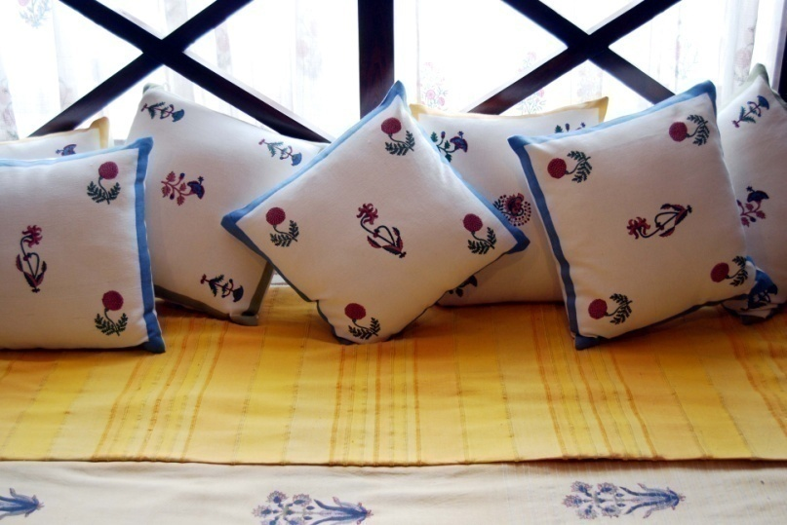
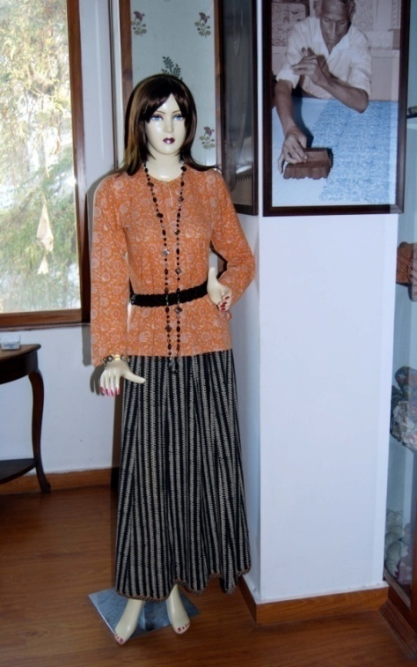
Mughal Print Kota Doria Curtains
Western Pattern Handloom Dress
(Kota Doria Skirt, Top & Dupatta)
Heavy Designer Zari Kota Doria Saree
Bed covers & Cushion Covers
Fashionable Handloom Dress
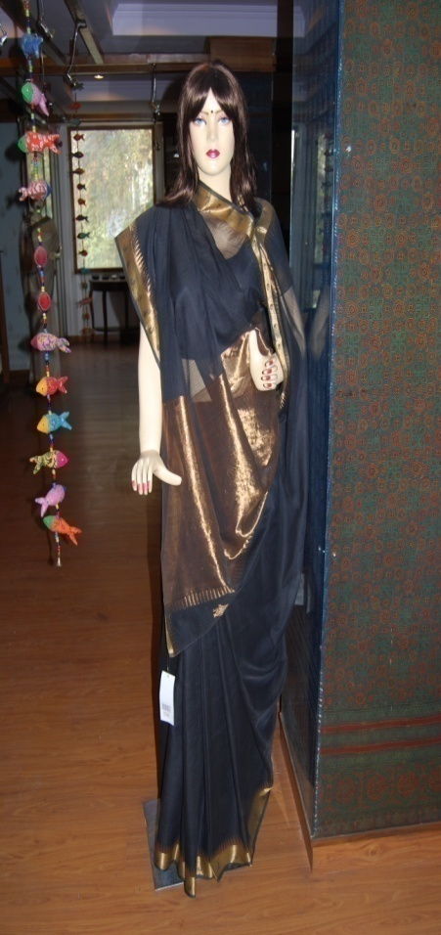

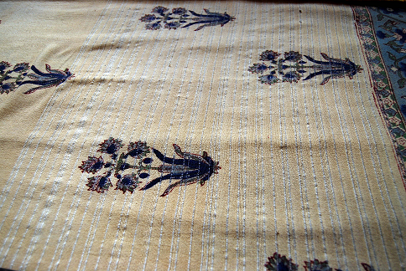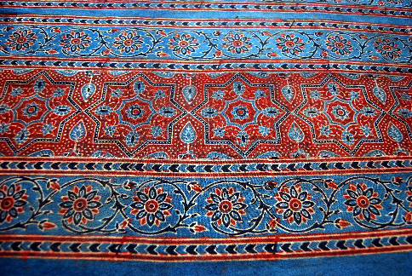
Ajrak Printed Cloth
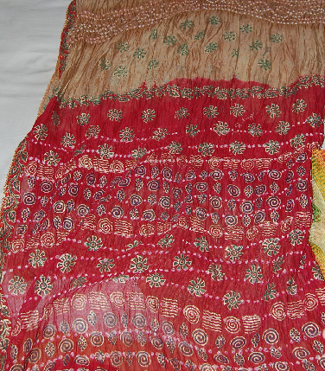
Tepchi Kota Doria Dress Material Ladnu Print Saree

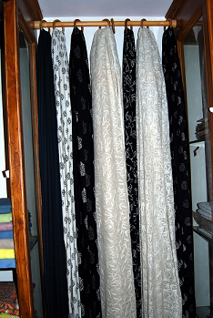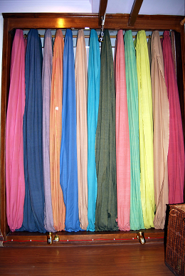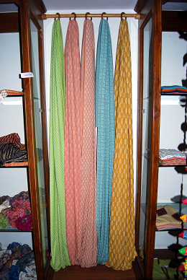
Fine Print/ Tapechi Dress Material Dyed Yarn Cotton Dress Material Khadi Printed Dress Material

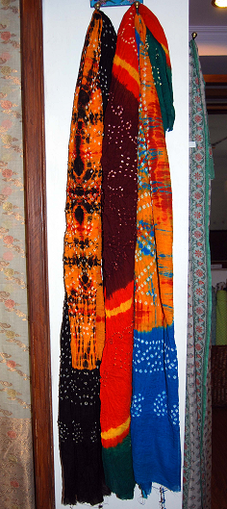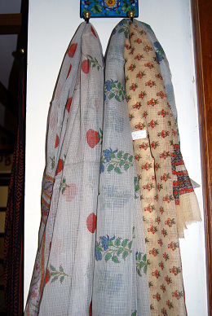
Bandhej Dupatte Mughal Print Kota Doria Dupatte
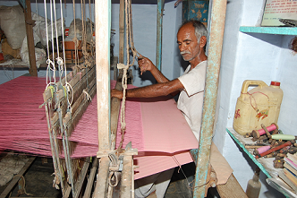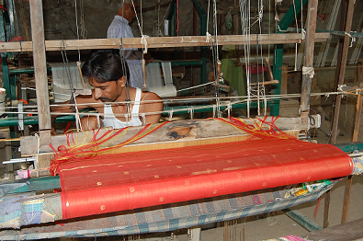
Pre-Weaving Process of a Kota Doria Designer Saree
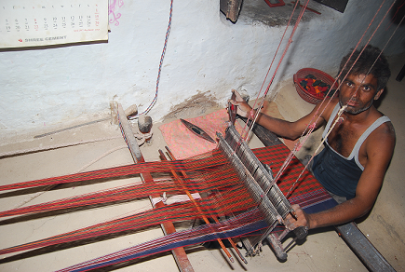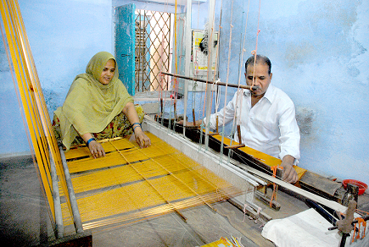
Weaving of a Jattu Saree on a Traditional Pitt Loom Weaving of Zari- Kota Doria Saree
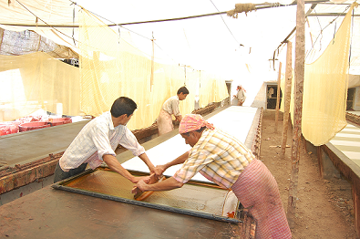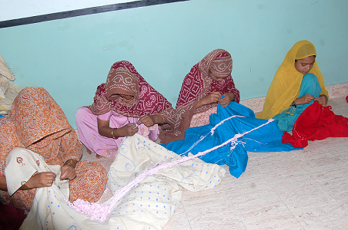
Women involved in Bandhej Work
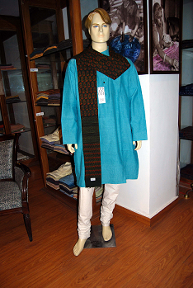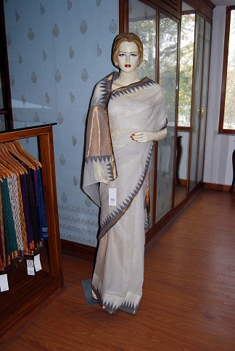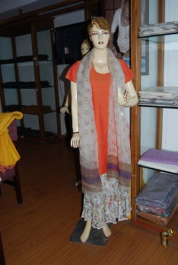
Dyed Yarn Cotton Kurta/ Payjama Temple Design Zari Kota Doria Saree Western Pattern Kota Doria Dress
(Kota Doria Skirt, Topper & Dupatta)

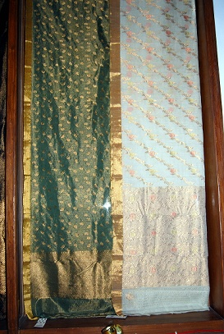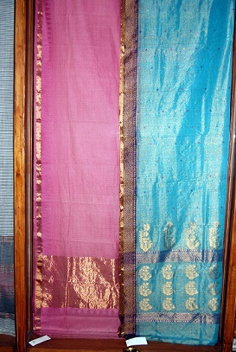
Heavy Zari Kota Doria Saree Light Zari Kota Doria Saree
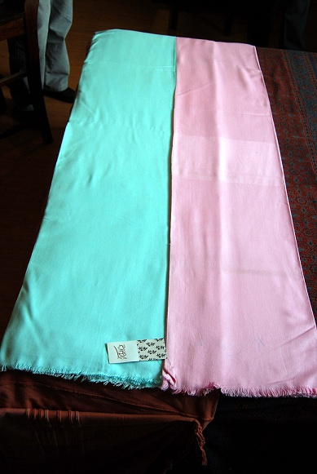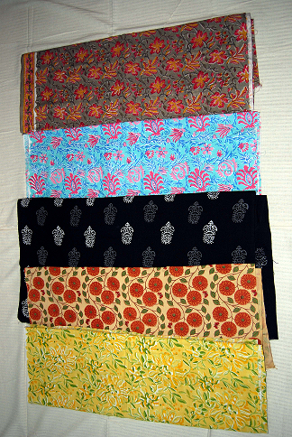
Super Fine Khes Sanganeri Block Print Dress Material

Prepared by:
KAMTECH ASSOCIATES PRIVATE LIMITED
G-4, G-5,Gajraj Apartment, Sarojni Marg,
C-Scheme, Jaipur -302001(India)
Ph: +91-141-2377559,2373226, 2371308 , Fax +91-141-4041885
e mail : kamtechassociates@yahoo.com
http://www.kamtechassociates.com

